REGULAR MEETING
AUGUST 19, 2015

A Regular Meeting of the Town Board of the Town of Hampton, County of Washington and the State of New York was held at the Town Hall, 2629 State Route 22A, Hampton, New York on the19th day of August , 2015.

PRESENT: David K. O’Brien------------Supervisor
Tamme Taran---------------- Councilwoman
David Jensen-----------------Councilman -arrived at 7:45p.m.
Donald Sady-----------------Councilman
Andrea Sweeney------------Councilwoman
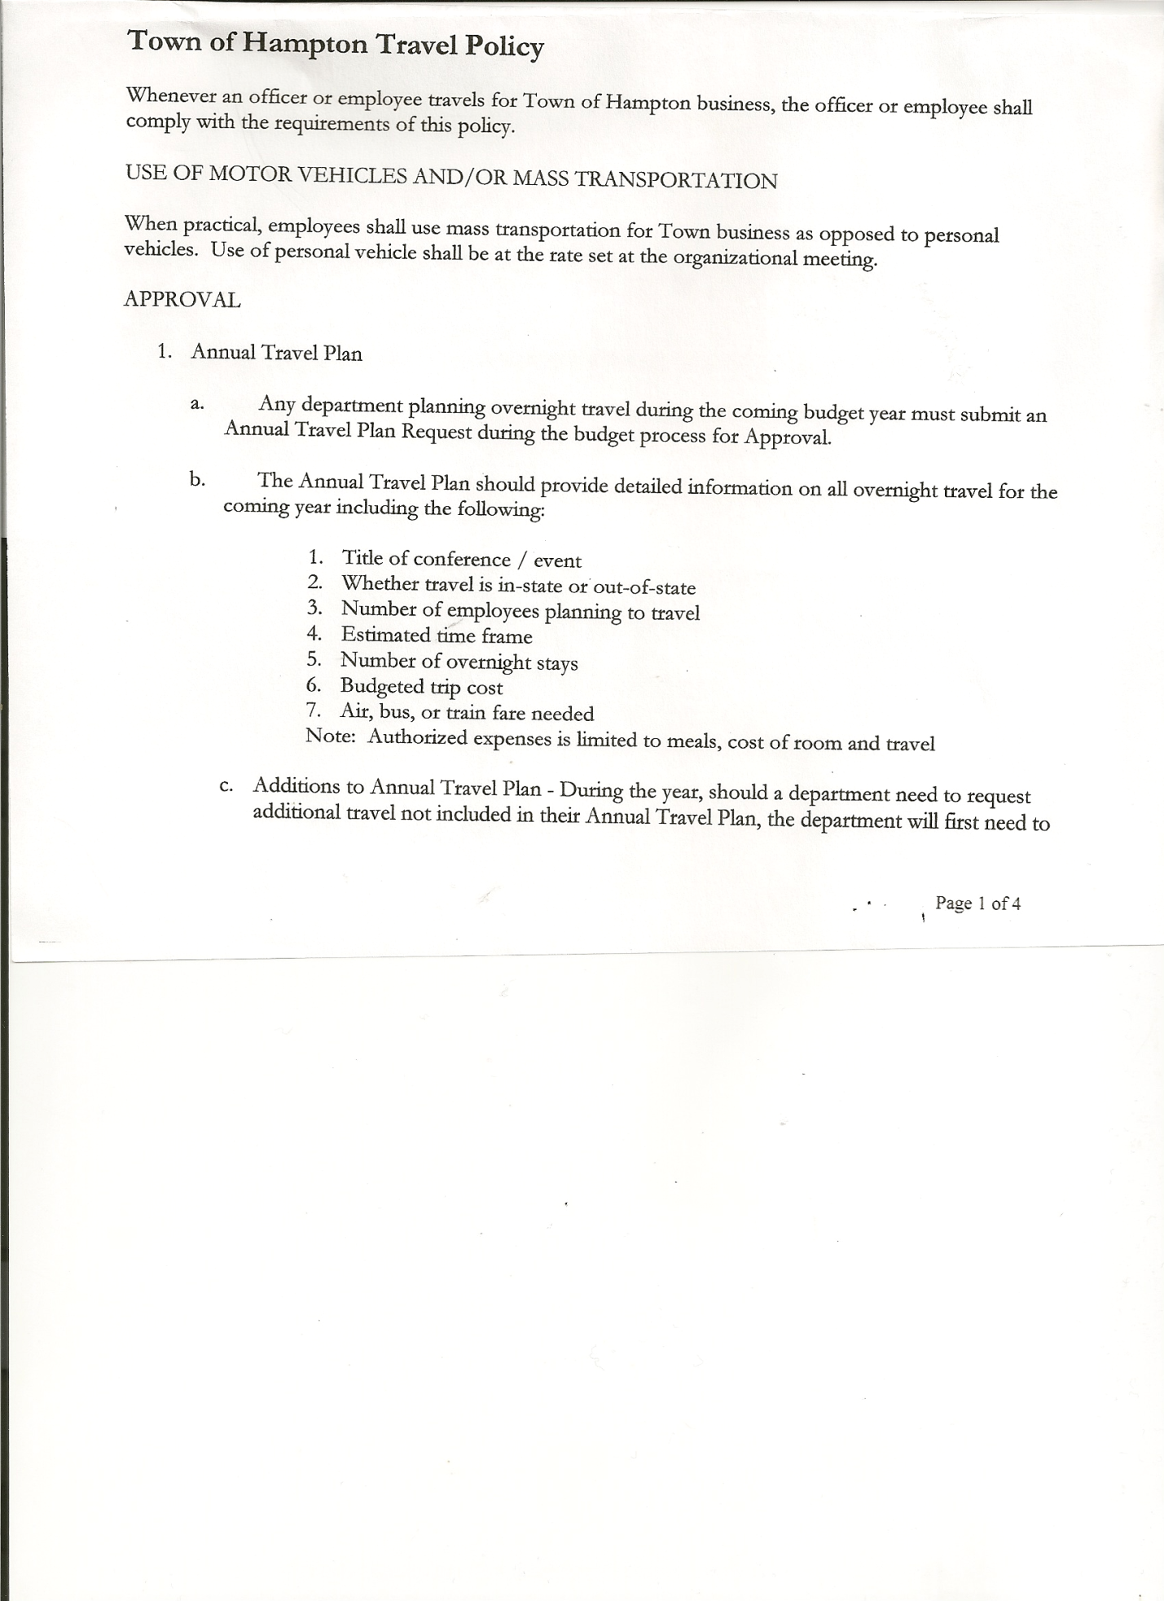
Rebecca Jones---------------Town Clerk - absent
Camilla Shaw----------------Tax Collector/Deputy Town Clerk
Herbert Sady, Jr.-------------Highway Superintendent -absent

Planning Board Member(s): Bonnie Hawley, Chair , Dianne Sophia and Francis Baker

Also present: Artie Pratt, Doran Pratt, Sr., Matthew Pratt and Christina Scanlon, Granville Sentinel reporter.

The meeting was called to order by Supervisor O’Brien at 7:30pm followed by the Pledge of Allegiance. Locations of Fire Exits were given.

RESOLUTION NO. 51-2015
APPROVAL OF THE MINUTES
On a motion of Councilwoman Taran, seconded by Councilman Sady, the following resolution was ADOPTED: Ayes 4 O’Brien, Taran, Sady, Sweeney
Nays 0
Absent 1 Jensen
RESOLVED that the Regular Town Board Minutes for July 15th, 2015 are approved.

Camilla Shaw, Tax Collector submitted her report to the Town Board , she also had board members sign and date bank reconciliation statement dated July 31st, 2015.

Supervisor O’Brien reported that Larry Carman, Dog Control Officer has been trying to catch a loose dog with no success. He will keep trying.

Planning Board Report….Bonnie Hawley, Chair gave the report:
- Mobile home park/campground law… copy of revised law given to Board members
will be introduced as a Local Law in September and a Public Hearing will be set for October

- Next Planning Board meeting will be at 7:00pm at the Town Hall on August 25th, 2015
Francis Baker submitted his resignation from the Planning Board effective September 1, 2015 due to health reasons (copy attached)

Herbert Sady, Jr., Highway Superintendent gave his report: (a copy is attached)
- Clearing side roads and trimming back brush
- Using County chipper, chips at sand pit for residents
- Mowing town and county roadsides
- Edged side of new blacktop in Chapman Road, filled potholes
- Met with Steve Haskins of Washington County for ideas on Vladyka Woods Rd
- Road salt will be going up 10% again this year.

TOWN BOARD MEETING
AUGUST 19, 2015 PAGE 2

County Updates/Communications
New Emergency Coordinator for Public Safety is being interviewed this week.
Workman’s Compensation is being reworked, may save about $750 for Town of Hampton
Cost to pave 1 mile of road was $80,166 in 2008, in 2015 it costs $149,562 per mile.
County Rt 18 from Brick Church to Hills Pond is scheduled to be paved in 2015

Justin Perry, Fire Chief, submitted the Hampton Fire Department budget report for 2015 and budget request for 2016

RESOLUTION NO. 52-2015
APPROVAL OF SUPERVISOR’S MONTHLY REPORT
On a motion of Councilman Sady, seconded by Councilwoman Sweeney, the following resolution was ADOPTED : Ayes 4 O’Brien, Taran, Sady, Sweeney
Nays 0
Absent 1 Jensen
RESOLVED that the Supervisor’s Monthly report be accepted as submitted for JULY 2015
6/30/15 7/31/15
ACCOUNT BALANCE RECEIPTS DISBURSEMENTS BALANCE
General Fund $ 74613.90 $ 5092.48 $ 6887.52 $ 72818.86
Highway Fund $ 118989.02 $ 4.62 $ 59720.94 $ 59272.70
Equipment Reserve $ 100183.46 $ 4.25 $ 0.00 $100187.71
Fire #1 $ 17013.96 $ .83 $ 0.00 $ 17014.79
Fire #2 $ 2377.00 $ 0.00 $ 0.00 $ 2377.00
Totals $ 313177.34 $ 5102.18 $ 66608.46 $251671.06

All Board Members present signed Supervisor’s Report.

The Town Clerk’s report for July 2015 was submitted to the Board. The Deputy Town Clerk had Board Members review and sign bank reconciliation statements for the Town Clerk Account and Special Town Clerk Account dated July 31st, 2015.

RESOLUTION NO. 53-2015

AUDIT OF CLAIMS
On a motion of Councilwoman Taran, seconded by Councilman Sady the following resolution was ADOPTED Ayes 5 O’Brien, Taran, Sady, Sweeney, Jensen
Nays 0
RESOLVED that the bills have been reviewed by the Town Board and are authorized for payment in the following amounts.
General Fund No. 106 through No. 115 $ 2534.80
Highway Fund No. 74 through No. 87 $ 57685.52
Total both funds $ 60220.32

On a motion of Councilman Sady, seconded by Councilwoman Sweeney , the meeting adjourned at 7:58pm. All in favor Aye.

Respectfully submitted,

Camilla M. Shaw
DeputyTown Clerk

