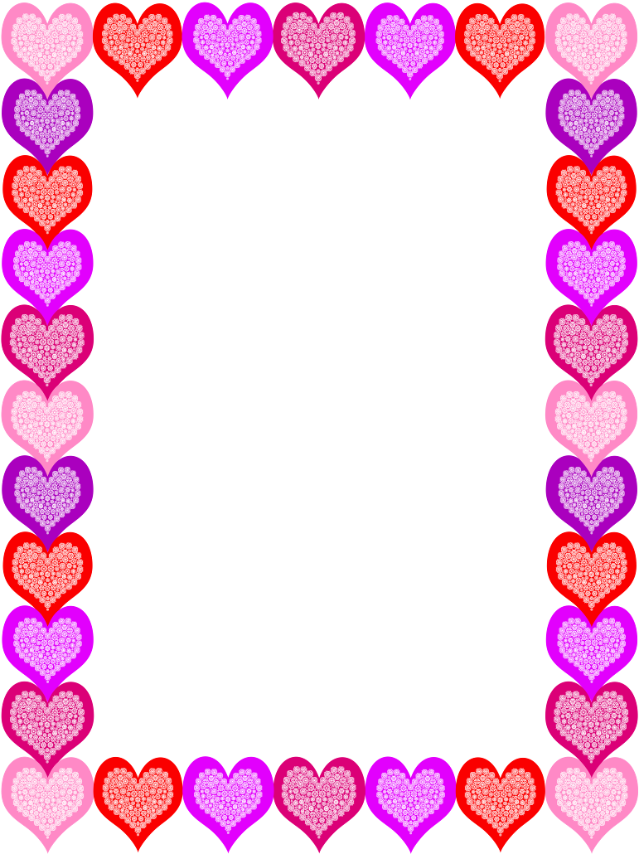
Valentine’s Day
Dear Student,

I’m so glad to work with you and get to know you. You make teaching fun!

Love,
Your Teacher
Valentine’s Day
Dear Student,

I’m so glad to work with you and get to know you. You make teaching fun!

Love,
Your Teacher
Valentine’s Day
Dear Student,

I’m so glad to work with you and get to know you. You make teaching fun!

Love,
Your Teacher
Valentine’s Day
Dear Student,

I’m so glad to work with you and get to know you. You make teaching fun!

Love,
Your Teacher
Valentine’s Day
Dear Student,

I’m so glad to work with you and get to know you. You make teaching fun!

Love,
Your Teacher
Valentine’s Day
Dear Student,

I’m so glad to work with you and get to know you. You make teaching fun!

Love,
Your Teacher
Valentine’s Day
Dear Student,

I’m so glad to work with you and get to know you. You make teaching fun!

Love,
Your Teacher
Valentine’s Day
Dear Student,

I’m so glad to work with you and get to know you. You make teaching fun!

Love,
Your Teacher
Valentine’s Day
Dear Student,

I’m so glad to work with you and get to know you. You make teaching fun!

Love,
Your Teacher
Valentine’s Day
Dear Student,

I’m so glad to work with you and get to know you. You make teaching fun!

Love,
Your Teacher
Valentine’s Day
Dear Student,

I’m so glad to work with you and get to know you. You make teaching fun!

Love,
Your Teacher
Valentine’s Day
Dear Student,

I’m so glad to work with you and get to know you. You make teaching fun!

Love,
Your Teacher
Valentine’s Day
Dear Student,

I’m so glad to work with you and get to know you. You make teaching fun!

Love,
Your Teacher
Valentine’s Day
Dear Student,

I’m so glad to work with you and get to know you. You make teaching fun!

Love,
Your Teacher
Valentine’s Day
Dear Student,

I’m so glad to work with you and get to know you. You make teaching fun!

Love,
Your Teacher
Valentine’s Day
Dear Student,

I’m so glad to work with you and get to know you. You make teaching fun!

Love,
Your Teacher
Valentine’s Day
Dear Student,

I’m so glad to work with you and get to know you. You make teaching fun!

Love,
Your Teacher
Valentine’s Day
Dear Student,

I’m so glad to work with you and get to know you. You make teaching fun!

Love,
Your Teacher
Valentine’s Day
Dear Student,

I’m so glad to work with you and get to know you. You make teaching fun!

Love,
Your Teacher
Valentine’s Day
Dear Student,

I’m so glad to work with you and get to know you. You make teaching fun!

Love,
Your Teacher

