REGULAR MEETING

SEPTEMBER 17, 2020

A Regular Meeting of the Town Board of the Town of Hampton, County of Washington and the State of New York was held at the Town Hall and via Zoom, 2629 State Route 22A, Hampton, New York on the 17th day of September 2020.

Due to the Corona Virus, occupancy inside the Town Hall is limited at this time. Supervisor O’Brien did provide a link to join the meeting via Zoom.

PRESENT: David K. O’Brien------------Supervisor

Tamme Taran----------------Councilwoman

Donald Sady-----------------Councilman

Andrea Sweeney------------Councilwoman – via Zoom

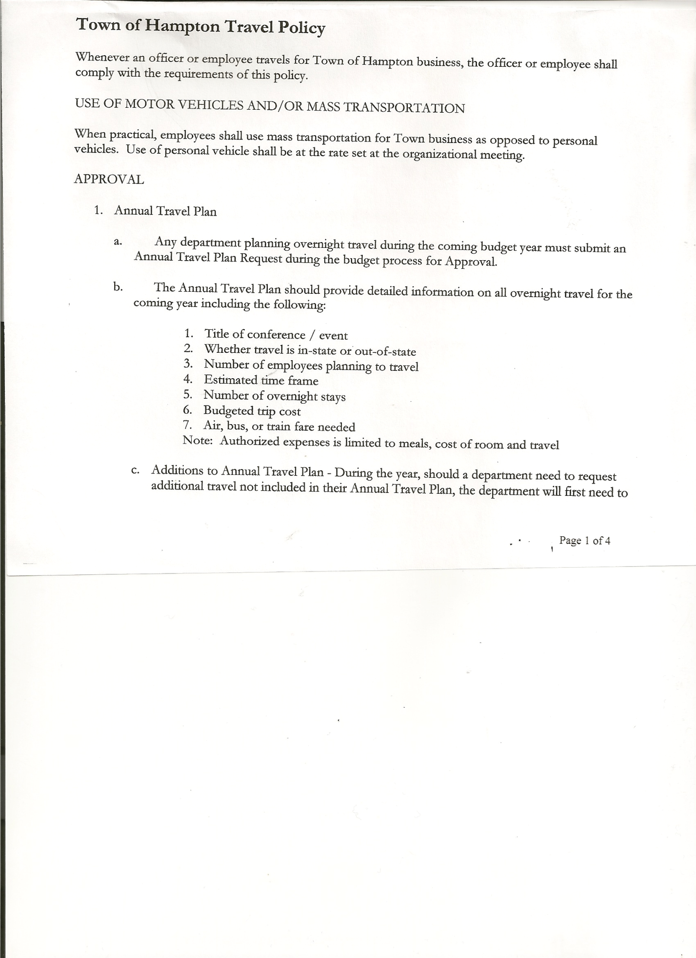 Michael Pietryka------------Councilman

Rebecca Jones---------------Town Clerk

Camilla Shaw----------------Tax Collector/Deputy Town Clerk

Herbert Sady, Jr.-------------Highway Superintendent

Kim Perry---------------------Bookkeeper/Budget Officer

Planning Board Member(s): Bonnie Hawley (via Zoom) and Matthew Pratt (via Zoom)

Others present at the Town Hall: Artie Pratt and Leonard Reed (came at 7:45p.m.)

The Regular Meeting was called to order by Supervisor O’Brien at 7:30pm, followed by the Pledge of Allegiance. Location of Fire Exits were given. Quorum of board members present.

Supervisor O’Brien asked for a moment of silence in memory of Jean Taylor Kroeber

**RESOLUTION NO. 68-2020**

**APPROVAL OF THE MINUTES**

On a motion of Councilwoman Taran, seconded by Councilman Sady, the following resolution was ADOPTED:

By Roll Call Vote: Supervisor O’Brien AYE

Councilman Sady AYE

Councilwoman Taran AYE

Councilman Pietryka AYE

Councilwoman Sweeney AYE

RESOLVED, that the Regular Town Board Minutes for August 20th, 2020 are approved.

Larry Carman, Dog Control Officer – no report submitted

Tax Collector’s Report – no activity. Submitted Bank Statement to the Board for review and signatures.

TOWN BOARD MEETING

SEPTEMBER 17, 2020 PAGE 2

Bonnie Hawley, Chair gave Planning Board Report…

* Planning Board met on August 26th…worked on finalizing the survey questions. They

resolved to accept the changes. They are now ready to do the mailing.

Some surveys will be mailed out at the bulk rate. Others with out of state owners and those with P O Boxes out of town will be sent by First Class mail.

Renee Rountree and Ginny Kinsey are working on a budget of how much it will cost to get out to each person. Goal is to mail out soon after the next meeting (9/23) and have mailed back by November 1st. Drop boxes will be put out around town.

* The board has reviewed the resolution….”*Exemption of Matters of Local Concern from County Planning Agency Review Agreement, 2020 Agreement Renewal”* ,that was received from Washington County Planning Department.
* On September 9, 2020 they met and the resolution was accepted by a motion from Matt Pratt, seconded by Renee Rountree.
* Next meeting will be September 23rd at 7:00pm at the Town Hall
* Yearly training will be held at the Town Hall on Friday, September 25th.

A question was asked about funds available for mailing. The Planning Board has $300 in their budget.

Herbert Sady, Jr., Highway Superintendent submitted his report, copy of which, is attached.

Highway Superintendent Sady requested $100 donation for a convoy to raise money for medical expenses for an individual. The town is not allowed to donate town money. Town officials offered to personally donate money.

Herb also had pamphlets on a new type of blades for the plow. They are more expensive, but should last much longer.

On hiring a new highway worker, there are 3 applicants so far. He plans to interview next week.

All sand for the winter is in as of today.

A question was asked about CHIPS money. He has not been able to contact anyone. Pete Ray’s phone number is not being manned. Supervisor O’Brien also said he has not received a confirmation email as has been done in the past.

TOWN BOARD MEETING

SEPTEMBER 17, 2020 PAGE 3

**BUDGET AMENDMENT**

**RESOLUTION NO. 69 – 2020**

**APPROVAL OF BUDGET AMENDMENT**

On a motion of Councilwoman Taran seconded by Councilman Sady the following

Resolution was ADOPTED:

By Roll Call Vote: Supervisor O’Brien AYE

Councilman Sady AYE

Councilwoman Taran AYE

Councilman Pietryka AYE

Councilwoman Sweeney AYE

RESOLVED that, the following Budget Amendment to the General Fund is approved:

Increase Assessor Personal Service Account A1355.1 in the amount of $4,750

Decrease Assessor CE Account A1355.4 for the same amount of $4,750

**SUPERVISOR’S REPORT/COUNTY UPDATES/COMMUNICATIONS**

**RESOLUTION NO. 70 -2020**

**APPROVAL OF SUPERVISOR’S MONTHLY REPORT**

On a motion of Councilman Sady, seconded by Councilwoman Taran, the following resolution was ADOPTED:

By Roll Call Vote: Supervisor O’Brien AYE

Councilman Sady AYE

Councilwoman Taran AYE

Councilman Pietryka AYE

Councilwoman Sweeney AYE

RESOLVED that, the Supervisor’s Monthlyreport be accepted as submitted for **AUGUST**

07/31/20 08/31/2020

ACCOUNT BALANCE RECEIPTS DISBURSEMENTS BALANCE

General Fund $ 60,251.35 $ 5,614.05 $ 6,039.75 $ 59,825.65

Highway Fund $ 123,406.06 $ 3.71 $ 68,849.07 $ 54,560.70

Equipment Reserve $ 54,886.56 $ 2.32 $ 0.00 $ 54,888.88

Fire #1 $ 21,224.00 $ 0.00 $ 0.00 $ 21,224.00

Fire #2 $ 5,000.00 $ 0.00 $ 0.00 $ 5,000.00

Cemetery $ 1,737.16 $ 1.18 $ 0.00 $ 1,738.34

Totals $266,505.13 $ 5,621.26 $ 74,888.82 $197,237.57

All Board Members present signed Supervisor’s Report.

TOWN BOARD MEETING

SEPTEMBER 17, 2020 PAGE 4

**OLD BUSINESS**

Handicap Ramp work has started. Materials were paid for by the grant. There will be some costs for labor not covered by the grant money. Some of that will be paid for by the Supervisor’s Contractual expenses and Town Clerk training funds that were unused.

The Town Clerk’s report for August 2020 was submitted to the Board. The Town Clerk had Board Members review and sign bank reconciliation statements for the Town Clerk Account and Special Clerk Account dated August 31st, 2020.

**NEW BUSINESS**

The **Tentative Budget** for 2021 was presented to the Town Board.

2021 Budget has about an $800 increase in General Funds. There are increases in Highway areas for paving and equipment reserve as were introduced last year to increase over a 2 year period. Highway Superintendent Sady and Kim Perry, the town bookkeeper will try to figure the expenses for the Highway Department for the rest of the year, by comparing last year’s and this year’s expenses.

**RESOLUTION NO. 71-2020**

**BUDGET WORKSHOP**

On a motion of Councilman Sady, seconded by Councilman Pietryka, the following resolution was ADOPTED:

By Roll Call Vote: Supervisor O’Brien AYE

Councilman Sady AYE

Councilwoman Taran AYE

Councilman Pietryka AYE

Councilwoman Sweeney AYE

RESOLVED, to set a Special Meeting for a Budget Workshop to be held on Thursday, October 8th at 7:30p.m. at the Hampton Town Hall.

**PUBLIC COMMENTS/COUNCIL COMMENTS**

Bonnie Hawley said that poles are being put up in Low Hampton to prepare for internet service to be available.

Matt Pratt said there is a tree on South Rd by Tatko’s skidder that needs to be taken care of.

TOWN BOARD MEETING

SEPTEMBER 17, 2020 PAGE 5

**RESOLUTION NO. 72-2020**

**AUDIT OF CLAIMS**

On a motion of Councilwoman Taran, seconded by Councilman Pietryka, the following resolution was ADOPTED:

By Roll Call Vote: Supervisor O’Brien AYE

Councilman Sady AYE

Councilwoman Taran AYE

Councilman Pietryka AYE

Councilwoman Sweeney AYE

RESOLVED that the bills have been reviewed by the Town Board and are authorized for payment in the following amounts.

General Fund No. 81 through No. 90 $ 6,670.77

Highway Fund No. 89 through No. 97 $ 13,361.55

Total both funds $ 20,032.32

**RESOLUTION NO. 73-2020**

**MEETING ADJOURNED**

On a motion of Councilman Sady, seconded by Councilwoman Taran, the following resolution was ADOPTED:

By Roll Call Vote: Supervisor O’Brien AYE

Councilman Sady AYE

Councilwoman Taran AYE

Councilman Pietryka AYE

Councilwoman Sweeney AYE

RESOLVED that the meeting adjourned at 8:11pm.

Respectfully submitted,

Rebecca S. Jones, RMC

Town Clerk

Assisted by Camilla Shaw,

Deputy Town Clerk