**Audrey Hepburn**

**Suggested Reading**

*Audrey & Givenchy* by Cindy De La Hoz (2016). Swoon-worthy photo book about the long partnership between Hepburn and fashion designer Hubert de Givenchy. Perfect for fans of Hepburn’s fashion

*Audrey at Home: Memories of My Mother’s Kitchen* by Luca Dotti (2015). A unique biography from her son. Combines anecdotes, excerpts from her letters, recipes for her favorite dishes and more than 250 previously unpublished family photos. Ideal for foodies

*Audrey in Rome* by Luca Dotti (2013). Mostly a photo book edited by Hepburn’s son. Chronicles Hepburn’s long-running links to the city, from *Roman Holiday* through her marriage to Andrea Dotti.

*Audrey Hepburn Treasures* by Ella Erwin, et al (2006). Rare. Hard to find. Great for collectors. Like a scrapbook with mix of text and photos. Includes small “treasures” in envelopes in the pages. Must have for the die-hard fans

*Audrey Hepburn: An Elegant Spirit* by Sean Hepburn Ferrer (2003). Written by her son

*Breakfast at Tiffany’s: The Official 50th Anniversary Companion* by Sarah Gristwood (2011). Half photograph and half narrative. Lots of behind-the-scenes scoop about the making of the movie.

*The Audrey Hepburn Estate* by Brenda Janowitz (2023). A fictional book inspired by Audrey Hepburn, especially the movie *Sabrina,* and full of Hepburn references

*Audrey Style* by Pamela Clarke Keogh (1999). Another great book for fashionistas. About half photography and half narrative. Includes interviews with designers including Givenchy and Ralph Lauren

*Dutch Girl: Audrey Hepburn and World War II* by Robert Matzen (2019). Riveting biography focusing on her childhood years during WWII. A must-read for those interested in Hepburn’s history, esp during World War II

*Audrey Hepburn* by Barry Paris (2001). The most ambitious and personal account ever written about Hollywood's most gracious star. Comprehensive, but some readers find it dry

*Enchantment: The Life of Audrey Hepburn* by Donald Spoto (2006). Juicy and sometimes salacious but engaging biography. Focuses on Hepburn’s insecurities and infidelities.

*Fifth Avenue, 5 AM* by Sam Wasson (2021).A history of the making of *Breakfast at Tiffany’s*.

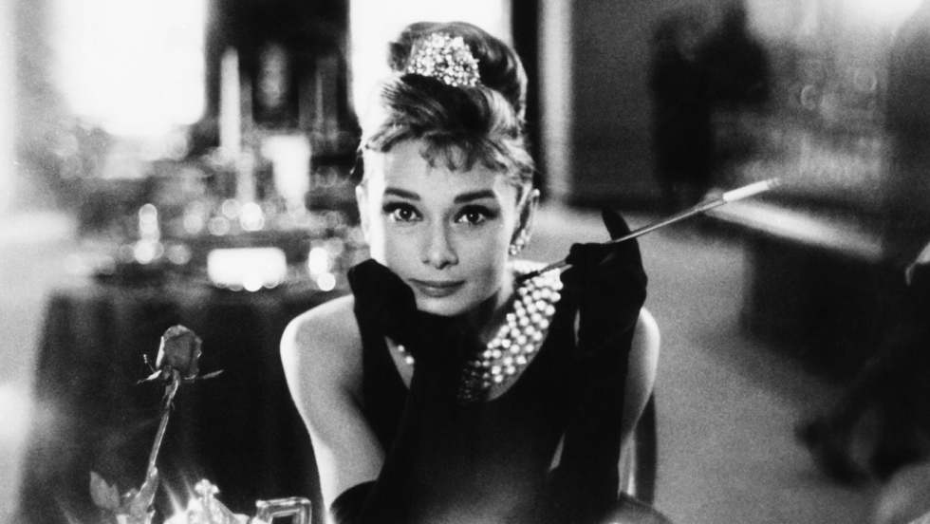

**Timeline: Audrey Hepburn**

1929 – Audrey Kathleen Van Heemstra Ruston born in Belgium on May 4

1935 – Her parents divorce, an event she considered one of the most traumatic of her life

1939 – Returns to her mother’s native Holland (the Netherlands) at the outset of World War II. Endures hardship during the war including severe malnutrition and anemia

1948 – Film debut in *Dutch in Seven Lessons*

1953 – *Roman Holiday* released, for which she receives an Academy Award for best actress

1954 – *Sabrina.* Marries Mel Ferrer, an actor and film director

1960 – Son Sean Hepburn Ferrer born

1961 – *Breakfast at Tiffany’s*

1964 – *My Fair Lady*

1969 – Marries Andrea Dotti, an Italian psychiatrist

1970 – Son Luca Dotti born

1988 – Named UNICEF International Goodwill Ambassador

1989 – Final film performance in *Always*

1993 – Dies from cancer at age 63, buried near her home in Switzerland

www.lesliegoddardpresents.com

Leslie@lesliegoddardpresents.com