* Thank you for taking the time to fill out the paperwork we require during your pet’s visit. Here are some pointers and explanations that will help you fill out the form correctly. Feel free to write as much as you want, as it will assist us in taking care of your family member.
- We typically fill out an identification card for each individual pet. If you would like to put multiple pets on one identification card that is completely acceptable. Just make sure that you are specific to what pet you are talking about if there are special requests.
RABIES DUE DATE: Please put the date that their rabies vaccines are due. We also require that dogs be current on Bordetella (kennel cough), and distemper. Cats must be current on Rabies vaccinations, FVR CP/Feline Booster, and show Negative for Feline Leukemia and Feline AIDS. Only the rabies due date needs to be listed on the form, however.
LICENSE NUMBER: Please put the updated license number if you are PA residents. Out of state residents do not require a license. If you are a PA resident and you do not have a license there is a chance that you could receive a $300 fine from the county as we are inspected periodically throughout the year.
DATE IN/DATE OUT: Here are our office hours to assist you in entering the correct dates.
Summer Hours
(Memorial Day-Labor Day)
Monday: 7:30-5:00pm Tuesday: 8:00- 5:00pm Wednesday: 8:00 - 5:00pm Thursday: 8:00- 5:00pm Friday: 8:00 - 5:00pm Saturday: 7:30- 12:00(noon) Sunday: 8:00-10:00am; 3pm-5pm
Sunday Afternoon Pick-Ups are charged an additional night's stay.
Off Season Hours
(Excluding Holidays)
Monday: 8:00-5:00pm Tuesday: 8:00-5:00pm Wednesday: 8:00-12:00 noon Thursday: 8:00-5:00pm Friday: 8:00-5:00pm Saturday: 8:00-11:00am Sunday: 8:00-10:00am; 3pm-5pm
Sunday Afternoon Pick-Ups are charged an additional night's stay.
DIET: Please write “own food” if you are bringing your own. We do feed Pedigree adult if you do not bring in your own. If you would like to use our food, please write “our food”. All food that is brought in must be put in a sealed container.
FEEDING INSTRUCTIONS: List the serving size, how often, and any other requests here.
FOOD ALLERGIES: If there are any food allergies, please list them here.
MEDICATIONS: Please list the types of medications that are to be administered and how often they should be given.
HEALTH ISSUES: Some good examples: Has seizures, sensitive skin, hearing problems, etc.
CAMP: is available to all canine guests who board with us. This option was created for dogs that have extra energy or enjoy getting outside as much as possible. Campers can enjoy long walks through our wooded nature trails, healthy sessions of “Fetch” and “Frisbee”, or perhaps a swim in our natural pond. This extra time is set aside for your dog so we tailor camp to the enjoyment of your pet and what he/she takes pleasure in doing. Camp is an additional $4/day. New clients get this service for no additional charge.
SLIP COLLARS: We use slip collars on all of our guests. If you would rather we use a harness that you provide please mark that off here. If your pet has trachea problems please list that here as well.
SEPARATE FOR FEEDING: If your pets need to be separated for feeding either because they will eat each other’s food or because they will attack one another PLEASE list that here. If they are food aggressive please mark that off under Aggression Issues.
AGGRESSION ISSUES: If your pet has any aggression issues or stress issues please list them here. Some good examples include: “food aggressive,” “doesn’t like cats,” “not friendly with other dogs,” “doesn’t like men,” etc. Be as specific as possible.
BELONGINGS: List any belongings that you plan on bringing. These could include toys, beds, food containers, medicine bottles, etc. Be as specific as possible.
SPECIAL REQUESTS: List any specific requests that you may have.
GROOMING: If you would like your dog bathed, nails clipped, ears cleaned, or bushed out, list them here. Please keep in mind full grooms (includes a hair trim) must be scheduled with our groomers. Call our office to complete this. 610-932-6980.

- Make sure you sign the form and date it.
- * PLEASE MAKE COPIES AND ATTACH RABIES CERTIFICATE, OTHER PROOF OF VACCINATIONS, AND UPDATED DOG LICENSE PAPER WORK. A rabies certificate is a form that has the due date for the rabies vaccine, the veterinarian’s signature, as well as the rabies tag number. Below is a good example of what we are talking about. Additional paper work may be needed to show that kennel cough and distemper are also up to date.
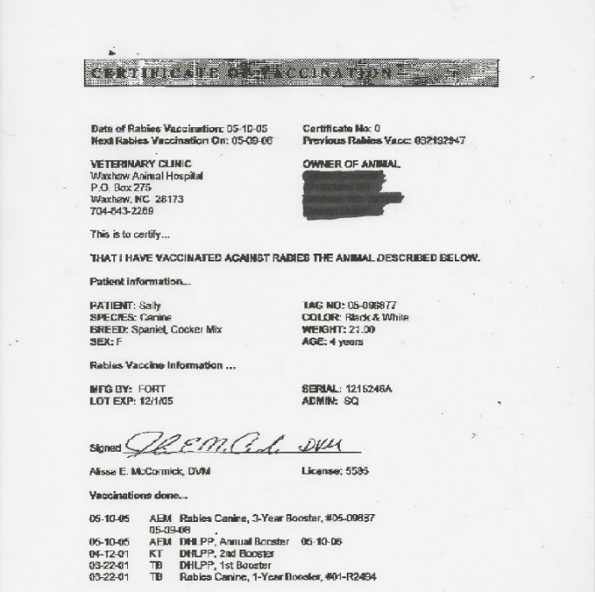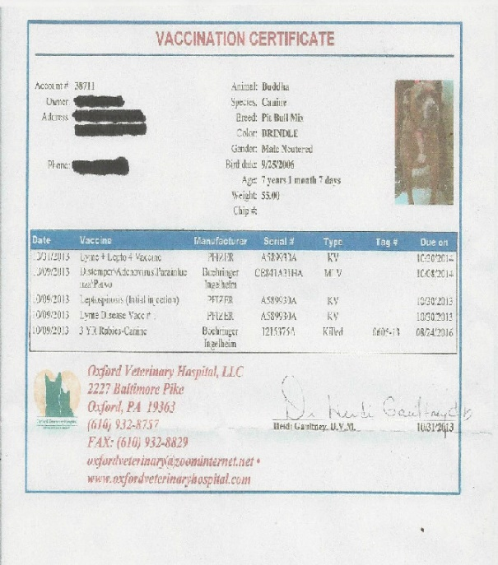
- The living room release form is only required for guests that are boarding in the living room. We will have this form in the kennel office for you to sign
- If you would like us to administer a kennel cough (Bordetella) vaccine please let us know when you are dropping off.

