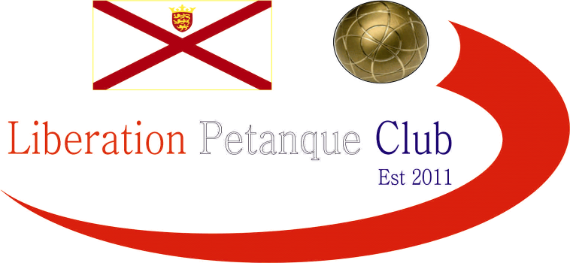

2024
Charity Doubles Open

The closing tournament of 2024 in the Charity Doubles raising money for Jersey Childrens Charity and Ronald McDonald House Charity. Eight teams took part helping raise £150 towards Jersey Childrens Charity & Ronald McDonald House Charity.

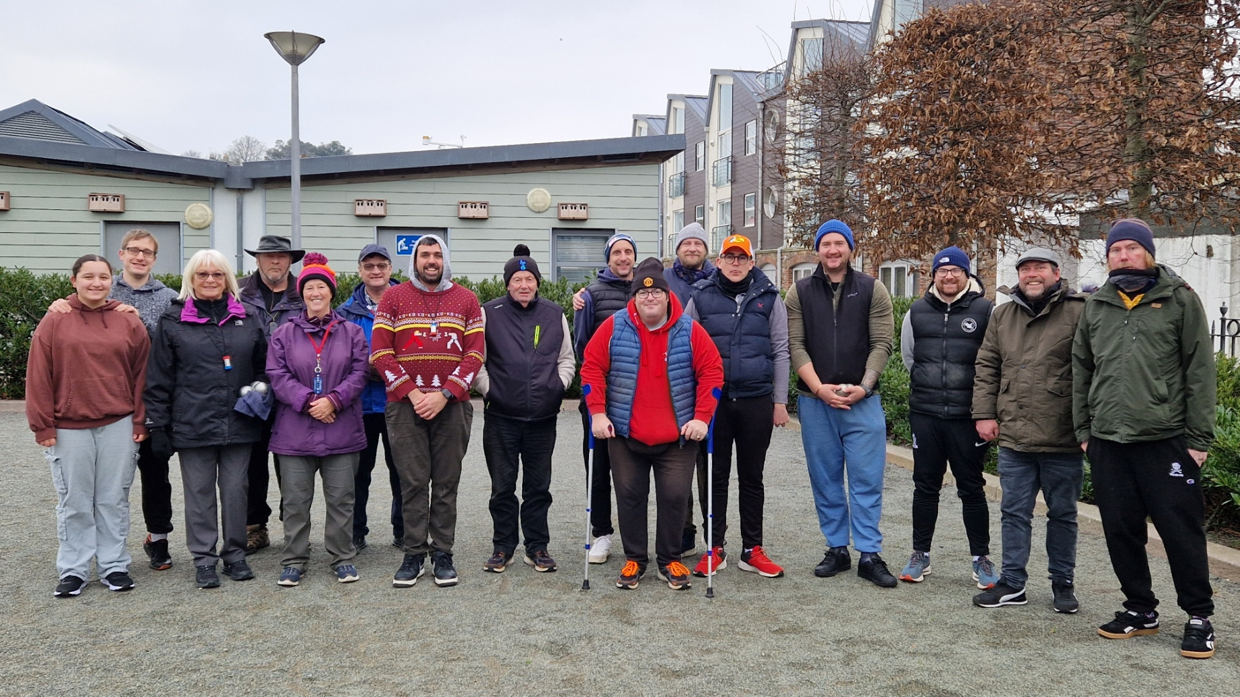

Two groups of four teams, followed by the top two playing the final and Runners Up playing for third and fourth place.

In Round One

The closest match was a 9 – 8 win for Ross Churchill & Michael De La Hunty over Andrew Bellamy Burt & Alan Oliveira. A big win also for Daniel & James Villalard over Gary Cowburn & Wendy Ritzema.

In Group 1 current champions Ross Payne & Callum Stewart won 13 – 6 over Mo De Gruchy & Keith White, whilst James Rondel & John Lane beat Martin & Eliyah Schwartz 13 – 7.

In Round Two

Callum & Ross won 13 – 0 over Eliyah & Martin and James & John just won against Keith & Mo 11 – 9.

In Group two, big wins for Andrew & Alan over Daniel & James and Gary & Wendy over Michael & Ross.

In Round Three

This was to decide who went into the final and who went into the third place play-off.

John & James found it tough going as champions Callum & ross ran out 13- 6 winners to make the final with John & James making the third place play off. Keith & Mo beat Martin & Eliyah.

Group two saw Andrew & Alan beat Gary & Wendy to finish on 2 wins + 12 and Daniel & James beat Michael & Ross 13 – 8 to also finish on two wins but with 0 points difference.

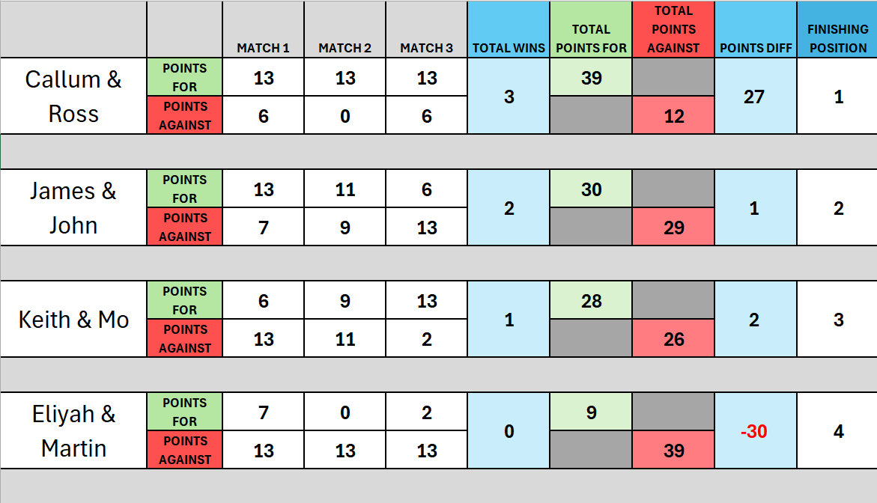

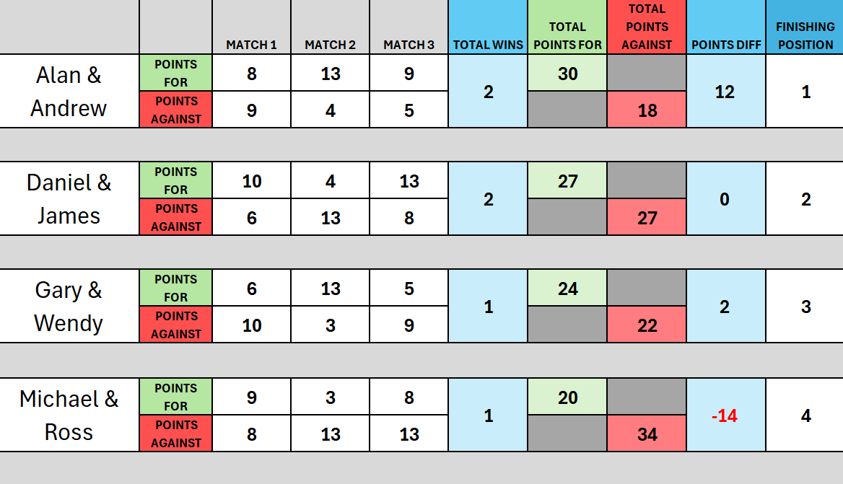

The third place play-off there was between Daniel & James Villalard and James Rondel & John Lane. A close match but John & James won 13 – 8.

The final between Alan Oliveira & Andrew Bellamy-Burt and Callum Stewart & Ross Payne.

A really close final going Callum & Ross way 13 – 10 for back to back titles.

2024 Winners – Ross Payne & Callum Stewart

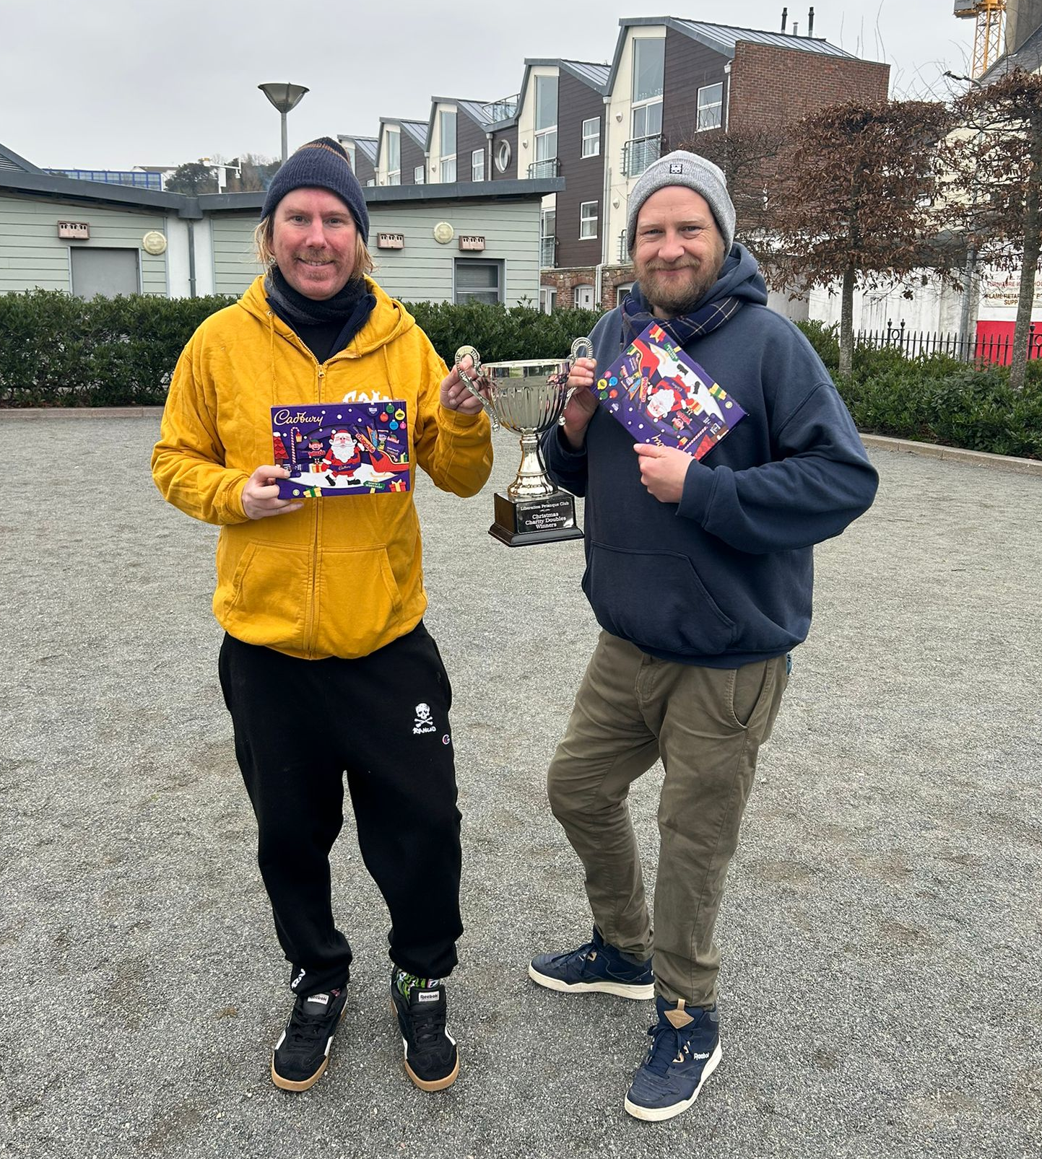

A special thank you to all those taking part and those donating to the charities and thanks to everyone who helped with the competition, especially Callum & Ross.

Club email address - liberationpc@gmail.com

Club Website - www.liberationpetanque.co.uk

Kind Regards

Toby Northern

Chairman

Liberation Petanque Club

