GFWC BWC NEWS

Dr. Suess Birthday March 2nd
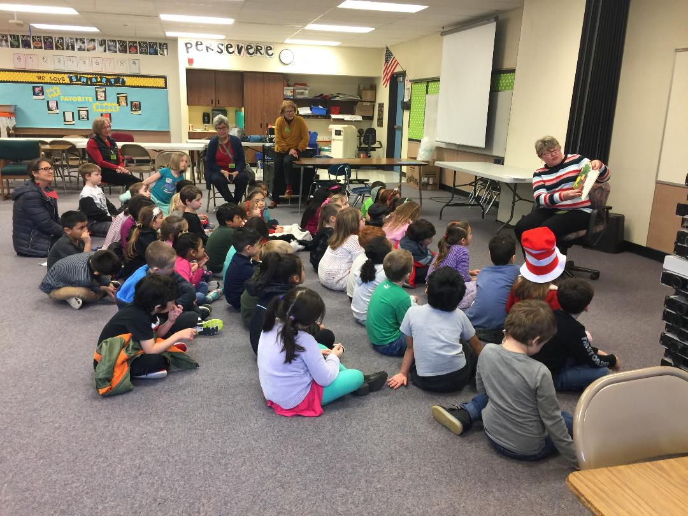  EACH KINDERGARTEN STUDENT  RECEIVED A BOOK TO TAKE HOME  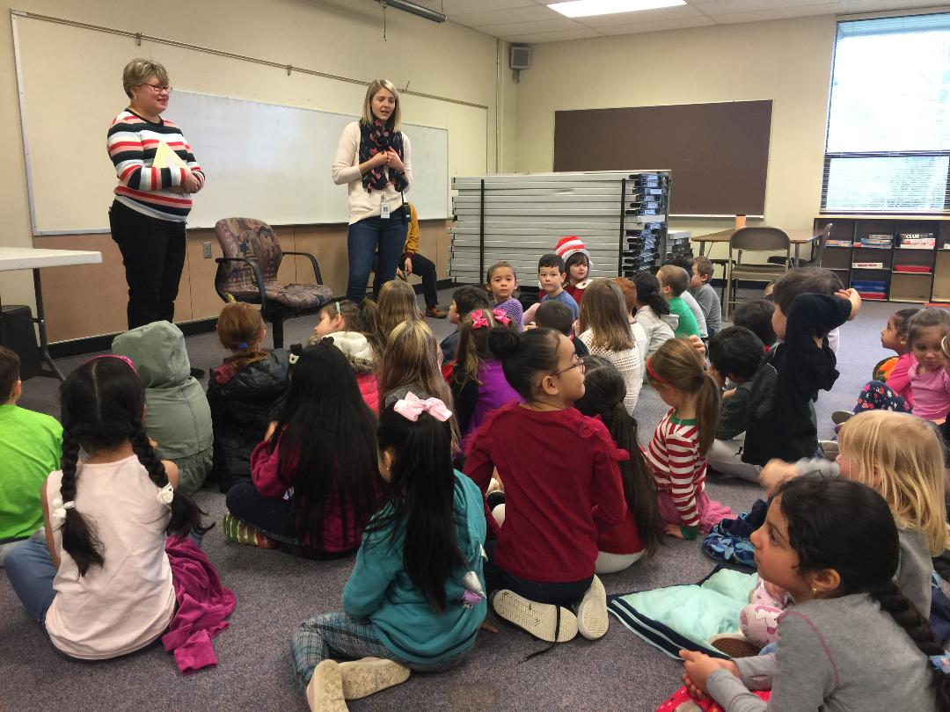  Girlfriends 20 th Anniversary Gala Tea  April 26  1:00 – 4:00 | 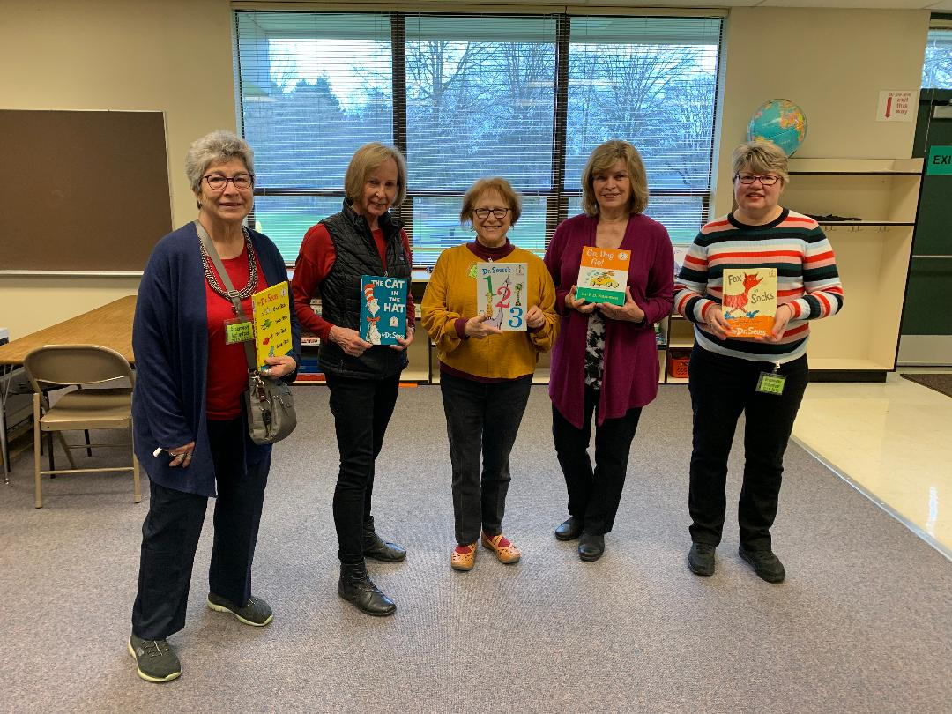  MEMBERS READ DR. SEUSS BOOKS  AT GREENWAY ELEMENTARY SCHOOL  UPCOMING EVENTS:  Volunteer Fair: April 4 Beaverton Library 9:30  April Monthly Meeting: April 7  Griffith Bldg. Room 100  6 pm Tea Mtg 7 pm Mtg  Speaker: Performing Arts Center  Fine Arts Scholarship Contest: April 11 Independence 10 AM  OFWC MAY CONVENTION  May 15-17 ASTORIA  Check out our WEBSITE  http://www.beavertonwomansclub.com/

