GFWC BWC NEWS

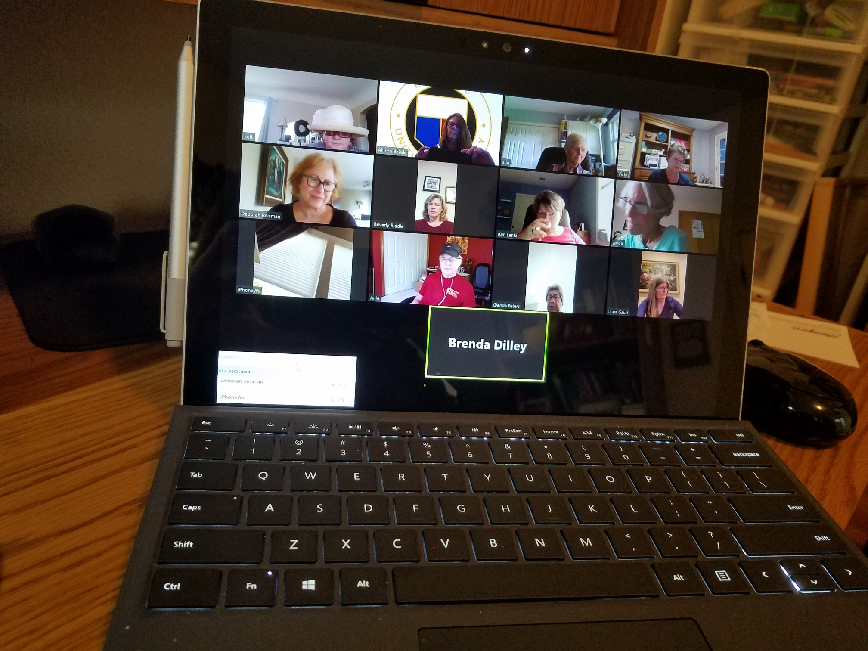  ZOOM CLUB MEETINGS  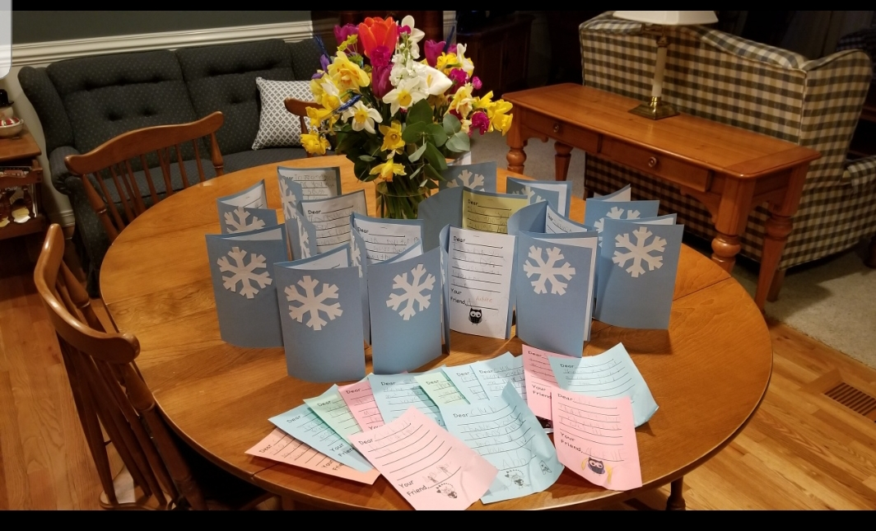  “THANK YOU” CARDS FROM  GREENWAY ELEMENTARY KINDERGARTEN STUDENTS FOR THEIR BOOKS.  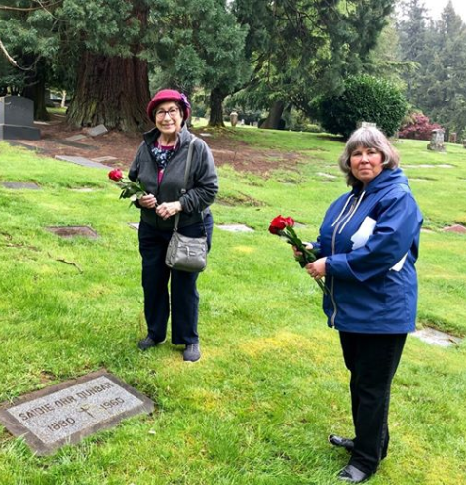  Glenda and State President Pam  visit Saidie Orr Dunbar’s Gravesite. | 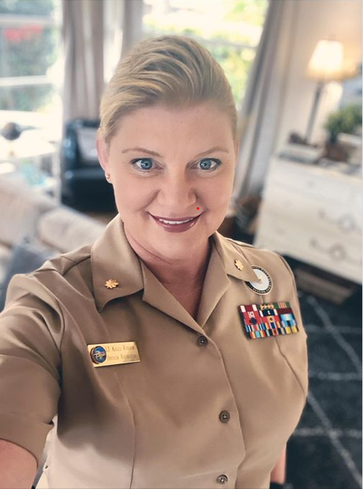  COGRATULATIONS TO CLUB MEMBER  KELLI ROESCH  PROMOTED TO ARMY LIEUTENANT COLONEL  The Club has been able to support the community in the following ways during this COVID epidemic:  $500 Homeplate  $250 Sunshine Pantry  $250 Meals on Wheels  $290 BSD Homeless Housing Fund  UPCOMING EVENTS:  JUNE MEETING: 6PM ON ZOOM
http://www.beavertonwomansclub.com/

