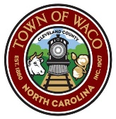
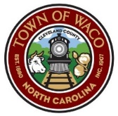
Town of Waco
Community Center Usage Policies
  - Absolutely no weapons of any kind (guns, knives, etc.) including concealed carry weapons are allowed on the Community Center grounds or in the building.
  - The consumption of alcoholic beverages is not allowed on the Community Center grounds or in the building. No smoking or use of vape materials is allowed in the building. Drug use is prohibited on Community Center property.
  - Please refrain from using any tape or tacks on walls / door frames for decorations.
- Please refrain from using excessive glitter for decorations.
- Please respect the building and its contents and be responsible for your actions
- Please do not remove any items from building that you did not supply.
- Please report any breakage of damage immediately to a Town official.
- Please wash any kitchen items used prior to putting them away.
- Please avoid opening windows or blinds unless approved to do so.
- Maximum occupancy per Cleveland County Fire Marshalls office is 69 guests.
Cleaning checklist prior to leaving
- Clean appliances (stove – microwave – coffee pot) and wipe down all tables and counters.
- Clean the refrigerator and throw everything away.
- Sweep and mop the floors in the kitchen, bathrooms and large gathering area.
- Clean restrooms and toilets.
- Pick up any trash left around the building exterior including around the picnic area.
- Remove all trash from bathrooms and kitchen and place in outside trash bin.
- Please roll large trash bin to sidewalk after all trash has been collected.
- Please leave heating / air conditioning set at 72’.
10. Please assure all doors are locked and lights are out when leaving.
Thank you!
Town of Waco
(The Town of Waco is not responsible for accidents on the property)

