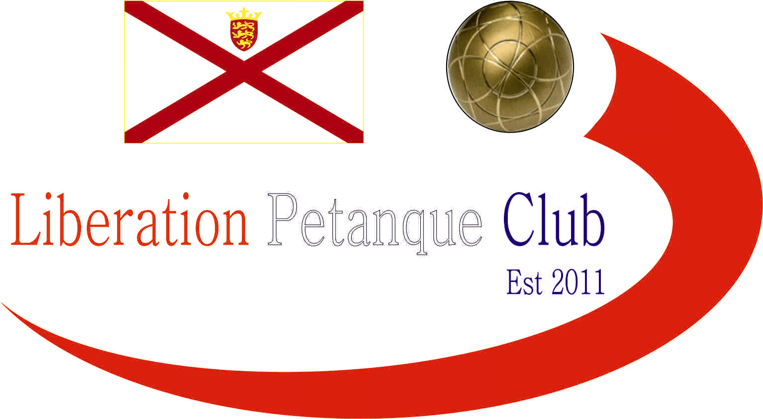

2014

Liberation Petanque Club

Elements Media (Jersey)

Singles Open

Champion

Toby Northern

This years competition saw a record 36 players take part, playing five rounds under the Swiss system, using the same Computer software as used in the European Championships.

This mean’t each round would get harder as winners would play each other with the top eight ranked players after five rounds going through to the quarter finals.

Two times Island Singles winner Matt Pinel topped the rankings winning all five matches including a win over current Island Singles champion Toby Northern. Craig Kelly finished second also with five wins, one of which was a 13 – 1 win over (Title holder) Ross Payne.

Andrew Bellamy won his last match 13 – 12 against title holder Ross Payne to qualify for the quarter finals at the expense of Ross.

Island Singles Champion Toby Northern just made the top eight with 3 wins 17 BHN (Opponents wins).

Wins BHN + Points

1st Matt Pinel 5 12 43

2nd Craig Kelly 5 12 27

3rd Michel Morel 4 18 8

4th Keith Pinel 4 14 19

5th Andrew Bellamy 4 14 12

6th Alan Lahiffe 4 13 24

7th Matt Buesnel 4 10 24

8th Toby Northern 3 17 5

The Quarter Finals were based on ranking positions.

1st Matt Pinel v 8th Toby Northern

2nd Craig Kelly v 7th Matt Buesnel

3rd Michel Morel v 6th Alan Lahiffe

4th Keith Pinel v 5th Andrew Bellamy

The seedings were turned upside down in the Quarter Finals as despite being beaten 13 – 4 in round four of the Swiss system by Matt Pinel, Toby Northern handed a similar defeat to Matt 13 – 5 in a repeat of last years quarter finals.

Craig Kelly was well beaten by rising star Matt Buesnel 13 – 2 and Michel Morel overcame Alan Lahiffe in the quarter finals for the second year running.

The closest match was Andrew Bellamy and Keith Pinel with little between them Andrew just sealed the win 13 – 11.

Semi Finals

Matt Buesnel took on Michel Morel who last year beat Matt 13 – 0 in his first ever match in a tournament having just started playing. Michel found it much tougher this time round at 10 – 10 though won three points on the next end to reach the final going one further than last year.

Toby Northern played Andrew Bellamy in the second semi final and was playing catch up all the way to 7 – 6 behind before picking up two points on the next end to move ahead for the first time. Leading 8 – 7 Toby then fired out 2 boules for 3 points and didn’t look back winning 13 – 7.

Matt Buesnel beat Andrew Bellamy 13 – 10 to seal 3rd Place.

The final between Toby Northern and Michel Morel was the third time the two had met in the latter stages of major tournaments in the last 12 months with Toby winning the last two in last years Liberation Open and Island Singles semi finals.

This was a close game with both players picking up single points to 6 – 6 before Toby gained the advantage picking up 3 points. Toby moved to 12 – 8 before Michel pulled it back to 12 – 10 but Toby placed a perfect shot on the next end and although Michel fired it out it took two attempts leaving the end open for Toby to seal victory.

Toby now holds both the Island Singles and Liberation Singles titles with the Carrefour Singles up next on the 10th May (See attached Entry form).

