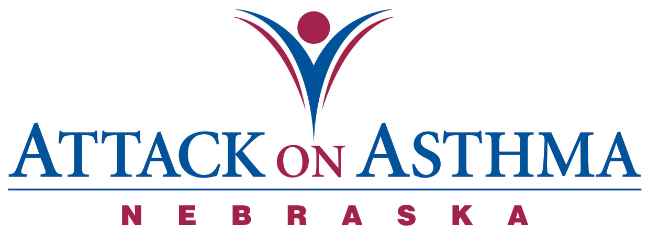

Characteristics of Individuals and Protocol Use in Nebraska Schools
2005-06

Data was voluntarily reported to Attack On Asthma Nebraska (AOAN) during and following the 2005-2006 school year. During this period of time there were 45 reported incidents of the Emergency Response to Life-Threatening Asthma or Systemic Allergic Reaction (Anaphylaxis) protocol being implemented. Schools submit data using a standardized form.

- While most schools reported only one incident of protocol administration with a student, there were 3 schools that reported two incidents with the same student.

- Over half the incidents occurred during the months of August, September, October, November (53%).

- More females (58%) than males (38%) were administered the protocol. Two reports did not signify gender, so 4% is not accounted for.

- The administration of the protocol was greater in High School (44%) and Elementary school (38%) than Middle school (16%). There was also one staff incident (2%) reported.

- A large percentage of incidents were reported in conjunction with activity; PE class and recess (42%).

- The majority of the incidents were with an individual with a history of asthma (82%). Five reported no history of either asthma or anaphylaxis (11%) and only three reporting a history of anaphylaxis (7%).

- Slightly over half (53%) received epinephrine as a correct usage of the protocol.

- Two individuals (4%) with no history of asthma returned to school with an action plan.

- Nine individuals (20%) with a history of asthma and no action plan on file returned to school with an action plan after protocol administration.

- Of those individuals with a history of asthma, seventeen individuals (38%) had an action plan on file.

- Two out of three individuals with a history of anaphylaxis did not have an action plan on file at school. One individual returned to school with an action plan and one returned only with auto-injectable epinephrine, but no action plan.

- No one required the administration of CPR.

- There were eighteen (40%) incidents in which albuterol only was administered.

- Emergency Medical Services (EMS) was summoned 34 times (76%). Of the eleven times that EMS was not summoned, eight of the incidents were treated with albuterol only.

- Twenty-eight individuals (62%) were transported to a medical facility via the Emergency Medical System. Eleven individuals (24%) were transported to a physician’s office or medical facility by a parent or were signed off by a parent.

- Twenty school districts reported the 45 incidents.

Assumption made: Action plans on file at school include prescribed medication(s).

Notes: The numbers and percentages above include all incidents, not to exclude the students of repeat protocol administration.

