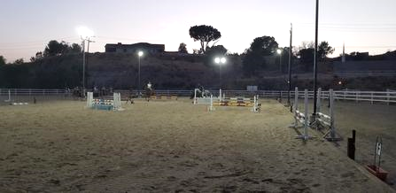

SATURDAY NIGHTS UNDER THE LIGHTS
2022 SUMMER SCHOOLING JUMPER SHOW SERIES

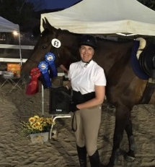

3 shows during this summer

Dates: June 11, July 16, and August 13

Classes start at 5:30 PM. Later classes will be under the lights.

Class List: 1. Trot poles ground poles (open)
2. Cross-rails 12”- 18” (17 and under)
3. Cross-rails 12” - 18” (18 and over)
4. Beginner Jumpers 2’ – 2’3” no oxers (17 and under)
5. Beginner Jumpers 2’ – 2’3” no oxers (18 and over)
6. Low Jumpers 2’3” – 2’6” with oxers (17 and under)
7. Low Jumpers 2’3” – 2’6” with oxers (18 and over)
8. Gambler’s Choice 2’3” – 2’9” with oxers (open)
9. Medium Jumpers 2’6” – 2’9” with oxers (open)
10. Upper Jumpers 2’9” – 3’ with oxers (open)

Fees: Entry fee $ 15.00 per class
CA Drug Fee $ 14.00 per horse
Trailer in fee $ 10.00 per horse
School horse fee $ 10.00 per horse (for Opava Eventing Clients using lesson horses)
Office fee $ 5.00 per horse
Late entry fee $ 25.00 per entry

Registration: Entries must be made in advance by online registration, mail, email or in person, and received by the Wednesday prior to the show. Payment must be made by the Wednesday prior to the show. No payment will be accepted the day of the show and entries not pre-paid will not be issued a number. Payment can be made by check, cash, Venmo, Zelle and PayPal. No refunds for scratches made on the day of show. No adding on classes after the closing date.

All entries must have a signed release. Entries will not be accepted with incomplete information or un-signed releases. All entries and payments must be received by the Wednesday prior to the show date. Entries received between Wednesday and Friday incur a $25 late fee. Absolutely NO entries, payment for such, will be allowed on the day of the show.
Class Format: All classes to follow USEF rules. All run as Table II, Sec. 2a. First round run with time limit. All clear rounds will return to the arena in order of go for the jump off, time to count. Jump off to be held only if 2 or more clear rounds are posted.

3 refusals in a course or at one fence is elimination. As a schooling show, management will allow an eliminated rider to attempt to jump one fence up to a maximum of 3 tries before exiting the arena.

Order of go will be set. If you need to specify clients, etc. go in a particular order, that information must be presented at the time of entry. Management will do their best to accommodate requests, but may be unable to.

Attire: Casual jumper attire, long or short sleeve shirts (no sleeveless or tank tops), breeches, tall boots or paddock boots with half chaps, ASTM approved helmet. Protection vests and gloves are optional.

Awards & Ribbons 1st through 6th per class per show, prizes for 1st
Points: 1st = 6 points, 2nd = 5 points, 3rd = 4 points, 4th = 3 points, 5th = 2 points, 6th = 1 point

Series high point per class/level to be awarded at the August 14th show. Management reserves the right to combine age classes into one high point per level, depending on entries.

Gambler’s Fences are given a point value. Riders plan their own route. Every fence can be jumped only twice.
Choice: The goal is to get as many points as possible in one minute. Jumps knocked down do not incur penalties, but the rider does not get the points.

Rules: The main jumping area will host trot poles, cross rails and beginner jumpers classes. Low jumpers, medium jumpers, upper jumpers and gambler’s choice classes will be set up in the dressage court.

Entries MUST check in and get their number BEFORE getting on their horse. A horse with no number attached to its’ tack while being ridden will be eliminated.

Warm up ring: A cross rail, a vertical fence and an oxer will be available for schooling in our small arena. They will be flagged for directional use to avoid accidents and keep all horses and riders safe. Anyone attempting to jump a warm up fence in the wrong direction may be subject to elimination from the show.

Riders will no longer have the option to school over the show course.

Show management reserves the right to combine, cancel, or divide classes when deemed necessary.

Please, no smoking anywhere on the grounds.

Dogs must be leashed.

Food: No food for sale on grounds.

