IP Intercom Quick Manual
Posted by edwin li on 24 November 2015 02:38 PM
Model:LCD1560BW, VTO2000A, POE1060A, DS-3503NO, PS2406,POE-TPE-S44
Title:IP Intercom Quick Manual
Date: NOV 24,2015
Content:
- Hardware Connection Diagram
- Camera & Monitor Setup
- Multiply Monitors Setup
- Multiply Monitors Setup on Camera
- Door Strike Setup
Before Start:
#1. A PC or Laptop connected to the local network and ready for use
#2. All wires and connections are ready
#3. Prepare IP address for device, using following information as the example:
Room No.:101
Extension Room No.:101-1
Camera IP address: 192.168.0.149
Master monitor IP address: 192.168.0.150
Extension monitors IP address: 192.168.0.151
- Hardware Connection Diagram | 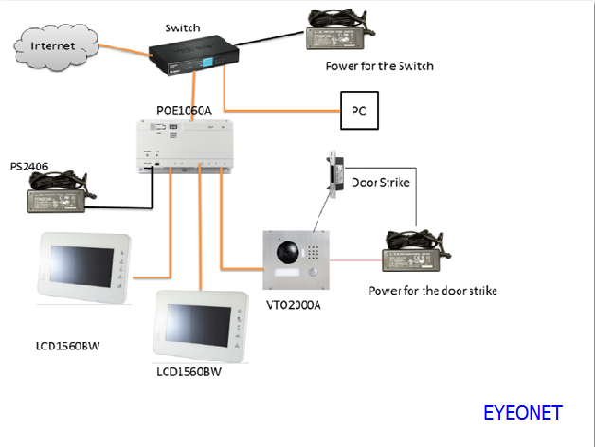
2.Camera & Monitor Setup  Outdoor station Setup  #1.Connect the outdoor station to the POE switch by using network cableand thenUsing IE browser to login to the outdoor station by using the information below:  Default IP address: 192.168.1.110  User name: admin  Password: admin | 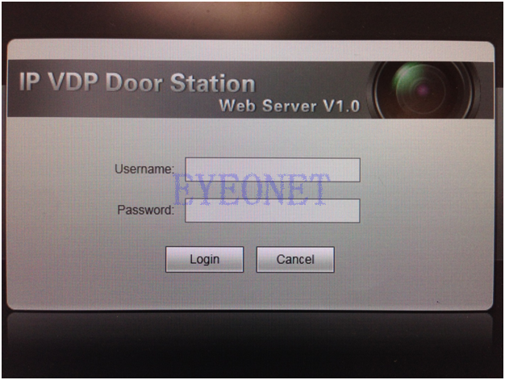
#2.Go to System Config-->Network Config to modify outdoor station IP address--> click OK
Indoor Monitor Setup  #3. Connect the master monitor to POE switch  -->setting-->Project Settings  Password: 002236 | 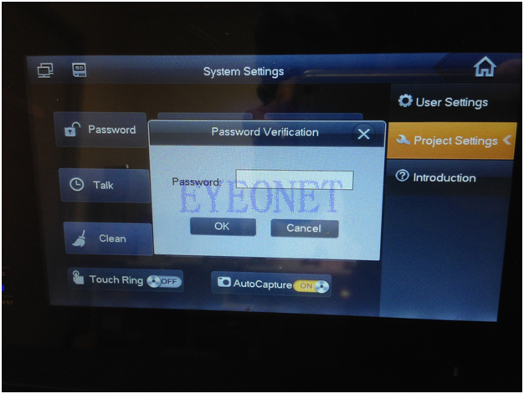
 | 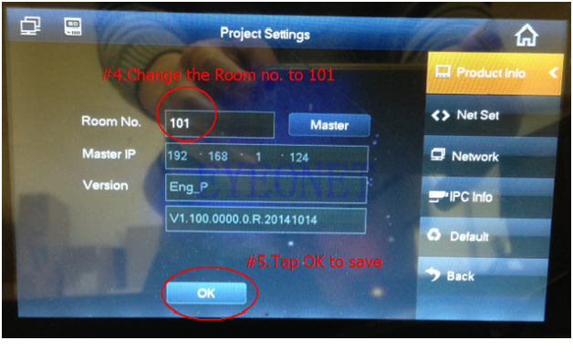
 | 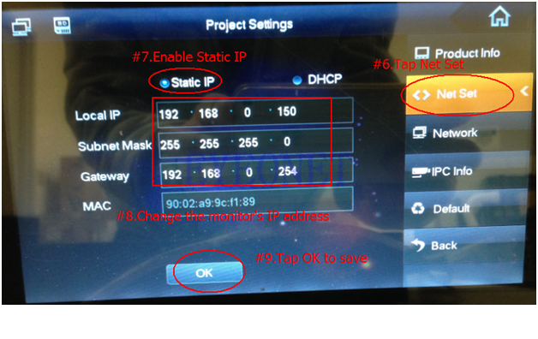
 | 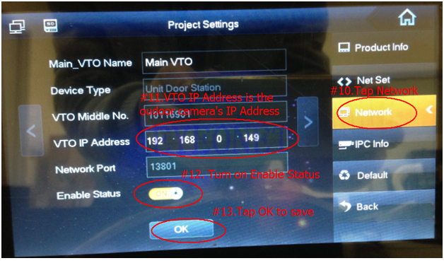
#14.Open IE-->enter 192.168.0.149 to login to the outdoor station-->System Config-->Indoor Station Manager-->Add the information shown on the right side -->OK | 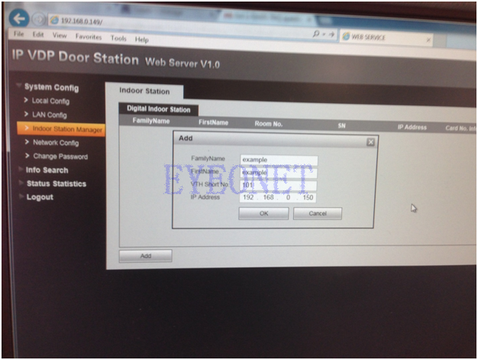
Congratulations!!
If customer needs to add more monitor, please continue...
3.Multiply Monitors Setup  Note: Please make sure connect the Master monitor to outdoor station  #1.Connect the extension monitor to POE switch-->setting-->Project Settings  Password: 002236 --> Product info | 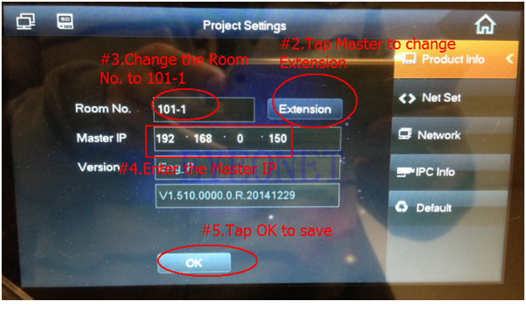
 | 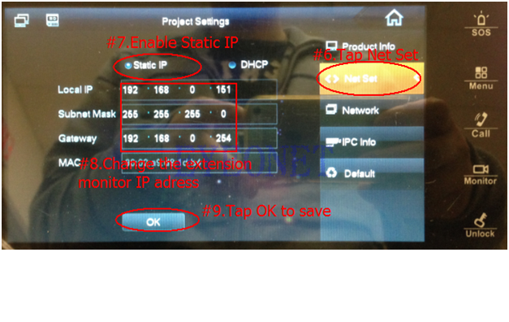
4. Multiply Monitors Setup on Camera  #1.Open IE-->enter 192.168.0.149 to login to the outdoor station | 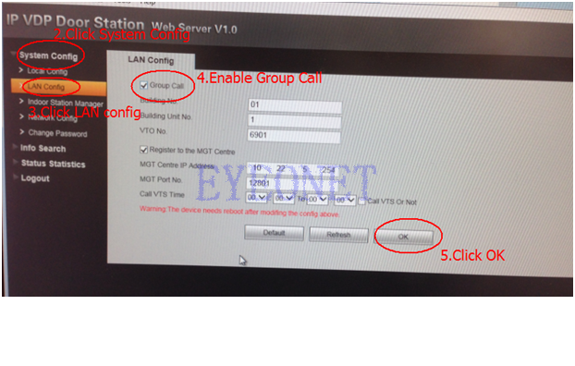  Note: the device need to reboot after modify this configuration.
5.Door Strike Connection Setup | 