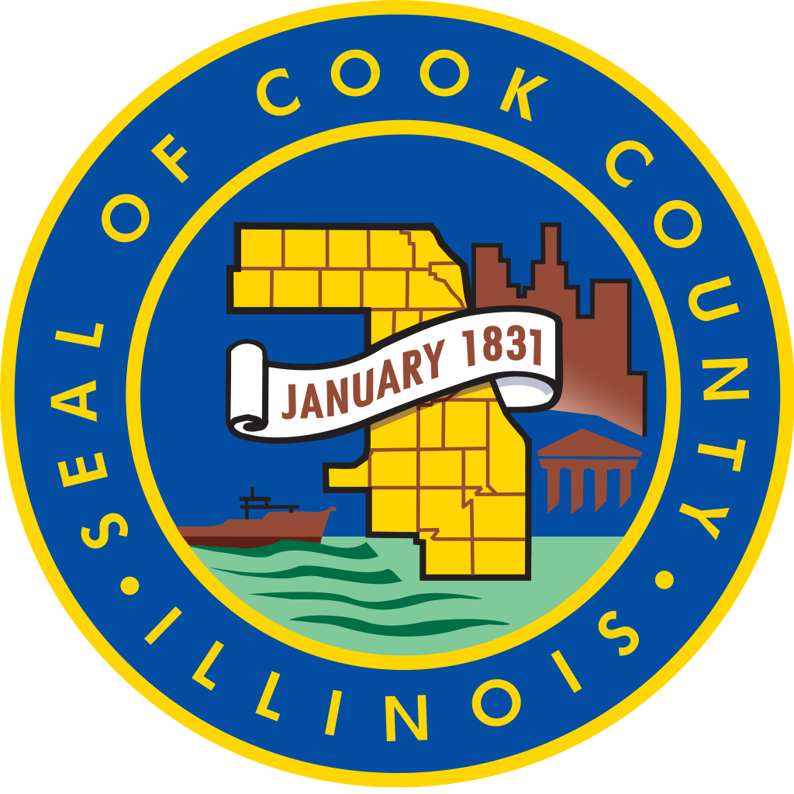

Cook County Commission on Social Innovation
Minutes

Thursday, December 15, 2016 4:00 PM CC Board Room
118 N. Clark, RM 569, Chicago, Illinois 60602

ATTENDANCE
Present: Marc Loveless, Marc Lane, Jesus Garcia, David Doig, Reggie Greenwood, Mark McHugh, Carrie Thomas, Valerie Leonard, Michael Jasso, Wendy Raymer, John Yonan, Howard Males, Pam Rodriguez, Maria Kim, Emile Cambry, Harold Rice, Victor Dickson.

Absent: Mike Hobbs, K Sujata, Eugene Williams, Ald. Sue Sadlowski Garza, Robert Gertner.

MINUTES

4:10 PM
Call to order – Commissioner Garcia

4:15 PM
Approval minutes from October 20, 2016. Motion by Mark McHugh, seconded by Howard Males; passed unanimously.

4:18 PM
Committee Reports

4:30 PM
Metra Electric resolution was presented by David Doig. Doig motioned for approval to submit the recommendation to the County Board. Amendments were suggested: P. Rodriguez: include two community meetings. V. Dickson: include the Westside as part of the conversation. Original item Seconded by Pam Rodriguez. All in favor. As amended: Motion by David Doig, seconded by Reggie Greenwood. Passed unanimously.

4:50 PM
Guest Speakers
Jerr Boschee, Executive Director, The Institute for Social Entrepreneurs – innovator, entrepreneur, professional manager
Daniel Diermeier, Ph.D., Provost, University of Chicago
Mark Weber, Ph.D., and Roy Wesley, Ph.D., CEO and COO, respectively, of Fermalogic, Inc.

5:55 PM
Adjournment
Motion by David Doig, seconded by John Yonan, passed unanimously.

