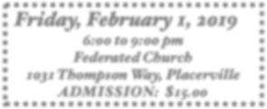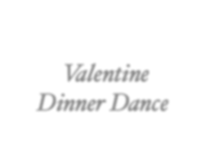

*Valentine*

*Dinner Dance*

***Friday, February 1, 2019***

***6:00 to 9:00 pm Federated Church***

***1031 Thompson Way, Placerville ADMISSION: $15.00***

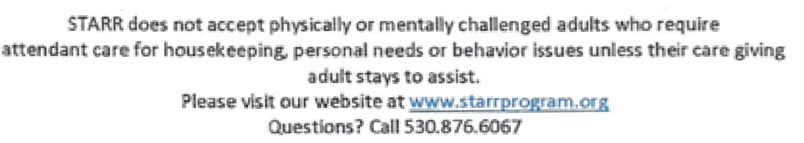

***DJ &Dancing!***



***Roses are Red***

***Violets are Blue***

***If You LOVE Having Fun***









*Roses are Red, Violets are Blue. If you love having fun, this party’s for YOU!*

***Dinner and Dessert will be Served***