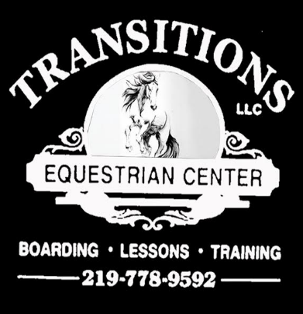
Transitions 2022 Dressage Schooling Show Series
Location: Transitions Equestrian Center | Show Manager: Melissa Ashcraft
Address: 2525 E. 850 N. La Porte, IN | Phone: (219) 778 – 9592
Email: Transitionshorses@gmail.com | Website: TransitionsEquestrianCenter.com
Show Dates: July 23rd & 24th  Entry Closing Date: July 15th | Show Date: Aug 27th  Entry Closing Date: Aug 19th | Show Dates: Oct 8th & 9th  Entry Closing Date: Oct 1st

All levels and tests are available.
If your test is not listed please write below.

Dressage Tests | Western Dressage Tests | Combine Training Tests
[ ] Dressage Equitation Walk/Trot  [ ] Dressage Equitation Walk/Trot/Canter  [ ] Dressage Horse Suitability Walk/Trot  [ ] Dressage Horse Suitability Walk/Trot/Canter  [ ] USDF Intro- Test A  [ ] USDF Intro- Test B  [ ] USDF Intro- Test C  [ ] USDF Training Level- Test 1  [ ] USDF Training Level- Test 2  [ ] USDF Training Level- Test 3  [ ] USDF First Level- Test 1  [ ] USDF First Level- Test 2  [ ] USDF First Level - Test 3  [ ] USDF Second Level - Test 1  [ ] USDF Second Level- Test 2  [ ] USDF Second Level- Test 3  [ ] Musical Freestyle:  Name Level/Test | [ ] Western Dressage Equitation  Walk/Trot  [ ] Western Dressage Equitation Walk/Trot/Canter  [ ] Western Dressage Horse Suitability Walk/Trot  [ ] Western Dressage Horse Suitability Walk/Trot/Canter  [ ] Western Dressage Intro- Test 1  [ ] Western Dressage Intro- Test 4  [ ] Western Dressage Basic- Test 1  [ ] Western Dressage Basic- Test 4  [ ] Western Dressage Level 1- Test 1  [ ] Western Dressage Level 1- Test 4  [ ] Musical Freestyle:  Name Level/Test | [ ] Green - USDF Intro Test B 8 to 10 Jumps will not exceed 18”  [ ] Elementary - USDF Intro C  8 to 14 Jumps will not exceed 2’ No Oxers  [ ] Starter - USEF Beg. Novice Test A  8 to 14 Jumps will not exceed 2’3”  [ ] Beginner Novice –  USEF Beg. Novice Test A  8 to 14 Jumps will not exceed 2’7”  [ ] Novice – USEF Novice Test A  8 to 14 Jumps will not exceed 2’11”  [ ] Stadium Round -
[ ] ANY USDF Test of Choice: Name Level/Test Below | [ ] Western Dressage Test of Choice: Name Level | [ ] Combine Training Test of Choice: Name Level

Please fill out separate entry forms for each horse and rider combination. No refunds. Ride times will be emailed by entry date but, are still subject to change. Show grounds are open after 3 pm the day before the show. All horses must have proof of vaccines. Horses crossing state lines should have a current negative coggins. If it rains all classes will be held in the indoor riding arena.

Awards: Schooling Show Classes will be placed AA, JR/YR,Open. No show clothes required but most be dressed in boots breeches and a helmet. Ribbons awarded 1-6th, No ribbons for test of choice classes. There will be a High Point and Reserve High Point Championship neck ribbon.

Stalls: No bedding included. Bring your own or place order below. Stalls are limited please reserve below. Protective head gear for all riders while mounted. Refer to USEF rules regarding optional adult participation in
Western Dressage Rules.

Please Check Your Classes and See Other Side For Entry Form
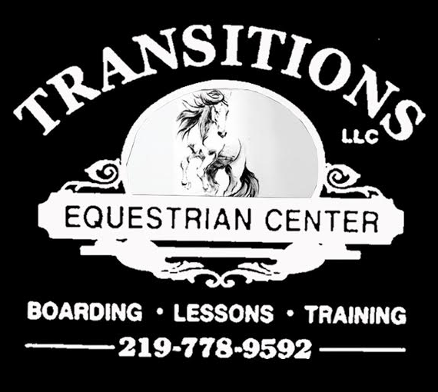
Please check the classes on the other page you will be entering an fill out information below:
Fill out separate entry forms for each horse and rider combination. No refunds.
Ride times will be emailed but, are still subject to change.

Horses Name:
Circle Type | Mare Gelding Stallion
Riders Name / Age:
Owners Name:
Circle Division: | Adult Amateur JR/YR Open
Address:
City/St/Zip:
Rider Phone:
Emergency Phone:
Email:

Office Fees ($10 Each Horse And Rider Entry Form) | $10.00
Classes $15.00 (Each Class)
Stall $40.00 (Stalls Are Limited)
Bedding $10.00 ( If You Would Like A Prepared Stall)
Test Caller $5.00 (Transitions Instructor or Volunteer Caller Available If Needed)
Horse Rental Fee $15.00 a Class
Total Amount Enclosed:

Transitions will take Cash, Credit Card, PayPal or Checks. Please make all checks out to Transitions. Please send Entry forms and payments to Transitions 2525 E. 850 N. La Porte, IN. 46350

Liability: I understand horses and horseback riding can be dangerous. I enter the competition at my own risk and will not hold Transitions LLC, Transitions Staff, or Volunteers responsible for any injures that myself, my horse or show guest or my property.

Rider Signature:(Parent If Under 18) ______________________________________________

Photo Release: I give Transitions rights to use pictures of my horse and myself from this competition for Facebook, Website and any other promotional info.

Rider Signature:(Parent If Under 18) ______________________________________________

