f

2018

Scholarship Application
Packet

Cedarburg Community
Scholarship Fund

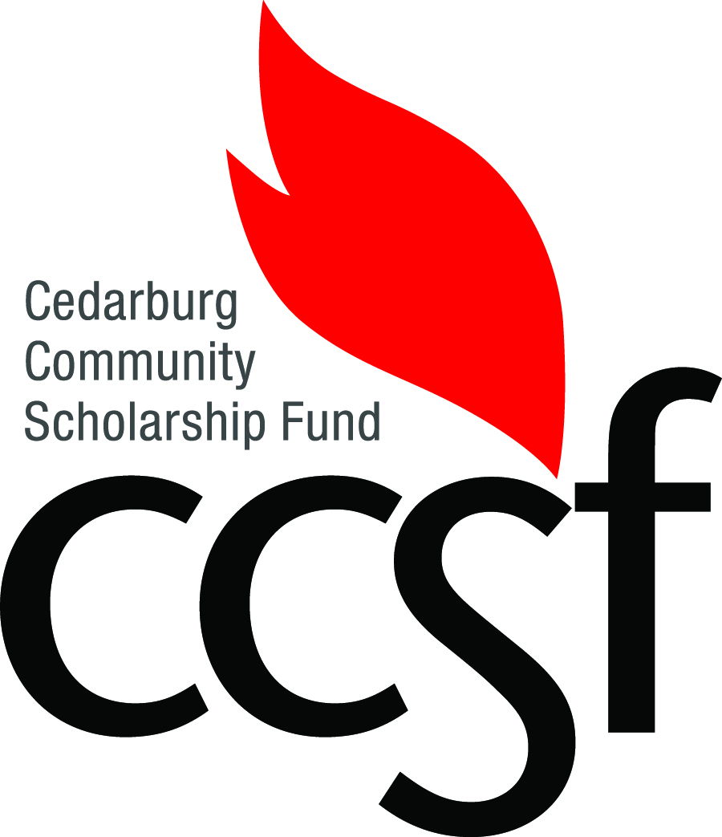

Founded 1973

PO Box 654
Cedarburg, WI 53012
www.ccsf.info

Our 45nd year assisting Cedarburg students
reach their higher education goals.

Congratulations on your decision

to further your education!

You will have many expenses during your college or vocational school experience. The Cedarburg Community Scholarship Fund was established to help you defray the cost of your education. You may apply for a CCSF scholarship if you reside within the Cedarburg School District, regardless of which high school you attend. Please read the instructions in this packet thoroughly and carefully.

IMPORTANT: The quality of your application will determine both your eligibility for a scholarship and the amount of scholarship money that you will be awarded. Give yourself enough time to do a good job of completing it.

Here is what you must do:

Scholarship Summary Form
Complete the Scholarship Summary Form on page 4. Use this form as the cover sheet for your application. It also serves as a check list to remind you of what must be included. Due to the quantity of applications received, please do not use binders, report covers or other creative packaging. While attractive, they slow down the review process. Use a single staple in the upper left-hand corner of the required forms and essays to create an application packet. Do not make double sided copies (back-to-back copies)

Student Profile Part 1
Complete the Student Profile Part 1 on page 5. Check off all that apply. This information helps determine qualification for CCSF awards with specific requirements. Awards are not limited to this information.

Student Profile Part 2
Complete the Student Profile Part 2 on page 6. It is a comprehensive look at your high school years. The CCSF Scholarship Selection Committee will use the information on this form to formulate an understanding of who you are and what you have done. In the spaces provided, indicate your activities, memberships and accomplishments, and the years in which they apply (i.e. “9” for your freshman year, “10” for sophomore, “11” for junior, and “12” for senior

Personal Resume
Prepare a Personal Resume similar to one you might use for a job interview. IT MUST BE WORD PROCESSED using a resume (not narrative) format. Place your name at the top of each page. The resume should be detailed enough to accurately represent who you are. However, excessively long resumes bog down the Committee’s work. Use your discretion in providing a resume that you are proud of. As a minimum, include the following:

- Your Goals - Understanding that many students modify their goals as they continue their studies, provide an overview of your interests and career objectives.

- Family Information - Realizing that personal family situations have an impact on all aspects of a student’s performance and record, indicate:
- Parental/Guardian Occupations
- Sibling Information
- Special Circumstances
- Anything else the Committee should know about that will affect the evaluation

- Education Record - The Student Profile gives an overview of your high school years. This is your chance to expand upon what you have done. Include:
- Extracurricular Activities
- Honors and Recognitions (both at your high school and with other organizations)
- Any other accomplishments that the Committee should know about

- Community Activities and Service - Since scholarships are not awarded based solely on grades, describe your involvement in other groups and organizations. Include such things as:
- Community Service Projects
- Youth Groups
- Volunteer Activities
- Church Activities

- Employment Record - The Committee considers a student’s time commitment to an employer, in addition to the skills learned in the workplace. Provide:
- Employers (company/store and name of immediate supervisor)
- Job Descriptions
- Experiences on the job that the Committee should know about

- Life Experiences - Describe anything else that will give the Committee an accurate picture of who you are.

5. Letter of Recommendation
Obtain one Letter of Recommendation from a person other than a relative, physician, CCSF board member or spouse, Cedarburg High School administrator, teacher, coach, or Community Service Volunteer Program coordinator. Consider asking: an employer, a family friend, a pastor, or a youth group leader. To help you with this process, give the form on page 7 to your letter writer. It contains information about what should be included in the letter.

IMPORTANT: The Letter of Recommendation you submit with your application MUST be specific to this scholarship process (CCSF and CHS). IT CANNOT HAVE BEEN USED FOR ANY OTHER PURPOSE and must be dated between December 7, 2017 and February 2, 2018.

6. Transcript of Grades
If you ARE a Cedarburg High School student, sign the “Transcript Release” section at the bottom of the Scholarship Summary Form. Your transcript will automatically be sent to the Committee. Students who have reached the age of 18 do not require a parental signature.

If you ARE NOT a Cedarburg High School student, you will need to obtain a Transcript of Grades from your high school. It is preferred that you include them with your application. Some schools will not give transcripts directly to students. If this happens, have your school send your transcript to: CCSF Scholarship Selection Committee, PO Box 654, Cedarburg, WI 53012.

Scholarship Essays
Certain scholarships require essays that will be scored by the Committee. These requirements are described on page 8. If you apply for any of these scholarships, be sure to complete the required essays.

Student Drive Commitment Form (2 copies)
To be eligible for a CCSF scholarship, you MUST participate in the annual CCSF Student Drive either via the phone-a-thon or by working with a group of students asking for donations door to door. This is a three-hour commitment. Include two signed copies of the form (pages 9 and 10) with your application.

EXTREMELY IMPORTANT: Only COMPLETE applications will be considered for scholarship awards. If any of the items listed in these instructions are missing, a student’s application will be marked “incomplete” and will not be evaluated by the Committee.

Application Deadline: Friday, February 2, 2018, 3:30 pm
All Applications must be turned in at the CHS Guidance Office
NO EXCEPTIONS WILL BE MADE

OTHER IMPORTANT DATES:

Mandatory Student Meeting for CCSF Scholarship Applicants:
Wednesday, March 7, 2:45 pm or 7:00 pm in the CHS Large Group Instruction Room (LGI).
Call (262) 376-6350 or email mcullen@cedarburg.k12.wi.us or lpackard@cedarburg.k12.wi.us for additional information.

Door-to-Door Campaign:
Organizational Meeting for all Door-to-Door participants Wednesday, March 21, from 2:45 to 3:30 pm in the LGI.
Friday, March 23, Saturday, March 24, and Sunday, March 25, with packet turn in from 3 to 5 pm on Sunday in Room 208.

Phone-a-thon Campaign:
Monday, March 26, Tuesday, March 27, or Wednesday, March 28, from 6 to 9 pm. Meet in Room 208.

Scholarship Awards Night:
Wednesday, May 23, 2018, 6:00pm in the CPAC

Scholarship Summary Form
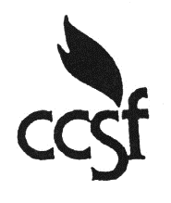
Name
Address

Schools Applied To (Check the box if you have also been “Accepted” by the school):
Accepted
Accepted
Accepted
Accepted
Accepted
Accepted
Planned Major
Career Goal

Application Check List (Please submit application packet in this order):
Scholarship Summary Form*
Student Profile Form*
Personal Resume*
Letter of Recommendation**
Transcript of Grades***
Larry Schmalz Foundation Scholarship Essay****
Levy & Levy S.C. Scholarship Essay****
Victoria Cleary Memorial Scholarship Essay****
Cedarburg Athletic Booster Club Scholarship Essay****
Alyssa Nicole Dorfler ‘Please Don’t Drink and Drive’ Memorial Scholarship Essay ****
Student Drive Commitment Form (2 copies) *
* Required.
** Required and sent directly to Kim Myczek, CHS Counseling Office Secretary.
*** Automatically sent to Scholarship Selection Committee for CHS students when this form is signed. Must be submitted directly by non-CHS students.
**** Optional scholarships available only to CHS students.

Transcript Release
Permission is hereby granted to release my grades (my son’s or daughter’s or ward’s grades) to the CCSF Scholarship Selection Committee. (Students over the age of 18 may sign for themselves. Students younger than 18 require the signature of a parent or guardian.)

Parent/Guardian Signature |  | Date
Student Signature |  | Date

Student Profile Form Part 1

Name
Address

Check all that apply.
This information helps determine qualification for CCSF awards with specific requirements. Awards are not limited to this information.

Cedarburg Schools Attended
Parkview Elementary
Thorson Elementary
Westlawn Elementary
Webster Transitional School
Cedarburg High School
St. Francis Borgia (Graduate)

Community Affiliations
Cedarburg Fire Department
(Parent, Grandparent,
Explorer)
Cedarburg Junior Woman’s Club
(Mother or Grandmother)

Extra-Curricular Participation
Tennis (Girls)
Wrestling
Currently Active in
CHS Community Service
Football
Swimming
Soccer
Visual Arts
Performing Arts
Member Cedarburg Athletic
Booster Club Senior Year
Athletic Team Captain

Work Experience
Olsen’s Piggly Wiggly

Utilities
Does your home receive utilities from Cedarburg Light and Water?
Yes
No

Essay
Levy Community Service
Larry Schmalz Safety
Victoria Cleary Good Citizen
Cedarburg Athletic Booster Club
Alyssa Dorfler ‘Please Don’t Drink and Drive’

College Major/Career Interests
Early Childhood
Elementary Education
Education
Engineering
Medicine
Health Care
Nursing
Natural Sciences
Biology
Environmental Science
Law
Political Science
Marketing
Computer Technology
Accounting

Student Profile Form Part 2

Name:

Community Service
 | 9 | 10 | 11 | 12

Performance Arts
 | 9 | 10 | 11 | 12

Honors/Awards
 | 9 | 10 | 11 | 12

School Clubs/Organizations
 | 9 | 10 | 11 | 12
Offices held:

Athletics
 | 9 | 10 | 11 | 12

Employment Dates and Employer
 | From | To

Request for Letter of Recommendation

Dear ,

A Cedarburg student, , requests that you write a letter of recommendation on his/her behalf for scholarship award consideration from the Cedarburg Community Scholarship Fund and/or Cedarburg High School.

Your letter can address such topics as the student’s judgment, initiative, motivation, industry, leadership, interpersonal skills, responsibility, and integrity. Any additional comments and observations that you wish to add would be welcomed.

Opinions and comments contained in the letter will be held in the strictest confidence by the Cedarburg Community Scholarship Fund and/or the Cedarburg High School Scholarship Committee. The letter will not be made available to the student; however, you may share its contents with the student should you care to do so.

Please forward your letter of recommendation to:

Kim Myczek
CHS Counseling Office Secretary
Cedarburg High School
W68 N611 Evergreen Blvd.
Cedarburg, WI 53012

Your letter of recommendation must be received no later than
FRIDAY, FEBRUARY 2, 2018

Thank you for your assistance.

Cedarburg Community Scholarship Fund
Cedarburg High School Scholarship Committee

Special CCSF Scholarships
(Essays required)

These CCSF scholarships are only available to CHS graduating seniors. Each requires a separate essay to be submitted with the scholarship application packet.

LARRY SCHMALZ FOUNDATION, INC. SCHOLARSHIP
The graduating senior awarded this scholarship must have a cumulative grade-point average of C or better. The student must also be enrolled or be planning to enroll part time or full time in a certificate or degree program at an accredited college, university, or vocational school. The awardee must have a good attendance record and participate in one or more school-sponsored extracurricular or community-oriented activities.

An applicant must complete an essay of 250 to 500 words on the topic, “The Importance of Safety in My Life.” The essay must be included in the application packet.
__________

THE LEVY & LEVY S.C. SCHOLARSHIP
The graduating senior awarded this scholarship will have at least 100 hours of community service and will have shown significant scholarship improvement throughout his or her high school career. The student must have a rate of attendance that exceeds the student body average.

An applicant must complete an essay of 250 to 500 words setting forth the benefits derived from performing community service. The essay must be included in the application packet.
__________

THE VICTORIA CLEARY SCHOLARSHIP
The graduating senior awarded this scholarship will have a cumulative grade-point average of C or better. The student must be enrolled in or be planning to enroll in a certificate or degree program at an accredited college or university with intent to major in education. The awardee will be someone who has demonstrated an extensive commitment (at least 180 hours) of service to school, church or the community at large.

An applicant must complete an essay of 250 to 500 words on the topic of “Why I Consider Myself To Be A Good Citizen.” The essay must be included in the application packet.
__________

THE CEDARBURG ATHLETIC BOOSTER CLUB SCHOLARSHIPS
These scholarships will be awarded to athletes, one male and one female, graduating from Cedarburg High School with plans to enroll in a certificate or degree program at an accredited college, university or vocational school. Candidates will be members of the Cedarburg Athletic Booster Club their senior year, have earned at least 1 varsity letter, and be honor students (3.0 or better). Additionally, extracurricular activities, including volunteer activities and work experience with an emphasis on leadership, and completion of an essay will further differentiate students applying for this scholarship.

An applicant must complete an essay of 250 words on the topic of “How has athletic participation contributed to my development and how do I think it will impact my future.” The essay must be included in the application packet.
__________

THE ALYSSA NICOLE DORFLER ‘PLEASE DON’T DRINK AND DRIVE’ MEMORIAL SCHOLARSHIP
This scholarship is awarded to student with a B average who participated as a member of the school swim team or soccer team. The student must be enrolled in or be planning to enroll in a certificate or degree program at an accredited college or university with intent to major in Accounting or Nursing.

An applicant must complete an essay of 250 words on the dangers of drinking and driving. The essay must be included in the application packet.

Student Drive Commitment Form
Student’s Name
Parent(s)/Guardian(s)
Home Phone Number
Email Address
High School

I understand that by applying for a CCSF scholarship, I am required to participate in the CCSF Student Drive in either the Door-to-Door Campaign or the Phone-a-thon Campaign, a commitment of approximately three hours.

Student’s Signature

Important Student Drive Dates

Mandatory Student Meeting for CCSF Scholarship Applicants:
Wednesday, March 7, 2:45 pm or 7:00 pm in the CHS Large Group Instruction Room (LGI).
Call (262) 376-6350 or email mcullen@cedarburg.k12.wi.us or lpackard@cedarburg.k12.wi.us
for additional information.

Door-to-Door Campaign:
Organizational Meeting for all Door-to-Door participants Wednesday, March 21, from 2:45 to
3:30 pm in the LGI.
Friday, March 23, Saturday, March 24, and Sunday, March 25, with packet turn in from 3 to 5
pm Sunday in Room 208.

Phone-a-thon Campaign:
Monday, March 26, Tuesday, March 27, or Wednesday, March 28, from 6 to 9 pm. Meet
in Room 208.

Student Drive Commitment Form

Student’s Name
Parent(s)/Guardian(s)
Home Phone Number
Email Address
High School

I understand that by applying for a CCSF scholarship, I am required to participate in the CCSF Student Drive in either the Door-to-Door Campaign or the Phone-a-thon Campaign, a commitment of approximately three hours.

Student’s Signature

Important Student Drive Dates

Mandatory Student Meeting for CCSF Scholarship Applicants:
Wednesday, March 7, 2:45 pm or 7:00 pm in the CHS Large Group Instruction Room (LGI).
Call (262) 376-6350 or email mcullen@cedarburg.k12.wi.us or lpackard@cedarburg.k12.wi.us
for additional information.

Door-to-Door Campaign:
Organizational Meeting for all Door-to-Door participants Wednesday, March 21, from 2:45 to
3:30 pm in the LGI.
Friday, March 23, Saturday, March 24, and Sunday, March 25, with packet turn in from 3 to 5
pm Sunday in Room 208.

Phone-a-thon Campaign:
Monday, March 26, Tuesday, March 27, or Wednesday, March 28, from 6 to 9 pm. Meet
in Room 208.

