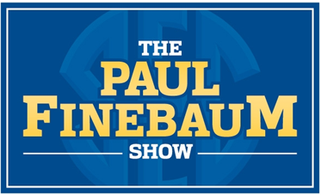

WWIC Radio presents “The Paul Finebaum Show” from ESPN Radio. Paul Finebaum is the most popular and most listened to sports radio show in the southeast. And now you have the opportunity to get your business message out to the thousands of Finebaum listeners at a very affordable rate.
WWIC Radio airs “The Paul Finebaum Show” every Monday-Friday from 1 – 5pm.
(Beginning Monday August 11th, the show moves to its new time of 2-6pm Central Time)
As a sponsor of “The Paul Finebaum Show” on 1050-AM WWIC, your business will get (80) 30-second ads per month in the show. That’s (4) ads per day in “The Paul Finebaum Show”. You also get your business name mentioned in on-air promotional announcements.
Your total net investment is $200.00 per month



