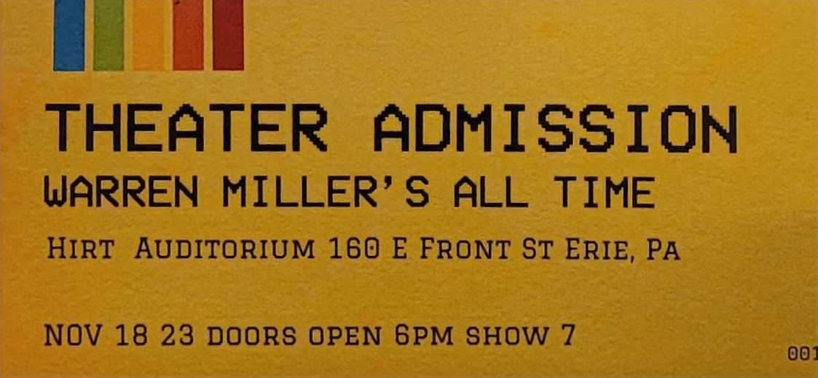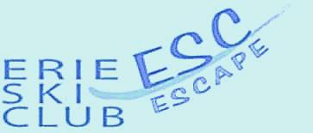

PRESENTED BY THE ERIE SKI CLUB September 24, 2023

The Erie Ski Club is presenting Warren Miller’s newest adventure ski film ALLTIME on Saturday, November 18, 2023 at 7PM at the Hirt Auditorium in the Erie County Blasco Library, 160 E. Front St. All profits from the event benefit the Lounsbury Adaptive Ski Program at Holiday Valley Ski Resort in Ellicottville, NY.

The film features amazing skiers and snowboarders on adventures throughout the United States and worldwide! It is a must-see film for anyone looking to get fired up for ski season!

With their paid admission, all movie goers receive discount coupons to Peek'n Peak, Mount Pleasant, and Holiday Valley Ski Resort as well as other ski related discount coupons. Attendees are entered to win door prizes, and also receive an entry for an international drawing for prizes including a ski vacation from Warren Miller. Noting, in 2017 a local person entered the contest at the Erie show, and won the top prize of a ski vacation to the famous resort Ski Portillo, in Chile’, South America, after their entry was drawn later from world-wide entries!

Doors open at 6:00PM with ski and snowboard related vendors, along with a snack bar.

The Lounsbury Adaptive Ski Program offers lessons to persons with virtually all disabilities, both physical and cognitive. Each student is instructed individually with full focus on his or her ability, rather than disability.

For more information or to pre-purchase tickets, contact Vince Ross vpross56@gmail.com or call 814-873-8287

Tickets can also be purchased at the door the night of the show

