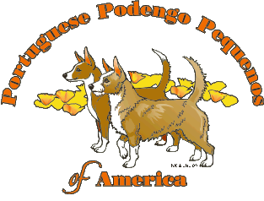

APPLICATION FOR JUDGES EDUCATION MENTORING OR PRESENTING

Please mark below all those that apply.

NAME:_________________________________ DATE:__________

1. Have at least 3 three years active PPP exhibiting experience with 3 three years’ experience in breeding PPP and have whelped at least 3 litters of PPP.
(Please specify years of exhibiting experience, years breeding and number of litters whelped.)

2. Attended 2 two PPPA Judges Education Seminars.
(Please indicate which JE Seminars you attended with dates)

3. Championed 5 five dogs or bred 3 three dogs you have championed.
(Please list dogs with titles or dogs bred with titles)

4. Passed an open book test on the breed standard.
(Please indicate date passed and who administrated test. Test must be administered by an approved JE Presenter.)

5. Hands on test of 4 four or more exhibits, rank ordering them, and justifying placements.
(Please indicate date passed and who administrated test. Test must be administered by an approved JE Presenter.)

6. Participated in 6 six PPPA educational events (brought dogs for Hands-on, participated in Meet the Breed, etc.)
(Please indicated which events you participated in with dates.)

Please returned completed application to any Board Member. This form may be mailed/emailed or faxed.

