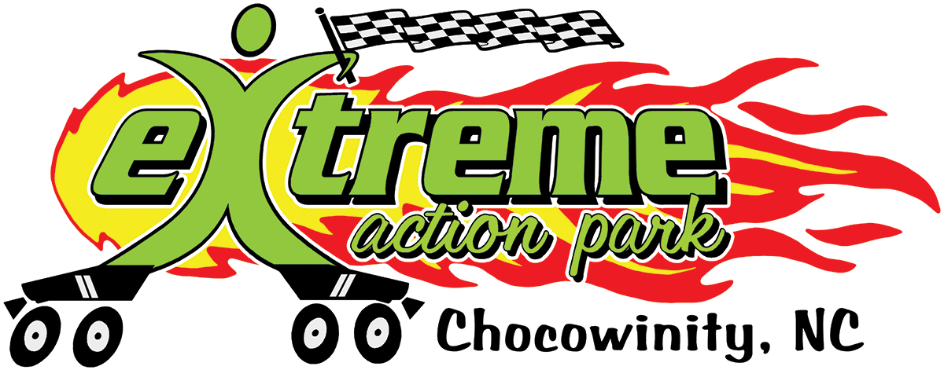
Extreme Action Park
Roller Skating Day
Camp Registration 2024
PO Box 746, Washington, NC 27889 252-946-6076
Please check all the apply: Registration and Payment due by date shown below.
___ June 10th -June13th Due: June 10, 2024
4 days $145.00
___August 19th-August 22nd Due: August 19, 2024
4 days $145.00
___Single Day Rate $40.00 Due: Day of Camp

Camp is from 9am-4pm with early drop off at 7:30am and late pickup until 5:30pm.

Last Name___________________________ First Name______________________

Birth date____________________ Age_________ Sex_______ Phone___________

Address_____________________________________________________________
Street City Zip
School____________________________________ Grade in 2024/25___________
Child’s skating level: Beginner Intermediate Advanced
Roller Skate Size(shoe size):___________________________________
Known medical conditions (allergies or other limitations) __________________________________________________________________

Parent #1 Name___________________________Relationship__________________

Phone(h)________________Phone(cell)_________________Phone(w)___________

Email address:______________________________________________________

Parent #2 Name___________________________Relationship__________________

Phone(h)________________Phone(cell)_________________Phone(w)___________
Emergency Contact (other than parent) Name_________________________________________Phone________________
Authorized persons to pick up your child:
Name Relation Phone
____________________________ _________________ ___________
___________________________ _________________ ___________
Parental Agreement
______I understand that refunds will be granted only if requested one week (7 days) prior to the start
(Initial ) of the weekly session.
I/We the parent(s) of the named minor, hereby give my/our approval for his/her participation in the Extreme Action Park Roller Skating Camp program. I/We assume all risks and hazards incidental to such participation. I/We do hereby waive, release, absolve, and agree to hold harmless and indemnify the organizers, sponsors, supervisors, participants, Extreme Action Park and/or its employees for any claim arising out of injury originating from participation in any activity associated directly or indirectly with the program and understand that any medical costs resulting from any such injury will be borne by the undersigned.
I also understand my child’s photo may appear in publicity items for Extreme Action Park.

_________________________________________________ ____________________________
Parent Signature Date

