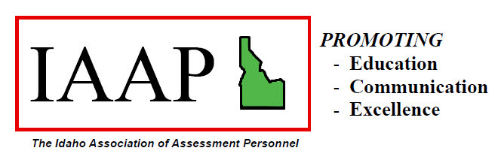

Membership Application

Name:

Address:

County / Agency:

Job Title:

E-Mail Address:

Areas of Specialization:

- Manufactured Homes
- Commercial
- Residential
- Other
- Personal Property
- CAMA
- Mapping

Dues are $15 per year and renewable January 1st of each year. Please send to:

International Association of Assessment Personnel
ICO: Connie Holmquist, Treasurer
700 Bank St #100
Wallace, ID 83873

Purpose of IAAP

The purpose of this organization is to benefit and enhance the evaluation and appraisal process of each assessing jurisdiction across the State of Idaho; to strive toward better communication between assessors, appraisers and the State Tax Commission; to support education and seek practical answers to common appraisal problems; to address existing and forthcoming legislation; to keep members aware of new laws and their impact; and to advance the concept of excellence and equity in the ad valorem appraisal process.

REFERRED BY:

