Linn-Mar Girls Basketball Shootout
Rules

Game Structure

ALL Games will consist of two 16-minute halves (3:00 halftime). We will use a continuous clock until the last 2:00 of the 2nd half provided that the score is within 10 points or less.

Each team should bring reversible jerseys or two different jersey colors (light and dark) that are numbered.

We will NOT provide basketballs for warm-ups, but will provide game balls.

Individual & team fouls will be kept. Teams in the bonus will shoot 1 free throw for 2 points until the last 2:00 of the second half (if the game is within 10 points). We will shoot "And 1" foul shots. A shooting foul will also be 1 FT for 2 points (or 3 points if fouled on a 3-pt attempt). Players will be disqualified after receiving a 5th personal foul.

During the last two minutes of a game that is within 10 points, we will shoot all free throw situations under normal game rules.

3-point goals will count in all age divisions.

Each team will receive 2 timeouts for each game (45 seconds in duration).

Teams will only be allowed to substitute during a dead ball. Please encourage your players to hustle in and out during substitutions as the clock will continue to run.

We will do our best to stay on schedule, but will not start games early. Please have your team prepared to play at their assigned time.

Zone defenses will NOT be allowed in 4th or 5th grade divisions. Teams may play any type of half court defense in the 6th – 8th grade divisions.

Full court pressure defenses will be allowed until a team is ahead by 15 points. If ahead by 15 or more points, teams may not defend in the backcourt (on makes or misses). Presses may be man or zone in all divisions.

All grade-levels and divisions will use a 28.5 oz basketball.

OVERTIME - We will play NFL rules for sudden death overtime. The ball will be tipped at center court and each team will be entitled to ONE possession. After the second possession of the overtime, if the score is still tied a sudden death winner will be determined. FT's and the bonus will continue as they did for the last 2:00 of regulation. No additional timeouts will be given during overtime.

EXAMPLE: Team A wins the tip and scores a 2-point FG. Team B will get one offensive possession (play continues with a normal throw-in). If Team B does not score on that possession, Team A wins. If Team B scores a 2-point FG to tie the game, the next team to score wins. If Team B scores a 3-point FG on their first possession, they win.

EXAMPLE 2: Team A wins the tip and does not score. The game will then be decided by sudden death (the next team to score wins).

Note: To allow for a more efficient, flexible, and predictable schedule, we will not declare grade-level champions. Consequently, we will not distribute awards or medals at the conclusion of the Shootout.

Admission will be $5 for all adults and $3 for school age children. Kids 5 & under will be admitted for free.
Scorekeepers will be provided. We will have adult and high school volunteers operating the clock and tracking fouls. Score sheets will be available at the scorer's table.

Questions? Please contact Nate Sanderson at SpringvilleGirlsBasketball@gmail.com

Sportsmanship is imperative! Players, coaches, parents, and fans will be expected to exhibit the highest levels of sportsmanship on the court and in the stands. Any unsportsmanlike behavior WILL NOT BE TOLERATED. This applies to players, coaches, and fans alike.

Concessions will be available. Please NO OUTSIDE COOLERS.

Please DO NOT dribble basketballs in the hallways or commons area.

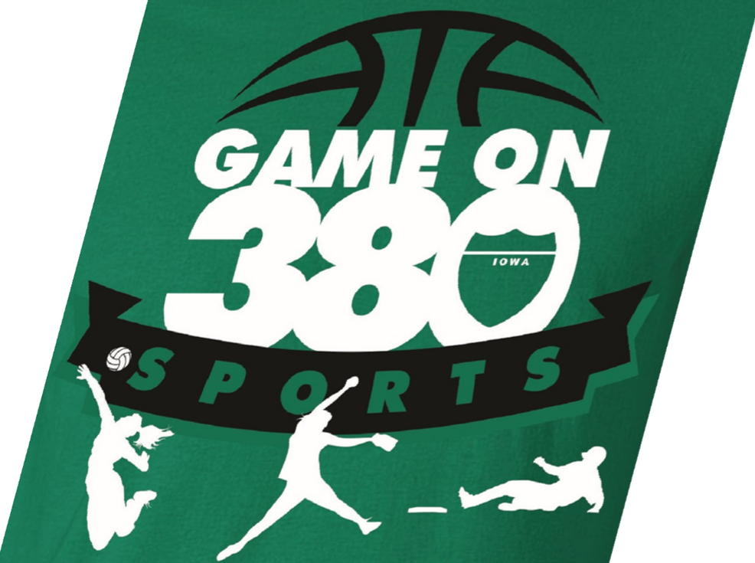
Linn-Mar Girls Basketball Shootout
Registration

Team Name: ________________________________________________________

Coach Name: _______________________________________________________

Coach Email: ___________________________________ Cell: ______________

Grade Level: __________ Ability Level: Beginner Experienced Advanced

Schedule Requests:

We will do our best to accommodate scheduling requests when possible.

Mail Registration To: Checks Payable To: GameOn 380 Sports

GameOn 380 Sports
7425 Prairie Hawk Drive SW
Cedar Rapids, IA 52404

For More Information Contact:

Doug Yanecek 319-533-1438 GameOn380Sports@gmail.com

Todd Ambrosy 319-213-0405

Nate Sanderson Nate.Sanderson@LinnMar.k12.ia.us

Disclaimer: Linn-Mar Community Schools and its employees assume no responsibility for injuries to participants and/or lost or stolen personal possessions throughout the Shootout.

