SIXTEENTH SUNDAY
IN ORDINARY TIME
JULY 20 & 21, 2019
A MINDSET OF SERVICE

There’s a lot of traveling, delivering, and visiting going on in our readings today. In Genesis, Abraham cares for the needs of three mysterious travelers. The Psalm responds, celebrating the kind of righteousness that Abraham practices. Then, in his letter to the Colossians, Saint Paul describes his own ministry as almost like a delivery service: he, God’s steward, brings the Word of God to their community. Finally, Luke’s Gospel shares the well-known story of Mary and Martha, and the different ways they welcome Jesus into their home. Amid all this coming and going, we are invited to pay attention to the ways we tend to the needs of others. Each of us can ask, How am I present to God and others in my life?

SPIRITUAL PROOF
By Dennis Tavares

Scientists studying the brain believe that memory images are stored as electrical states in the brain cells; our intellect is rooted in our material brain. What about imagination? In which our mind can form a scene, which we have never experienced in real life. Where does the scene originate since no electric states were ever created for that scene we never experienced? This proves to me that the mind is a separate entity from the material brain; it must be connected to the spiritual world. The mind, which is not material, uses the brain to connect to the body. So, we have here proof of the spiritual realm in our own bodily processes. It makes sense that God would not have hidden from us the source of our intellect and will. We need to think about such things like Socrates, Aquinas, and Jesus did.

MAGNIFICAT DAYS: SUMMER CAMP 2019
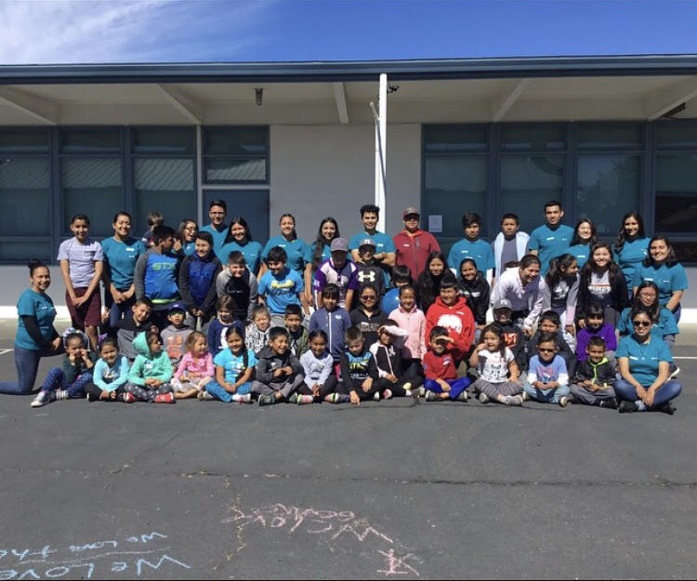
The Don Bosco Youth Group had just conducted a 3-day Summer Camp for 42 children of our parish (ages ranging from 7–14 years old.)
Led by Yesenia and Griselda Huerta including Sofía Durán, they single-handedly provided inputs that focused on the enhancement of their young participants’ Christian faith based on Scriptures and Catholic Church teachings.
Our Youth facilitators’ holistic teaching engaged the MIND, BODY AND SPIRIT of their participants; hence, ensuring that they had lively and action-packed activities like basic faith catechism, arts-and-crafts, music (learning hymns and songs) and sports.
Special thanks to all the parents who brought their kids to spend the “Magnificat Days” closer to God even during their summer vacation. This annual program would not have been possible without the committed service of the young people of OLGC Parish: Griselda Huerta, Naiyleah Arellano, Alexa Hernández, Kiara Hernández,
Sofía Durán, Analyah Cruz, Noemí Hernández, Alan Morán, Erik Huerta, Anahía Huerta, Humberto Arellano, Tony Rivas, Daisy Maravilla and Yesenia Huerta.
May God reward our parishioners who donated food and time to make our Parish Summer Camp for children a huge success.

-OLGC “Don Bosco” Youth Group

PLEASE PRAY FOR OUR SICK PARISHIONERS
Teresa Serpa, Ana María López, María Cristina Reyes, Karma Mendez, Juan Hernández, Frank Richards, Lisa Wright, Ricardo Contreras, Florencia Chávez, Refugio Yáñez, Tarcicio García, Sofía García, María de Jesús Mendoza, Antonio Cazares, Ana García, Ryan Moore, Jane Vartanian, Marianne Brannan, Lilia Parrish, Nancy Smith, Julián Palomar, Luisa Martínez, Jennifer Vera, John Braet, Kim Koskinen, Margaret Valencia, Matthew Marcoulier, Dennis Tavares, Jose Freitas, Alfredo Sousa, Juana Arreguín, Aron Yasskin, Victoria Walzer, Fidela Yáñez Jara, Erika Ramos, Bill Gibson, Carla Tomas, Erasmo Yáñez, Memo Soria, Patricia Vargas, Fidela Yáñez, Elvia Flores, Yonel Ruíz, Angie Freitas, Russel Bryant, Derrick Heater, Luis Angel, Juan Barrera-Terán, Gabriel Hurtado, Gerald Butler, Helen Reynolds, Toni Clark, Ann Gallagher, Brianna Lopez, Margaret Milliken, Gina Pivirotto, Nick Quin, Mary Servis, Denis Sousa, Victor Venegas, Matty Walker, Charles Lorenz, Rebecca Lorenz, Ofelia Ibarra, Leonardo Naal, Gina Leal.

PRAY FOR OUR FAMILY AND FRIENDS THAT ARE
IN THE MILITARY SERVICE
Rebecca Sánchez, José Araiza Jr., Edgar Toscano, Marina González, Alondra Jara, Sonia Jara, Jason Lorenz,
Matt Mill & Jared Schroeder.

Our Lady of Good Counsel’s 65th Annual Church BBQ and Parish Carnival is Sunday, August 4th.
By OLGC BBQ Fundraiser Team

Please join us for a great day of community and family fun.
Dinner is served from 11am until 5pm or until chicken is sold out.
Unable to join us that day? You may still support the Parish by purchasing dinner tickets, or kids bracelets for unlimited rides. Father Andre will see to it that deserving families in our Parish receive a free meal and/or all-day ride bracelets on August 4th.
All proceeds from this event will be used to finance our Parish year long up keep and various ministries.
Your generous donations are much appreciated!
Likewise the helping hands of volunteers create the miracle of fun, camaraderie and community.
No one has to do a lot, if everyone does a little.
Thank you. God bless you and your family.

We need to provide 4 generators to power the rides for our Chicken BBQ. If you can loan your generator for the day on August 4th, please contact Frank Richards at 964-4446 or the Parish Office at 964-0229.
This will save a $300 rental charge.

A CALL TO ACTION
WE ARE UPDATING OUR PARISH REGISTRATION LIST.
PLEASE TAKE A FORM AND GIVE US YOUR CURRENT INFORMATION.
YOU CAN PUT IT IN THE COLLECTION BASKET, RETURN IT TO THE OFFICE, CALL US AT 707-964-0229 OR E-MAIL US AT olgcinfb@gmail.com.

OUR SILENT & DUTCH AUCTIONS
NEED HELP
WE ARE ASKING EACH FAMILY TO CONSIDER MAKING A BASKET OR DONATING AN ITEM FOR THE AUCTION.
SOME SUGGESTIONS ARE: A SPA BASKET, MOVIE NIGHT BASKET, TOURIST BASKET, OR; ARTWORK, JEWELRY, AND VARIOUS TYPES OF WOODWORK, ETC.

MASS INTENTIONS
JULY 24 - 28, 2019
Wednesday (24)  Thursday (25)  Friday (26)  Saturday (27)  Sunday (28) | 12:05pm  12:05pm  12:05pm  5:00pm  6:30pm  8:00am  10:00am | Pacita Tan †  Santiago Tan, Jr. †  Joseph Semborski †  Roberto Velazquez †  Fred & Clara White †  All deceased members of the Wooden Family  Joseph Rozyla †  Luisa Martínez †  Brianda Venegas †  Yolanda Cazares †  Margarito Martín †  Esperanza Barba (health)  James Braga Melo †  Maria Alda Melo †

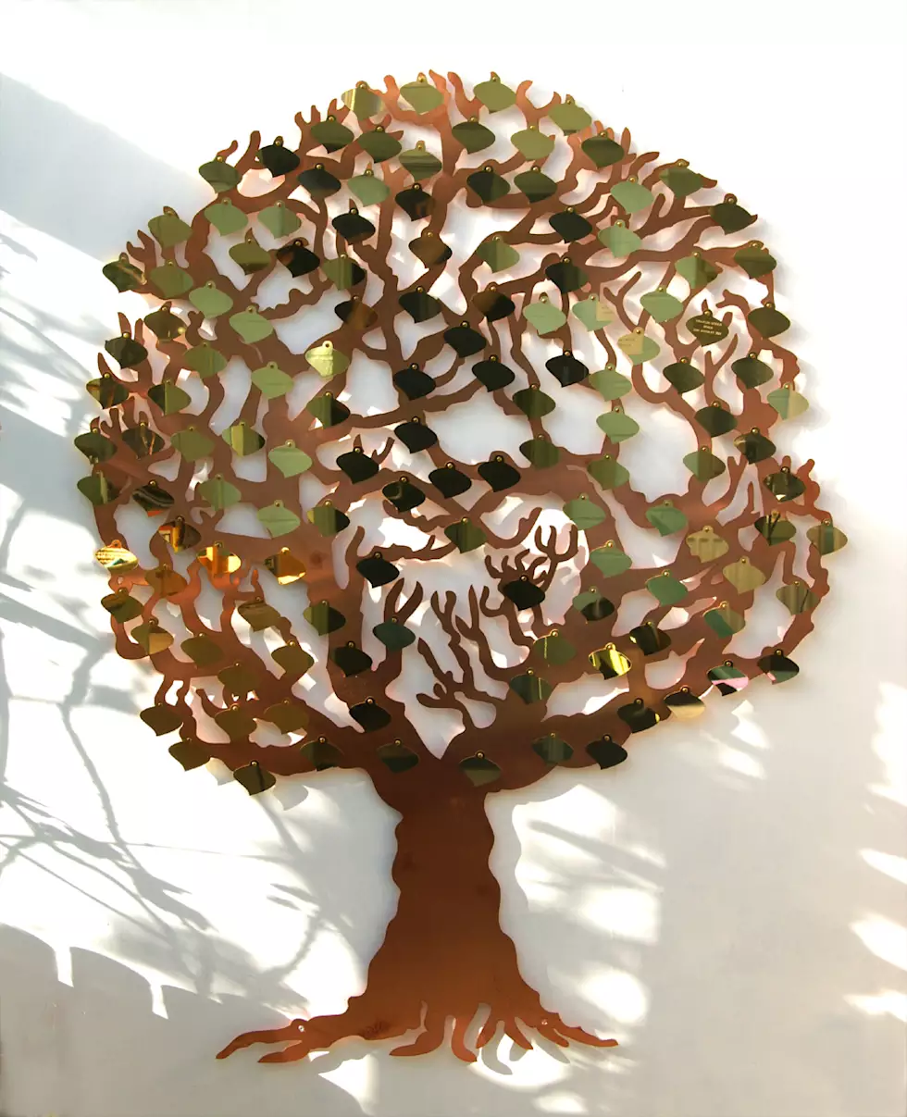
OLGC’S MEMORIAL TREE

In the vestibule of the Church, on the southern wall, is a beautiful Memorial Tree.
Its bright leaves represent permanent memorials to the departed of our Parish.
For the sum of $200.00, you can give to the Parish Secretary, the correct spelling and dates of the departed and in due time the leaf is printed and attached to the tree: a permanent reminder of a loved one who is gone.
For more information, call the Parish Office at 964-0229.

WEEKLY COLLECTION

JULY 13 & 14, 2019…..$ 1,882.00
MAINTENANCE FUND…..$779.22

THIS WEEKEND’S SECOND COLLECTION:
BLACK AND INDIAN MISSIONS
NEXT WEEKEND’S SECOND COLLECTION:
YOUTH MINISTRY & RETREATS
THANK YOU
FOR YOUR SUPPORT & CHRISTIAN GENEROSITY

ATTENTION PARENTS:

Catechism Registration will be held on
Wed., July 31st, 5:30-7:00pm,
Sunday, August 11th, 11:00am-12:30pm, &
Monday, August 26th, 5:30-7:00pm.

If you are enrolling your child in First Year 1st Communion, you will need to bring copies of the Baptism Certificate. If you are enrolling your child in First Year Confirmation you need copies of both the Baptism and the Holy Communion Certificates.

For any concerns, please contact Fr. Andre and/or our catechists.

UNITED CHRISTIAN WOMEN’S
POTLUCK SALAD LUNCHEON

DATE: SATURDAY, JULY 27, 2019
TIME: 12:00 NOON
WHERE:
CHAPEL OF THE REDWOODS
31201 COMPTCHE UKIAH RD.
COMPTCHE, CA

PLEASE BRING A SALAD AND FRIENDS TO SHARE IN THIS DAY OF CHRISTIAN FELLOWSHIP.
THE COMPTCHE WOMEN WILL PROVIDE DRINKS AND DESSERTS.
PLEASE CALL THE CHURCH AT 937-0850 WITH YOUR RESERVATION COUNT.

