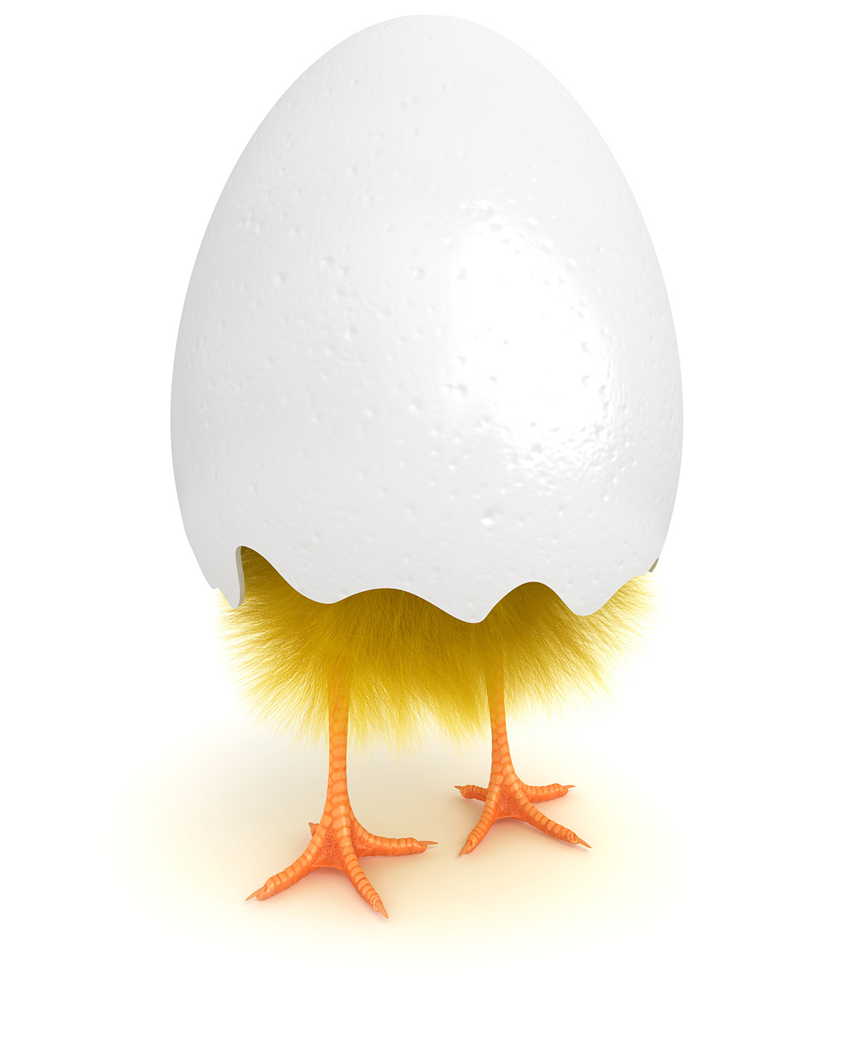

Just part of your comprehensive wellness program. Find out more at www.empowerlinc.com or call a health coach today at 888.882.LINC (5462).



Fun and effective programs to help u live healthy

UFit • UMove • UBreathe • U&Yours • Ubalance   
UPlusOne • URest • UBEAT • UBody • Ufuel • Ucents

WILL U

MAKE A

CHANGE?