REGULAR MEETING
OCTOBER 19, 2023

Four (4) Public Hearings and the Regular Meeting of the Town Board of the Town of Hampton, County of Washington and the State of New York was held at the Town Hall, 2629 State Route 22A, Hampton, New York, on the 19th day of October, 2023.

PRESENT: David K. O’Brien------------Supervisor
Donald Sady----------------- Councilman
Tamme Taran----------------Councilwoman
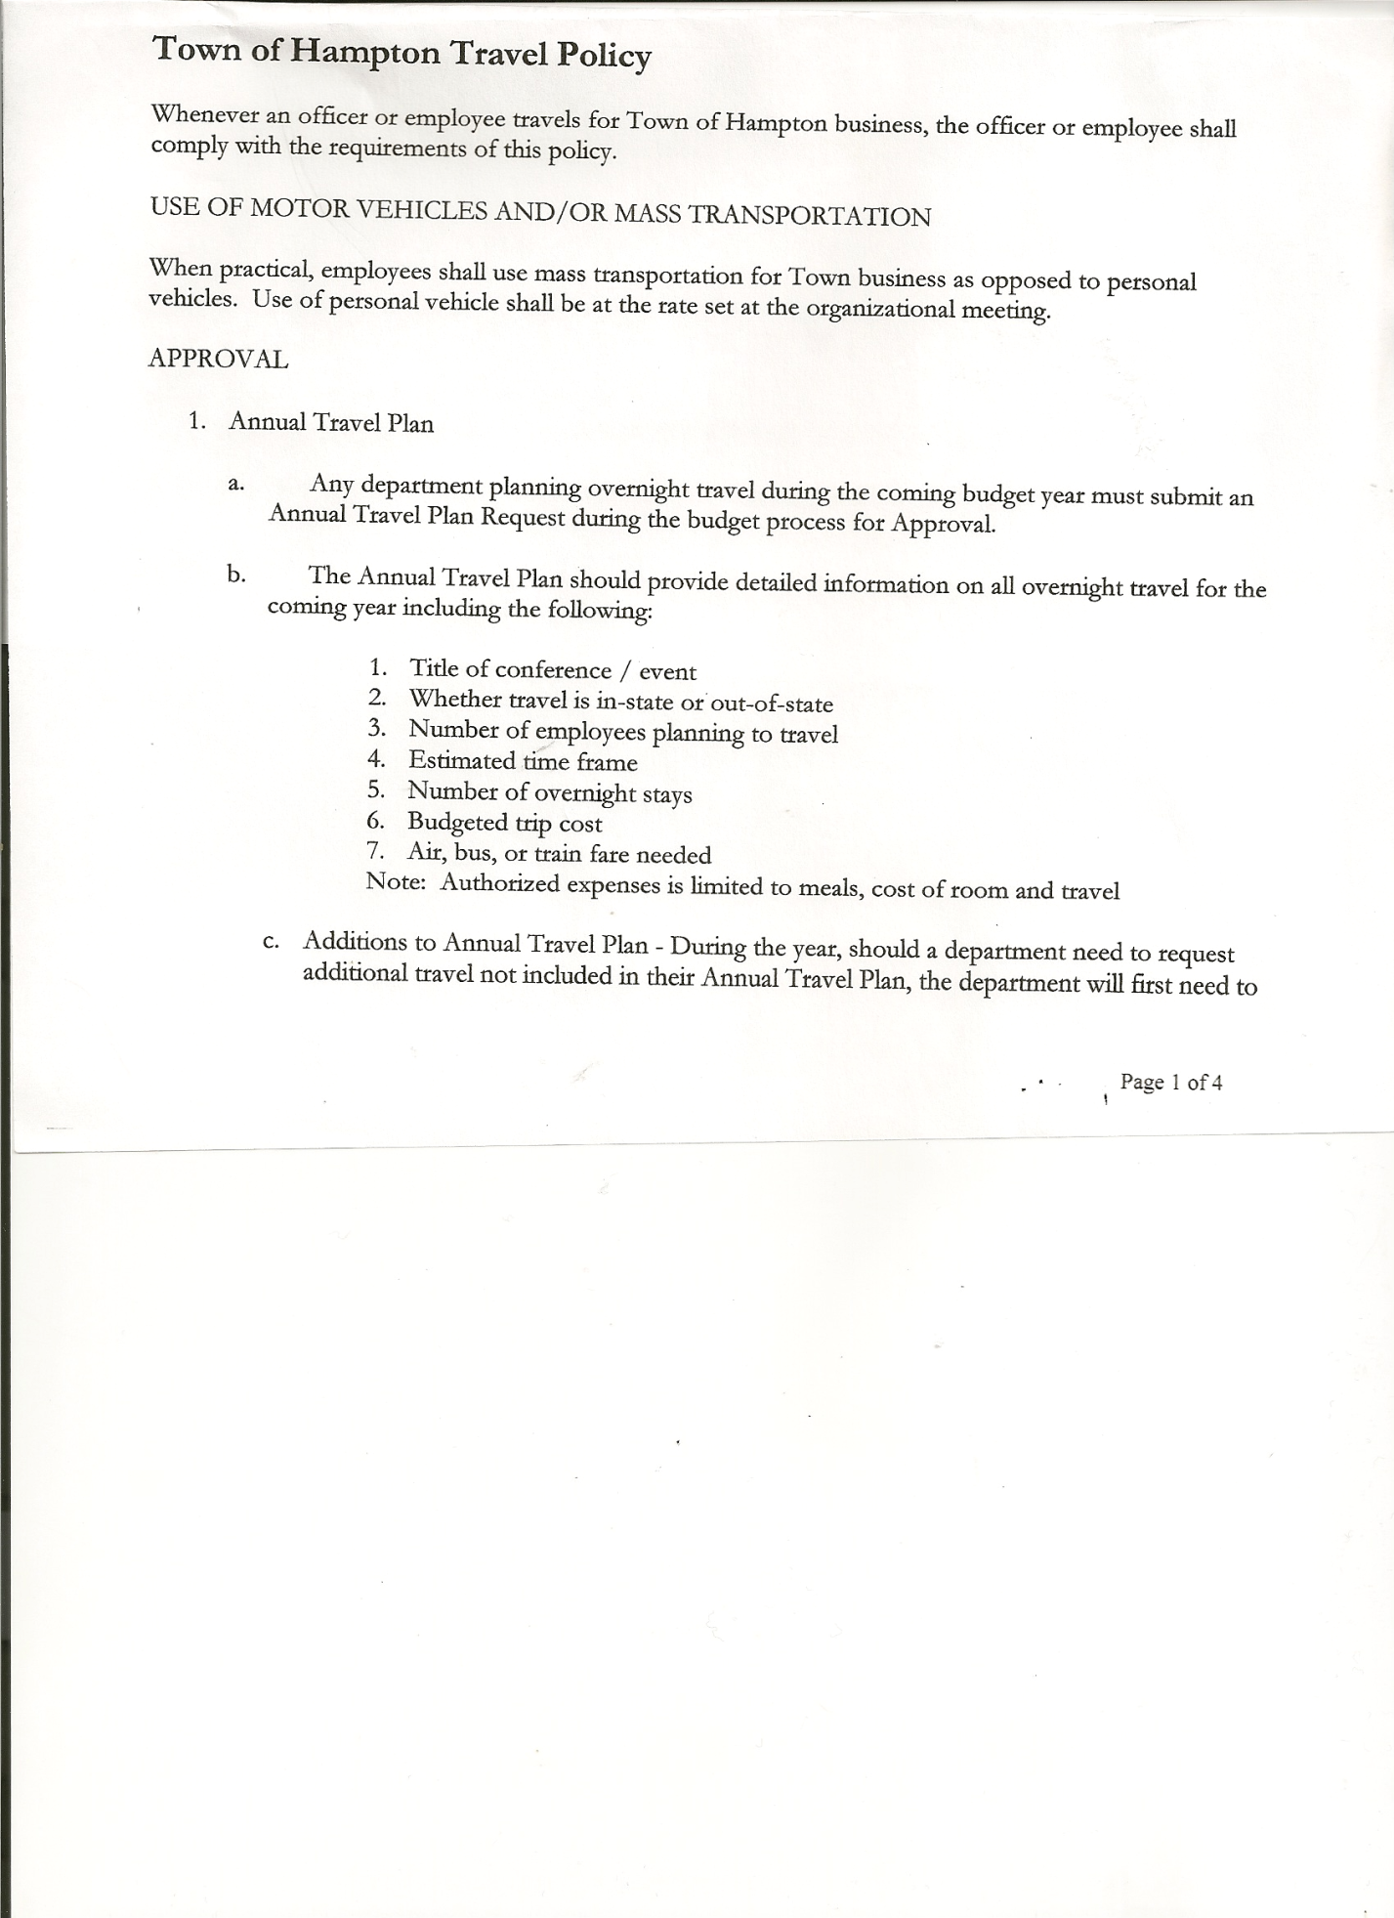
Michael Pietryka------------Councilman
Andrea Kugler---------------Councilwoman - absent
Rebecca Jones---------------Town Clerk
Camilla Shaw----------------Deputy Town Clerk
Tyler McClure---------------Highway Superintendent

Planning Board Member (s):… Bonnie Hawley, Chair; Richard Cole and Matthew Pratt
Others present at the Town Hall: see attached sheet

The FIRST Public Hearing was called to order by Supervisor O’Brien at 7:00pm.

Town Clerk Rebecca Jones read the Legal Notice of Public Hearing (copy attached), which was published in the Manchester Newspapers on 10/12/23 to discuss the proposed contract with Hampton Fire Protection District 1.

All persons desiring to be heard, having been heard, the Public Hearing was closed at 7:03pm.

The SECOND Public Hearing was called to order by Supervisor O’Brien at 7:05pm

Town Clerk Rebecca Jones read the Legal Notice of Public Hearing (copy attached), which was published in the Manchester Newspapers on 10/12/23 to discuss the proposed contract with Hampton Fire Protection District 2. Supervisor O’Brien commented on merging the two Fire Districts, the Town Attorney will work on paperwork.

All persons desiring to be heard, having been heard, the Public Hearing was closed at 7:07pm.

The THIRD Public Hearing was called to order by Supervisor O’Brien at 7:10pm

Town Clerk Rebecca Jones read the Legal Notice of Public Hearing (copy attached), which was published in the Manchester Newspapers on 10/12/23 for the Preliminary Budget for 2024.

All persons desiring to be heard, having been heard, the Public Hearing was closed at 7:17pm.

The FOURTH Public Hearing was called to order by Supervisor O’Brien at 7:25pm

Town Clerk Rebecca Jones read the Legal Notice of Public Hearing (copy attached), which was published in the Manchester Newspapers on 10/12/23 to discuss the proposed local law to override the tax levy limit.

All persons desiring to be heard, having been heard, the Public Hearing was closed at 7:29pm.

TOWN BOARD MEETING
OCTOBER 19, 2023 PAGE 2

REGULAR MEETING
The Regular Meeting was called to order by Supervisor O’Brien at 7:30pm, followed by the Pledge of Allegiance. Location of Fire Exits were given. Quorum of board members present.

RESOLUTION NO. 89-2023
APPROVAL OF THE MINUTES
On a motion of Councilman Sady, seconded by Councilman Pietryka, the following resolution was ADOPTED: AYES 4 O’Brien, Sady, Taran, Pietryka
NAYS 0
ABSENT 1 Kugler
RESOLVED, that the Regular Town Board Meeting Minutes for September 21st, 2023, and the Special Town Board Minutes for September 26th, 2023 are approved.

Assessor Interviews……
- Arek Gordon, current Assessor for the Town of Hampton for the past 10 months. Leaving the County to go out on his own as an Assessor. Is currently and will be continuing as an Assessor for Cambridge, Hebron and Fort Ann. Attached is a copy of the information provided, per Supervisor O’Brien’s request. Arek also provided the Board with his resume and Continuing Education Report.
- Bobbi Stone, current Assessor in Whitehall and Sand Lake. Attached is a copy of the information provided, per Supervisor O’Brien’s request.

Dog Control Report….no report

Tax Collector Report…..no activity. The Town Clerk/Collector had Board Members review and sign bank reconciliation statements for the Tax Collector Account September 30th, 2023.

Bonnie Hawley, Chair Planning Board…the Public Hearing held on October 11th regarding the Ag Plan was well attended. There will be another Public Meeting on November 8th at 7:00pm at the Town Hall for any further questions regarding the Ag Plan.

Tyler McClure, Highway Superintendent submitted his report, copy of which, is attached.

SUPERVISOR’S REPORT/COUNTY UPDATES/COMMUNICATIONS
RESOLUTION NO. 90-2023
APPROVAL OF SUPERVISOR’S MONTHLY REPORT
On a motion of Councilman Sady, seconded by Councilman Pietryka, the following resolution was ADOPTED: AYES 4 O’Brien, Sady, Taran, Pietryka
NAYS 0
ABSENT 1 Kugler
RESOLVED that, the Supervisor’s Monthly report be accepted as submitted for SEPTEMBER
08/31/23 09/30/23
ACCOUNT BALANCE RECEIPTS DISBURSEMENTS BALANCE
General Fund $ 71,455.09 $ 3,843.40 $ 8,037.56 $ 67,260.93
Highway Fund $179,803.66 $ 4.38 $ 21,405.76 $ 158,402.28
Equipment Reserve$149,984.16 $ 3.70 $ 0.00 $ 149,987.86
Fire #1 $ 23,185.50 $ 0.00 $ 0.00 $ 23,185.50
Fire #2 $ 7,680.50 $ 0.00 $ 0.00 $ 7,680.50
Cemetery $ 2,024.11 $ .81 $ 0.00 $ 2,024.92
Totals $434,133.02 $ 3,852.29 $ 29,443.32 $ 408,541.99
All Board Members present signed Supervisor’s Report.

TOWN BOARD MEETING
OCTOBER 19, 2023 PAGE 3

County Budget…..continuing to work on
Laura Chadwick, Director of Real Property Tax Services at the County will be retiring at the end of 2023.

RESOLUTION 91-2023

MOTION BY: Councilman Michael Pietryka
SECONDED BY: Councilwoman Tamme Taran

RESOLUTION ADOPTING A LOCAL LAW TO OVERRIDE THE TAX LEVY LIMIT ESTABLISHED IN GENERAL MUNICIPAL LAW SECTION 3-C

WHEREAS, pursuant to Section 3-c(5) of the New York State General Municipal Law, the Town Board (the “Board”) of the Town of Hampton (the “Town”) has the authority to adopt a local law to override the real property tax levy limit as defined in General Municipal Law §3-c; and

WHEREAS, a budget has been prepared for the Town of Hampton for fiscal year beginning January 1, 2024 and ending December 31, 2024 that exceeds the tax levy limit as defined in General Municipal Law §3-c; and

WHEREAS, a local law to override the tax levy limit in accordance with the provisions of General Municipal Law §3-c has been prepared; and

WHEREAS, the Board scheduled a public hearing to be held before the Town Board on October 19th, 2023 at the Offices of the Town of Hampton, 2629 State Route 22A, Hampton, New York 12837, to hear all interested parties regarding the adoption of the proposed Local Law; and

WHEREAS, notice of said public hearing was duly posted and then published in the Manchester Newspapers, the official newspaper of the Town of Hampton pursuant to and in conformance with Section 20 of the Municipal Home Rule Law; and

WHEREAS, said public hearing was duly held and all parties in attendance were permitted an opportunity to speak on behalf of or in opposition to the proposed Local Law.

NOW, THEREFORE BE IT RESOLVED by the Town Board of the Town of Hampton as follows:

Section 1. The Town Board finds that the proposed Local Law is required pursuant to General Municipal Law section 3-c and is in the best interests of the residents, inhabitants and guests of the people of the Town of Hampton.

Section 2. The proposed Local Law, copies of which are attached hereto and made a part hereof, is hereby adopted.

TOWN BOARD MEETING
OCTOBER 19, 2023 PAGE 4

Section 3. The Law shall take effect immediately upon its filing in the Office of the Secretary of State.

Section 4. This resolution shall take effect immediately.

Roll Call Vote:
DATED: October 19, 2023 Supervisor O’Brien AYE
Councilman Sady AYE
Councilwoman Taran AYE
Councilman Pietryka AYE
Councilwoman Kugler ABSENT

RESOLUTION NO. 92-2023
AUDIT OF CLAIMS
On a motion of Councilman Sady, seconded by Councilwoman Taran, the following resolution was ADOPTED: AYES 4 O’Brien, Sady, Taran, Pietryka
NAYS 0
ABSENT 1 Kugler
RESOLVED that the bills have been reviewed by the Town Board and are authorized for payment in the following amounts.
General Fund No.111 through No. 122 $ 3,328.85
Highway Fund No.107 through No. 119 $ 21,602.15
Total both funds $ 24,931.00

The Town Clerk’s report for September 2023 was submitted to the Board. The Town Clerk had Board Members review and sign bank reconciliation statements for the Town Clerk Account and Special Clerk Account dated September 30th, 2023.

RESOLUTION NO. 93-2023
EXECUTIVE SESSION
On a motion of Councilwoman Taran, seconded by Councilman Pietryka, the following resolution was ADOPTED: AYES 4 O’Brien, Sady, Taran, Pietryka
NAYS 0
ABSENT 1 Kugler
RESOLVED, the Town Board enter into an Executive Session at 8:22pm to discuss the appointment of the Assessor.

RESOLUTION NO. 94-2023
RETURN TO REGULAR SESSION
On a motion of Councilman Pietryka, seconded by Councilwoman Taran, the following resolution was ADOPTED: AYES 4 O’Brien, Sady, Taran, Pietryka
NAYS 0
ABSENT 1 Kugler
RESOLVED, that the Town Board return to regular session at 8:40pm.

TOWN BOARD MEETING
OCTOBER 19, 2023 PAGE 5

RESOLUTION NO. 95-2023
MEETING ADJOURNED
On a motion of Councilman Sady, seconded by Councilwoman Taran, the following resolution was ADOPTED: AYES 4 O’Brien, Sady, Taran, Pietryka
NAYS 0
ABSENT 1 Kugler
RESOLVED that the meeting adjourned at 8:40pm.

Respectfully submitted,

Rebecca S. Jones, RMC
Town Clerk

