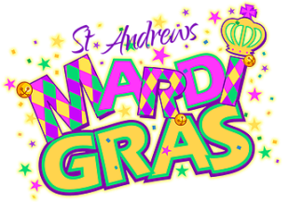
Our Weekly Activities These are the days/hours for the – . Week of February 12, 2017
Sunday, February 12, 9:30am, Sunday school, Fellowship Hall; 11am, Morning Worship, preaching, Scott Perry. Monday, February 13, 9am, TOPS #217, Fellowship Hall. Tuesday, February 14, 9:30am, Fitness – posponed – Using Fellowship Hall for Valentine Dinner – this evening at 6pm. Also, there is no program for Friday, February 17- Mardi Gras weekend. Wednesday, February 15, 8:30am, Walk about neighborhood begins at Fellowship Hall; 9:30am, Fitness, Strength, Fellowship Hall; 3pm, Choir Practice, Choir room. Thursday, February 16, Stramp Club, Fellowship Hall. Weekend Mardi Gras parades – Friday & Saturday.
Week of February 19,2017
Sunday, February 19, 9:30am, Sunday school, Fellowship Hall; 11am,

Announcements & Items of Interest . . . Welcome to St. Andrews’ Valentine Dinner with a Mardi Gras party theme.
When: Tuesday, February 14 @ 6pm.
Wear your beads, mask, or anything Mardi Gras and join the parade to Fellowship Hall.
A menu of New Orleans cuisine that is sure to delight. The finest service and music a person could wish for to celebrate Valentine day.
Bring friends and neighbors – a good time will be had by all.
Come see Fellowship Hall transformed into a festive and fun place to get into the Mardi Gras spirit. Who will be the King and Queen? Could it be you?

Parades: Kids & Pets, Friday, February 17 – afternoon. Jimmy needs help and items for the refreshment tables. Regular Parade Our work begins early Saturday morning and we’ll be busy most of the day.

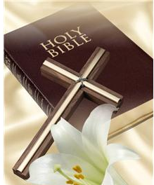
Announcements Continued. . .
February 5, 2021
Rev. Chris Nelson, Supply Pastor Thank you Chris, we need your message & prayers to get us through the next two weeks. February 14 – Valentine’s Day and the time for our Dinner for the Ladies. Please make plans to attend – theme is “Mardi Gras” . . . then it Mardi Gras parade weekend. For our Visitors! There are tan cards in pockets in the back of the pews. Please provide us the requested information & place the card in offering plate. Blue cards are for those wishing to pass on general information to the church. Thank you! CHURCH OFFICERS & SESSION CHAIRSPERSONS Treasurer: Patricia Fuller Clerk of Session: Jennifer Whisenant Chair of Budget, Finance & Personnel: George Carothers Co-Chairs of Christian Education: Rose Stallins & Jennifer Whisenant Chair of Property: Jimmy Whisenant Co-Chairs of Witness & Service: Sally Teer, Vern Ballard Chair of Worship: Dixie Retherford St. Andrews Presbyterian Church ‘serving the Christian community of St. Andrews, since 1886’ 3007 West 14th St. @ Beck Av, Panama City, FL 32401, 850/785-8358 standrewspresch@Knology.net www.saintandrewspc.com

