Classroom Letterhead, The Artful Classroom

You can use this letterhead to communicate with your parents. There are two different versions. Choose the one you prefer.

1. Type in your school’s name.
2. Replace (Room #) with your own room number.
3. Type in your name, in “writing” and in type.
4. Save As, Letterhead Template, Artful Classroom, or a name of your choice.

The date will automatically update each time you open the template. Just type in your text, print, and you’re ready to go!
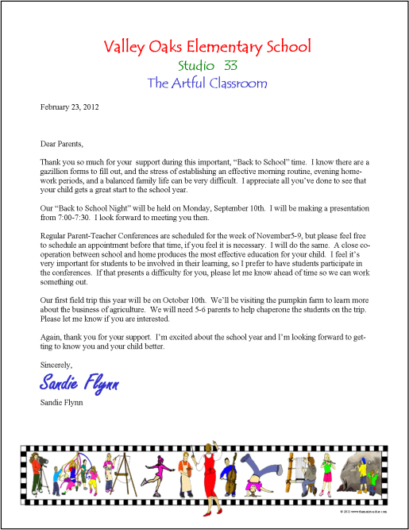

Type Your School’s Name
Studio (Room #)
The Artful Classroom
February 23, 2012

Dear Parents,

Type the body of your text here.

Sincerely,
Type your name here.
Type your name here.
© 2011 www.thematicteacher.com


Type Your School’s Name
Studio (Room #)
The Artful Classroom
February 23, 2012

Dear Parents,

Type the body of your text here.

Sincerely,
Type your name here.
Type your name here.
© 2011 www.thematicteacher.com

