9/22/2017 The Day of Trumpets 2017 Report

The Day of Trumpets 2017 and 666

The Hebrew Day of Trumpets is a day of shouting and blowing of trumpets, a day for calling men to assemble for war.

We know from previous research that 9/8/1945, the Day of Trumpets 1945, was the date calculated to be the conception date for President Donald Trump. The date was arrived at by subtracting 280 inclusive days from his birth date, 6/14/1946. The normal mean (average) human gestation period is 40 weeks, or 280 days.

Here's a chart showing the birth and calculated conception dates for recent Presidents of the United States:
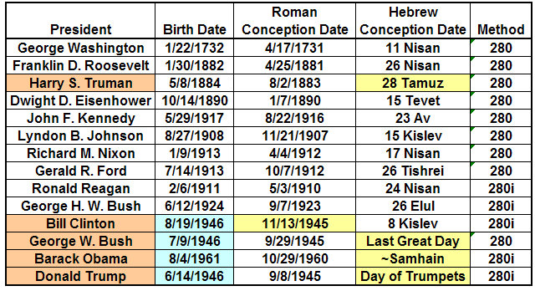

September 21, 2017, was the Day of Trumpets according to the Jewish Hillel Calendar. That day was the 72nd Hebrew Hillel calendar anniversary date from the calculated date of conception of President Donald Trump.

The completion of 72 years of Donald Trump's life from conception is a doubling of the number 36. It was noted previously that there were 36 gods worshipped in ancient Babylon. Those gods were each given a number from 1 to 36.

Amulets were produced containing the numbers 1 through 36 that were worn for protection by the gods, like the St. Christopher's medal worn by some people today. The arrangement of the numbers on the amulet, called a Babylonian magic square, were arranged ao that each column and each row added up to
111. All 36 gods, 1 to 36, added up to 666.

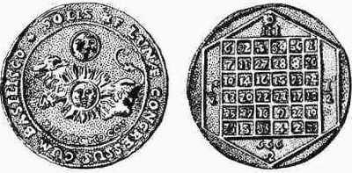

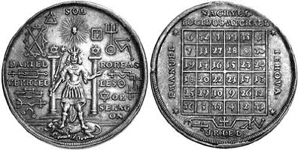

Above: Two versions of the ancient Babylonian Magic Square 666 amulet.
Both upper and lower amulets show the sun in the constellation Leo, which is where the sun was located during the recent solar eclipse of 8/21/2017 that crossed the United States. The number 666 is visible at the bottom of the magic square on the upper amulet.

The Latin Inscription on the Babylonian Magic Square Amulets Above

We also know that the term "Pontifex Maximus" was originally attributed to the ancient Babylonian Priesthood. The term was eventually bestowed upon the Roman Caesars after the Roman Empire conquered ancient Babylon. The ancient Babylonian term "Pontifex Maximus" was transferred from the line of the Caesar's to the Bishop of Rome and rests upon the Roman Catholic Pope today, linking today's militant Jesuit Pope and the Vatican city-state with ancient Babylon.
First Light and 666

The lower amulet contains the name Uriel at the bottom of the magic square. Uriel is a Latin translation of the Greek "Urias" and the Hebrew name Uriah. Uriah means "light of Yah", and references the messenger (angel) of light that first emanated from the tower used for the Trinity atomic test in New Mexico on 7/16/1945.

From the Septuagint:

Isaiah 21:8 Hearken with great attention, and call thou Urias to the watch-tower: the Lord has spoken.

The reference to Uriah (Greek - Urias, Latin - Uriel), meaning "the light of Yah", is veiled in the Masoretic text (and as a result most modern bibles) of Isaiah 21:8.

From the Masoretic text used for most modern bible translation:

Isaiah 21:8 And he cried, A lion: My lord,...

The difference between the Hebrew word for Uriah and the Hebrew word for lion is one Hebrew letter.

Note the command in the Septuagint version of Isaiah 21:8 to "Hearken with great attention". Although the Septuagint is a Greek version of the original Hebrew (a negative attribute), it is also about 1,000 years older than the Masoretic text (a positive attribute).

Global News on the Day of Trumpets 2017

We're to be especially watchful on the appointed days of YaHuWaH Elohim.

Note that on the Hebrew Hillel calendar Day of Trumpets, September 21, 2017, the 72nd (2 x 36 years, Babylonian 2 x 666) Hebrew anniversary of President Donald Trump's conception on or about 9/8/1945, the country of North Korea threatened to test a Hydrogen device over the Pacific ocean.

President Trump's response was given on the Karaite Day of Trumpets September 22, 2017, and is available here: http://www.foxnews.com/world/2017/09/22/trump-responds-after-north-korea-threatens-hydrogen-bomb-test.html

Additional opinion issued on September 22, 2017, from a former CIA analyst: http://www.foxnews.com/opinion/2017/09/22/buck-sexton-trump-is-pushing-kim-jong-un-into-corner-who-knows-what-happens-next.html

Take heed, calls and warnings of the possibility of catastrophic nuclear warfare were issued on the Day of Trumpets 2017 on the 72nd anniversary of the conception of President Donald Trump, the king of modern Babylon the great.

