Pleasant Township Board of Trustees Meeting
Date _October 10, 2023 Next Resolution No._ _48---10-10-2023_ _

- Call to Order -- The meeting tonight will also be on WebEx.
- Please stand for moment of silence. --Pledge of Allegiance-----Roll Call
- Minutes to approve- No minutes
- Financial Reports – Motion to pay expenditures.
- Visitors –
- Hanna Poling with the Southwest Messenger via WebEx.
- Swearing in of 3 new fulltime firefighters
- Department Reports
- Franklin County Sheriff’s Report- Deputy Adkins- (cannot attend tonight)
Total Calls for Service/Self-Initiated Runs: 147
Total Reports Taken: 20
Total Arrests/Citations:7
Burglaries: 1
Traffic Crashes: 11
Medic Runs:23
Thefts: 2
Missing Persons:0
Stolen Vehicles: 0
Suspicious Persons/Vehicles:6
Vandalism:3
Traffic Offenses: 22
Motorcycle/ATV/Bike Complaints:0
Noise Complaints: 2
Overdose: 1
Calls of Note: There has been an increased number of calls related to the destruction of outdoor seasonal decorations. I have notified our Patrol Deputies to increase patrols during the overnight hours. I am also working with Grove City Police and the Columbus Division of Police to see if there are any connections with similar activity in their respective jurisdictions. If anyone has had issues or knows of someone who might have, please report to our Patrol Division, or contact me.
A reminder that hunting season is here. Battelle Darby Metro Park does have several tracks of land open to the public for hunting purposes. For the residents who utilize this park, please be careful and to report any suspicious activity.
Secondly, as the weather gets colder and people start to warm/defrost their vehicles, please do so cautiously. Law Enforcement routinely witnesses increased vehicle thefts during the early morning hours once cold weather sets in
Road Department- Greg Geiger
- Harrisburg Georgesville drainage tile replaced.
- Georgesville alley paved.
- Fall clean up.
- Mowing roads.
- Truck #22 at ELW.
- 1 burial.
- Any updates on Gay Rd. about repairs due to heavy rains washing the roadway and gravel away. (meeting on 8-8-23 we said we’d keep it on the agenda till resolved in some way.)
- Fire Dept. – Chief Whiting
  - Apparatus
  - E-231 electrical short in headlights, waiting on parts.
  - Staffing
  - Swearing of new employees on October 10th.
  - Fairfield Township
  - Met with trustees on October 2, 2023, and presented a proposal for coverage.
  - Station
  - Plumbing for gear washing machine. A plumber has been in to assess our needs.
  - Electronic sign-waiting on parts.
  - Levy Update
- Ongoing
  - Fire Prevention Week
- ‘Cooking Safety Starts with You.’
  - Executive session on contract.
- Old Business-
- Need to appoint a representative for all things OTARMA (Paula has the form): To ensure we have the most updated information in your file, attached is a form for the appointment of a representative(s) to act as liaison for all things OTARMA. We kindly ask that you complete the form and return it at your earliest convenience.
RaeLee Nimmo | Processing Specialist | Burnham & Flower Insurance Group. Appointed Chief Whiting as the representative and Robert Bausch as alternative.
- New Business –
  - Received the Audit Report for 2018-19-20. It needs reviewed and two signature sheets signed after reviewing.
- Motion to make Trick or Treat for Pleasant Township, Tuesday, October 31st 6pm to 8:30pm.
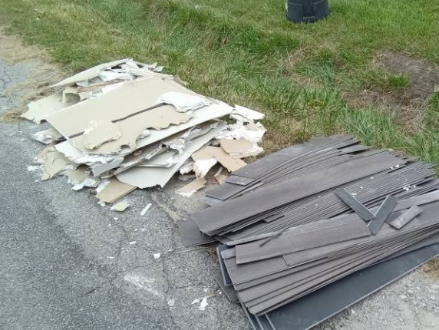
- Announcements-
- Reminder: Received an email from Local Waste about a trash pick up. (see photo) The flooring will need to be secured and bundled with rope or twine weighing 50lbs or less. Any loose items will need to be secured in bags for the next normal service day.
- Clerk Updates- Paula
- Miscellaneous correspondence
- Has the payroll problems been worked out? Yes
- Speaker Sheets-
  - Sharon Clark from Lukens Rd had questions about septic systems and problems with property next to them with noxious weeds.
- Executive Session – requested by Chief Whiting
- “I move to go into Executive Session according to Ohio Revised Code Section 121.22 (G)(_1& 4) for the purpose of discussing _personnel and contract negotiations___.
- Under the Ohio Revised Code Section 121.22(G), I move to come out of Executive Session.
- Adjourn-

