Client Information
Client Name: _____________________________ Date: ____________________ Date of Birth: _______________
General and Medical Information:
Y N Have you ever had a professional massage? If yes, how often? ___________________________
Y N Are you pregnant? If yes, how far along are you? ______________________________________
Y N Are you sensitive to pressure/touch anywhere (ticklish)? _________________________________
Y N Are you allergic or sensitive to any oils (essential oils, nut oils, scents)? If yes, please list: _____________________________________________________________________________________________
List of current medications and reason for taking: ____________________________________________________
_____________________________________________________________________________________________
Any topical medications (ointments or creams): Y N ___________________________________________
List of surgeries, if any (type and date) or recent injuries: ______________________________________________
Please check all that apply:
- Skin condition, rash, wart, hives, skin cancer, Other:_______________________________
- Lymphatic condition, swollen gland, nasal congestion, lymph edema
- Joint problem/stiffness, arthritis, sacroiliac problem, TMJ, other____________________
- Bone condition, osteoporosis, fracture
- Headaches
- Recent injury or accident, whiplash, sprain, bruise, other __________________________
- Circulatory issue, high/low blood pressure, Varicose veins, blood clots
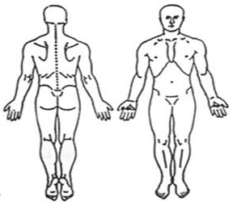
- Numbness/Tingling, sciatica
- Tendonitis, bursitis
- Diabetes
Indicate Areas of Pain Tension:
On a scale of 1-10, 10=highest, rate your levels of:
Stress: _______ Pain: _______ Energy: ______
How did your symptoms begin? When did they start?
___________________________________________
___________________________________________
What have you done for relief? _________________
Is the condition getting better/worse? ____________
Preferred Pressure:

- Light/ Meditative
- Medium/ Relaxing
- Heavy/ Invigorating
- Deep/ Trigger Point

Consent for Treatment
If I experience any pain or discomfort during this session, I will immediately inform the practitioner so that the pressure may be adjusted to my comfort. I further understand that massage should not be construed as a substitute for medical examination or diagnosis. I understand that massage therapists are not qualified to perform spinal adjustments, diagnose, prescribe, or treat any physical or mental illness. I affirm that I have stated all my known medical conditions and answered all questions honestly and understand that there shall be no liability on the practitioner’s part should I fail to do so. Understanding all of this, I give my consent to receive care.

Client Signature: ________________________________________________________ Date: _________________
Client ________________________________________________
Admin use only
Last Name ____________________
Client ID _____________________

Date of session_________________ Time of session___________________ Length of session____________
S _______________________________________________________________________
O _______________________________________________________________________
_________________________________________________________________________
_________________________________________________________________________
A _______________________________________________________________________
P _______________________________________________________________________
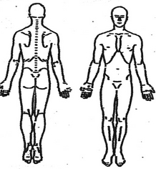

Date of session_________________ Time of session___________________ Length of session____________
S _______________________________________________________________________
O _______________________________________________________________________
_________________________________________________________________________
_________________________________________________________________________
A _______________________________________________________________________
P _______________________________________________________________________

Date of session_________________ Time of session___________________ Length of session____________
S _______________________________________________________________________
O _______________________________________________________________________
_________________________________________________________________________
_________________________________________________________________________
A _______________________________________________________________________
P _______________________________________________________________________

