A Night Out
Friday, February 7, 2020 | Marriott Northwest, Brooklyn Park
Supporting Students in Osseo Area Schools
district279foundation.org/a-night-out

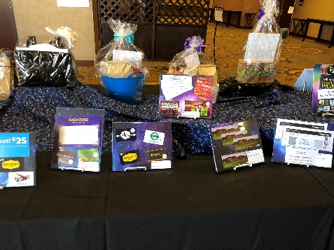
District 279 Foundation invites you support students in Osseo Area Schools through a donation for our event auction. District 279 Foundation’s A Night Out event will feature live entertainment, games, dinner, silent/live auctions and a program. Your support will be a wonderful addition to the event and will enhance the dollars that are raised provide innovative and creative learning opportunities for students.

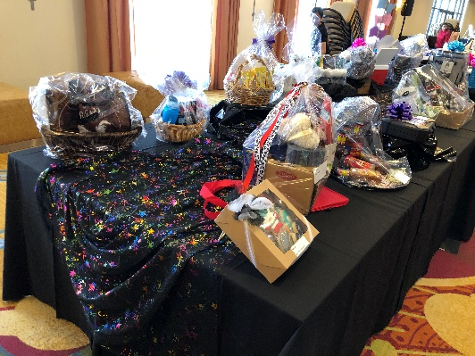
To contribute, please:
- Complete and submit the donation form by Dec. 13.
Email: andersondebra@district279.org
or
Mail: 11200 93rd Avenue North, Maple Grove, MN 55369
- Plan for the item to be delivered/received by Jan. 10.
- Keep a copy of the form as a receipt for your records.

About District 279 Foundation
For more than 25 years, District 279 Foundation has been supporting students in Osseo Area Schools. Located in Hennepin County, ISD 279 - Osseo Area Schools is the fifth-largest school district in the state of Minnesota, serving all or parts of Brooklyn Center, Brooklyn Park, Corcoran, Dayton, Maple Grove, Osseo, Plymouth, and Rogers. District 279 Foundation is a nonprofit organization that partners with the school district, parents, students, educators, volunteers, city officials, civic organizations and the business community to support and make a difference in Osseo Area Schools.

Our Mission
District 279 Foundation’s vision is to provide learning opportunities for students by funding programs, projects and other opportunities that are not presently available through the district's budget. The funds for these programs are generated by contributions from district employees, community members and business partners. Your investment provides access to educational experiences that inspire students and spark deeper learning.

A Night Out
Auction Donation Form
Submission Deadline - December 13, 2019
Items should be received/delivered by - January 10, 2020

Yes! We are proud to support District 279 Foundation’s event!

Donor Information:
BUSINESS/DONOR NAME (As it should appear in catalog)

CONTACT NAME: |  | DONOR ADDRESS:
PHONE |  | CITY: STATE: ZIP:
EMAIL (This is how we will send you your receipt. Please Print Clearly)

Item Information:
ITEM DONATED: |  |  | ESTIMATED DOLLAR VALUE:
ITEM DESCRIPTION – INCLUDE QUANTITY, SIZE, COLOR, NUMBER OF PERSONS, DAYS/NIGHTS AND ALL RESTRICTIONS:

MARK APPROPRIATE BOX:  ___ Delivery of item by Donor ___Donor provides Certificate  ___ Item needs to be picked up ___Committee to create Certificate  ___ Promotional material provided by Donor |  | SIGNATURE |  | DATE:

Committee Member | NAME: | PHONE:

PLEASE RETURN YOUR DONATION FORM BY 12/13/19.
Items should be received/delivered by 1/10/20.

For more information, contact:
Deb Anderson | andersondebra@district279.org | (763) 391-7118
Fed Tax ID #: 41-1705060 | district279foundation.org/a-night-out

