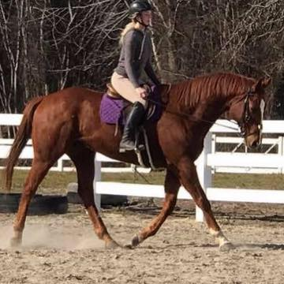
AGE: 19 YEARS
SCHOOL: GRADUATED SOUTH JOHNSTON HIGH
HORSE: BLAZE
​DICIPLINE: JUMPER/ EVENTOR
AGE YOU STARTED RIDING: 5 YEARS
​"I ride almost everyday!” I would like to become a professional rider and trainer and eventually own my own stable. Until then, I enjoy “Liberty Work” which entails doing what the horse needs to work on that day. I often ride bareback, or without a bridle, but you can often find me in the round pen working on ground work. I am currently re-breaking and training a project horse which entails a lot of round pen work. I am always up for riding a horse who needs the extra work and I will take my time to make sure its done correctly. My advise to other riders is to Always get back on when you fall, no matter what and never give up on what you believe in! Cait works for JRF Equestrian as an evening feeder and she has been with us for over 3 years! Cait is reliable and always willing to come out in a pinch to help out, always willing to take on a new project and most of all, Cait is a good and responsible horse owner. This has earned her Student of the Month Honors for April!
​​​

