Board of Directors
Mary Gessner
President
Barbara Adamson
Vice President
Brenda Rawlings
Secretary
Thomas Spiggle
Treasurer

Members
Bob Cline
Carol Fogle
Katie Gosswein
Diane Gould
Fred Hoerr
Susan Holsinger
Candi LoPresti
Suzanne
Montgomery
Dennis Morris
Ed Provost

Staff
Sheila Orndorff
Executive Director
Katie Furneisen
Certified Housing
Counselor
Janice Dickinson
Office Administrator
Megan Bly
Housing Assistant
BJ Stout
Centralized Intake Coordinator

Springtime is finally here!

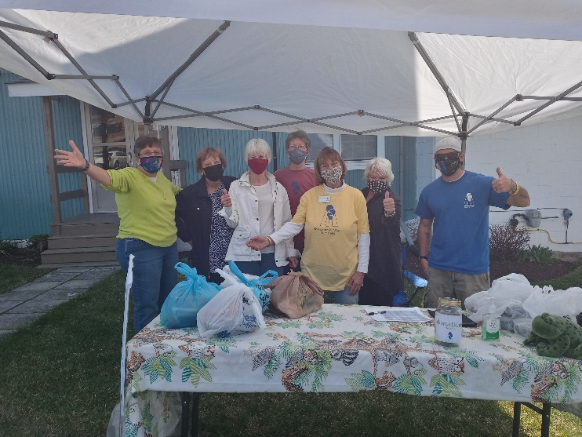
The Shenandoah Alliance for Shelter Board and Staff would like to thank everyone who purchased and/or donated during our pork BBQ fundraiser this past March. The fundraiser was successful and each one of you supporters were more than generous.
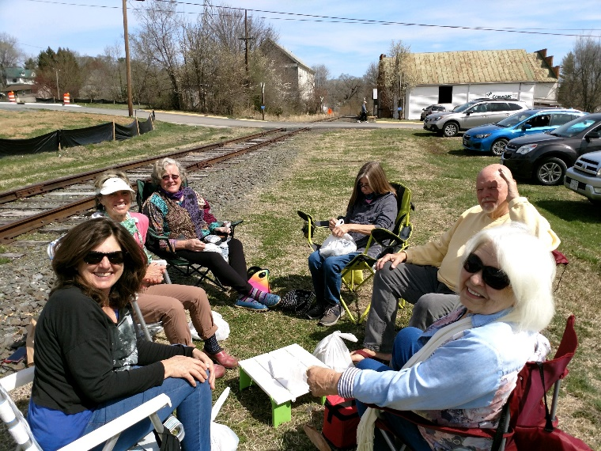
Your donations and purchases allowed us to help many families in our area. Your generosity and support are always appreciated. Thanks for always being a part in our struggle to prevent homelessness.

*During the COVID pandemic we are operating under altered business hours. Our office is open Monday through Thursday 8:30am to 4:30pm. Please call to schedule an appointment to ensure staff availability. Call the central housing intake line at (540)271-1701 if you are experiencing a housing crisis.

Summer Events
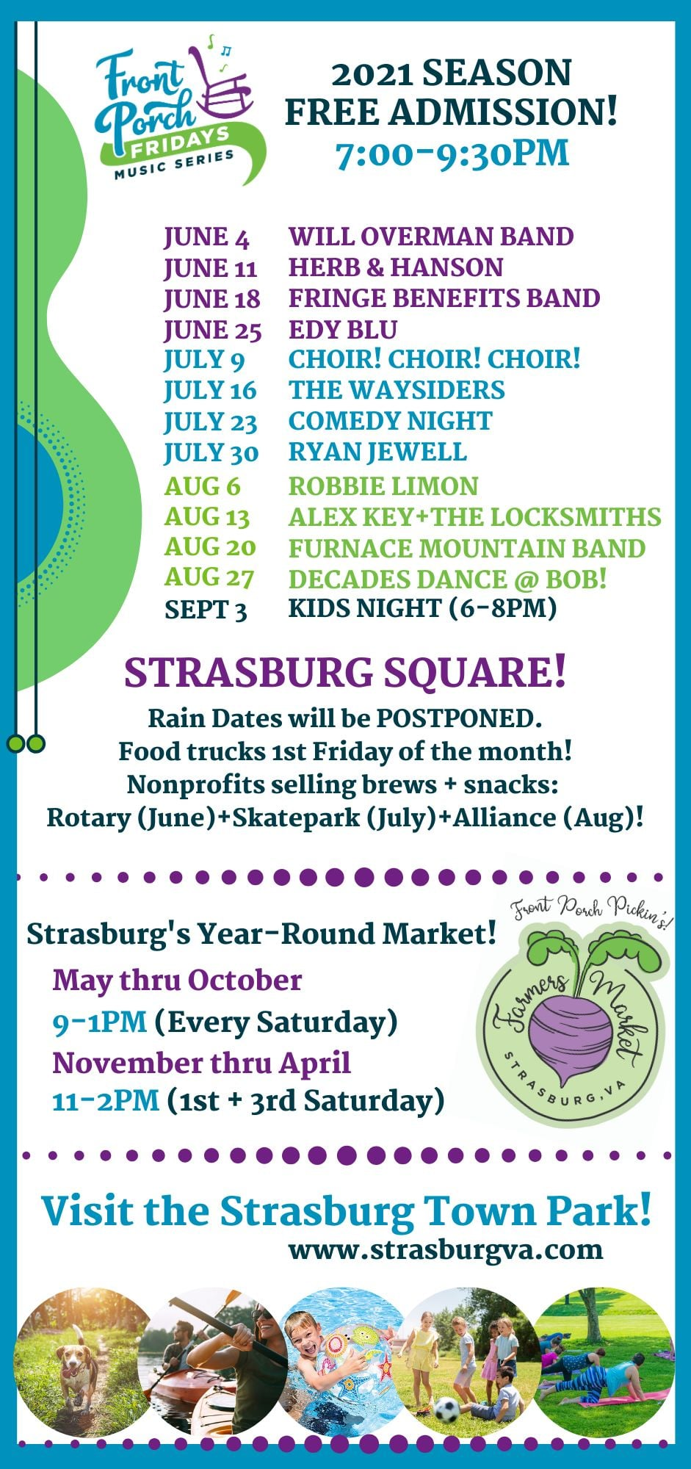
The Shenandoah Alliance for Shelter will be onsite and offering refreshments the first three Fridays in August at Strasburg’s Front Porch Fridays. The entertainment lineup for those nights are as follows: August 6th, Robbie Limon, August 13th, Alex Key + The Locksmiths, and August 20th, Furnace Mountain Band. Come on down, listen to some tunes and have a cold brew to support the Alliance. All donations and proceeds will go towards our efforts in preventing homelessness. On August 28th, the SAS Board and Staff will be volunteering at the Car Show in Strasburg. The car show is a part of the second annual ‘Vintage in the Valley.’ All the proceeds from the car show go to support the Shenandoah Alliance for Shelter. Please visit our Facebook page for more details.

Goodbyes and New Beginnings

It is with mixed emotions that I announce my retirement from the Shenandoah Alliance for Shelter (SAS). I have been with SAS for 21 years, starting in 2000 as the part time services coordinator. After 5 years I was promoted to Executive Director. If I am completely honest it feels like I am leaving a large part of myself behind and starting a whole new chapter in a storybook. When I left my corporate job back in 2000, I never imagined I would still be working at Shenandoah Alliance for Shelter 21 years later. My role at SAS has been so rewarding and fulfilling. My journey here reminds me of my favorite children book the “Giving Tree.” Each time a client presented me with a need or challenge I would go to our (tree) churches, services agencies, community civic groups, team members, and other non-profit colleagues to meet their need or request. Our community, Shenandoah County, is one of the most giving and caring communities in our region. Our community has the highest service resources in the region. Just like the tree in the story, giving of yourself and your time is the greatest gift you can offer. We are blessed to have a whole community full of people that work and live to help their neighbors and give back to their community with a loving and kind heart. I am excited and eager to begin a new journey. I hope to do more traveling and spending more time with my elderly parents, and my grandchildren. Maybe even find part time work to balance out retirement with work and play. I will be leaving Shenandoah Alliance in talented and capable hands. Katie Furneisen, our current Housing Counselor, has accepted the position of Executive Director, effective July 1, 2021. I will stay on until September 30, 2021 during this transition. It has been such a pleasure working with all of you and truly working together to make a difference in our community.

Sincerely,
Sheila Orndorff

Welcome
The SAS Board and Staff would like to welcome its newest members: Bob Cline, Fred Hoerr and Candi LoPresti. We are looking forward to working with you all.

A Thank You to Our Donors
St. Luke Brethren Church | David Brotman | Karen Nathan
Strasburg SDA Church | Margaret Lorenz | Mary Jane Field
1st Church of Columbia Furnace | Susan Moose | Renaissance Charitable Foundation
Woodstock Ministerial Fund | Ann Davison | Kandace Muller
Laurel Hill Christian Church | Sharon Gochenour | Caleb Cofflett
Woodstock United Methodist | Craig & Christine Furneisen | Steven & Wendy Pieper
Zion Lutheran Church | Janet Wagniere | Mary Gessner & Bernard Griswold
Toms Brook United Methodist Church | Ann Elizabeth Follansbee | Garland-Uhl Fund
Lighthouse Ministries | Jeffery & Alice Carithers | Laurel Hill Christian
St. Paul Lutheran Church | Bruce & Gay Griffin | St. John's Church of Christ
Amazing Flame, LLC | JA Garrett | Emmanuel Episcopal Church
Woodstock Lions Club | SM Raynor | Strasburg Christian Church
Hamburg Ruritan Club | Timothy & Patricia Funk | Strasburg Presbyterian
Basye-Bryce Mountain Lions Club | Brooks & Dick Nana | St. John's UCC Hamburg
Susan Chiccehitto & Donald Hindman | Anne Dellinger | Strasburg UMC
The Church of Jesus Christ of Latter Day Saints | Janet Monroe | John Mears
Shenandoah Valley Electric Co-op | Prince of Peace Church | John & Barbara Adamson
Woodstock Presbyterian | Teber Amos | Network for Good
St. Mary Pine Lutheran Church | Ed & Bea Provost | BBQ Fundraiser Donors
Wakemans Grove COB | Katie Gosswein | Frank Cihlar
Lebanon Lutheran Church | Barbara Halvorson | Maurertown Brethren Church
Shenandoah Community Foundation | Donna Mumaw | Front Stream Platform Donation
Zion Christian Church | Massanutten Eagles Club | Mary Jane Koch
Zelda Zadnik | Carla Wallen | Janet Sommerfeldt
Col. Richard & Laura Mary Ryan | Cindy Wright | Diane Gardner
Fred Hoerr | Katherine Morrison | Jenna French
Michael Rohrbaugh & Lucy Banks | J. Timothy Dalke | Helen Smith
Robert Cline | Dee Hockman | Rich Church
Jean & Coe Sherrard | Frances Foltz | William Grillo

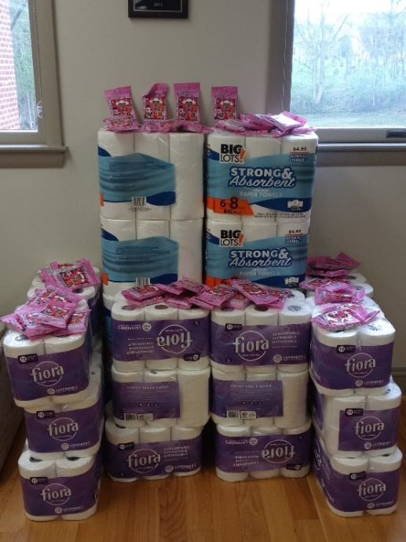

A Special Thank You

Working closely with local organizations allows us to share resources. The Shenandoah Alliance for Shelter would like to thank Family Promise of Shenandoah County for giving us paper towels, toilet paper and hand sanitizing wipes. Sharing resources and working together helps us better serve those in need.

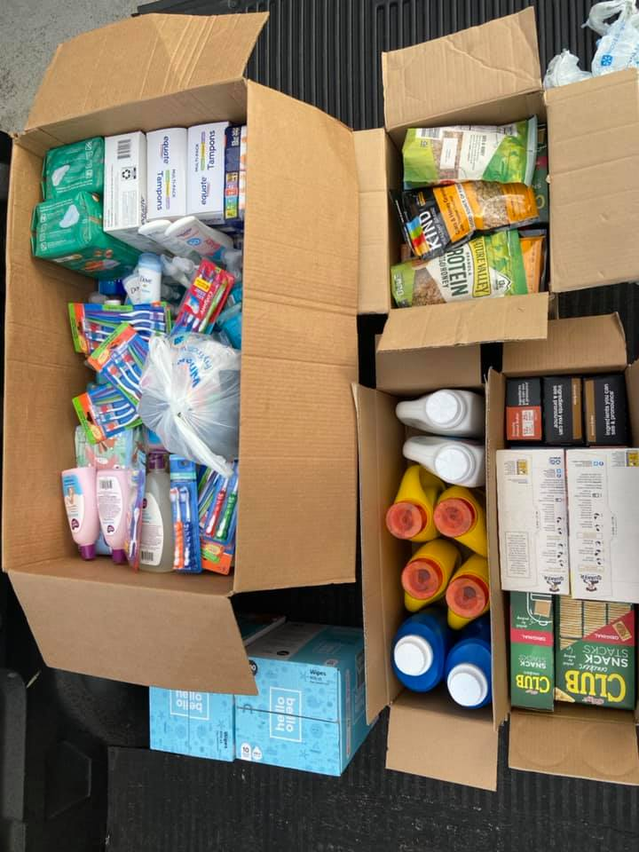
When we were contacted by Alondra Ortega a few weeks ago regarding a donation drive on our behalf we had no idea what to expect. On May 25th, Alondra and her crew showed up with what we thought would be a few items. If it weren't for our masks you would have been able to see the shock on our faces when they started pulling box after box off their truck. There were donations of tooth brushes, toothpaste, sanitizing spray, soap, baby wipes, socks, crackers, detergent, baby lotion, diapers, trash bags, suntan lotion, deodorant, body lotion, shampoo, and so much more. We are so grateful for their generosity and kindness in support of Shenandoah Alliance and the households we serve. Something as simple as having access to basic hygiene items when you're not feeling good about yourself, or going through a tough time, can change your whole world.

Information Corner
Currently, Dominion Energy and Shenandoah Valley Electric Cooperative have discontinued shut offs and instead are allowing consumers to set up payment plans. They do not plan on lifting these “shut-off bans" until the end of June. We do anticipate an influx of consumers needing utility assistance with higher than usual bills. Our utility program only allows us to pay a small portion of their bill so this will leave many families needing to reach out to other community resources or in some cases, without electricity or water. If you find yourself in this situation, or know someone in need, please contact your local social services department or go online and access the website http://commonhelp.virginia.gov/access to see if you are eligible for cooling assistance. Also, reach out to your electric provider to see if you are eligible to set up a payment plan.
Announcing Community Awards
Shenandoah Community Foundation Award- Project: Client Needs: Unrestricted funds to cover costs associated with stabilizing housing, employment, and/or meeting basic needs that could potentially cause the household to experience a housing crisis or homelessness.
United Way Impact Grant- Financial Stability: To support the Centralized Housing Intake staff in Shenandoah County who connects callers experiencing homelessness or a time sensitive housing crisis with resources.
Crescent Cities Charities: Sponsorship award to assist with our annual Empty Bowl Soup Supper to raise awareness and provide financial assistance to households experiencing a housing crisis or homelessness.
We are so grateful for all the community support we receive year-round. These awards help supplement our federal and state grants and aid households that would not be eligible under federal or state regulations and/or eligibility requirements.
In Our Next Newsletter look for
- Information pertaining to our annual Empty Bowl fundraiser scheduled for November. As with 2020, it may have a different look and feel but with all the same fun! We will be utilizing the Give Smart platform for this event and are planning a “drive-thru” bowl and soup pick up.
- A letter from our new executive director
- Updates about our organization and utility assistance programs

