ISSUE
December 2022

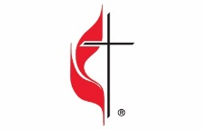
In This Issue

Pg 1, 2 Pastor’s Corner Pg 7, 8, 9 Keeping You Informed
Pg 3, 4, 5 Coming Up Pg 10 Calendar for December 2022
Pg 6 Bible Studies & Small Groups Pg 11 Church Information

This Pastors Corner finds us in the season of Advent, the period of preparation for the celebration of the birth of Jesus Christ at Christmas and also of preparation for the Second Coming of Christ. It is a time for celebrating and remembering that God keeps his promises, all of them not just some of them. Yet there are those who hold positions of authority in the United Methodist Church who would seek to undermine the importance of Advent.
Two newly elected Bishops in the United Methodist Church have publicly stated that the Jesus we worship and celebrate this Advent season is not Central to the “Church”. When asked if it was important for United Methodists to at least agree on who Jesus is. In response, they confidently declared, “No, it is not important that we agree on who Christ is.”
I vehemently disagree! The scriptures tell us exactly who Jesus is! Jesus is the fulfilment of the promise made by God to Abram in Genesis and to David in the Psalms. Jesus is the “Corner Stone”, Jesus is, the tested stone, a precious cornerstone for a sure foundation; the one who relies on it will never be stricken with panic. Jesus is, “Son of God, loves pure light.”
When asked, When asked if they believe in the basic orthodox doctrine of the incarnation, of God becoming flesh in a particular human body in a particular time and particular place.
They replied: “God became flesh, but not particular flesh. There’s no particularity around that. God became incarnate in a culture, but not one culture.”
Now I don’t know where that Bishops belief that “God became flesh, but not particular flesh. There’s no particularity around that. God became incarnate in a culture, but not one culture.” Comes from, but I know that God became incarnate in the body of Jesus in a virgin named Mary and was born in the fulfillment of the scriptures in Bethlehem the town of David.
Continued

If we don’t believe that Jesus is the Messiah promised in the scriptures, then how can we believe in all his promises, and I am declarations in the Gospels? Look them up, JOHN 6:35, JOHN 8:12, JOHN 10:7,9,11,14-16, JOHN 11:25-26, JOHN 14:6, JOHN 15:1-2,5, If we don’t believe in the Jesus that this Advent season celebrates then all the messianic prophecies in ISAIAH 9:2,6-7, and ISAHIA 11:1-5 along with JEREMIAH 23:5-6 and MICAH 5:2,4 are meaningless too.
No thank you Bishop, I’ll continue to believe in the scriptural declaration of who Jesus is and where the incarnation occurred and to the particular people the incarnation occurred in, … “salvation is from the Jews.”
Another newly elected Bishop stated, we are living in a time of epochal change, which requires the church find sacred ways to die in order to be reborn. They call for heretics and edge-dwellers to lead the church forward. Now is the time, they say, to push these new leaders to the forefront of church restarts.
That statement begs that two questions be asked, first which church must find a sacred way to die, the church of Christ or the church of human beings’ creation? And second what exactly is a sacred death? Since Jesus Christ is the head of the Church, I certainly hope that this Bishop is not suggesting that the sacred death the Church needs to die is a death to Jesus Christ as the head of the Church. Because if that is the sacred death, they are talking about who would replace Jesus Christ as the head of the Church the human beings known as the Council of Bishops? As for Heretics and edge dwellers being at the forefront of church restarts, no thank you, that kind of thinking will not bear any fruit at all. As Jesus says in John 15:5-6 “I am the vine; you are the branches. If you remain in me and I in you, you will bear much fruit; apart from me you can do nothing. If you do not remain in me, you are like a branch that is thrown away and withers; such branches are picked up, thrown into the fire, and burned.
I will celebrate this Advent season with all the joy that it brings, God keeps his promises all of them and Jesus Christ is the same yesterday and today and forever. “Son of God, loves pure light.”
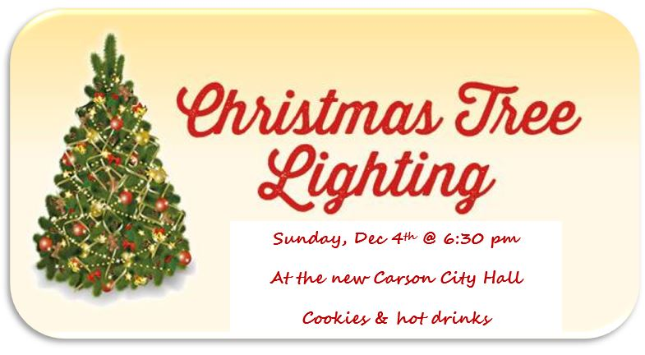

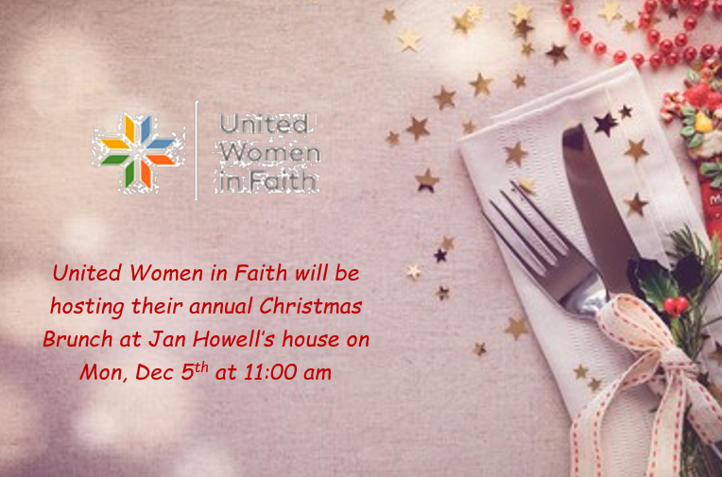

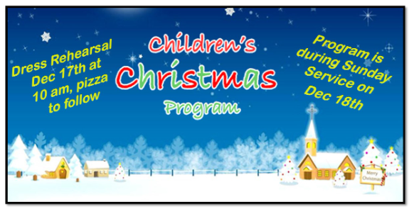
===========================================================
Christmas Day 2022 Service: With Christmas Day falling on Sunday for 2022, below is the schedule for CCUMC. This is so individuals can spend Christmas Day with family and friends.
Christmas Candlelight Service: 12/24/22 @ 7 pm
Christmas Day Service: No Sunday Worship Svc
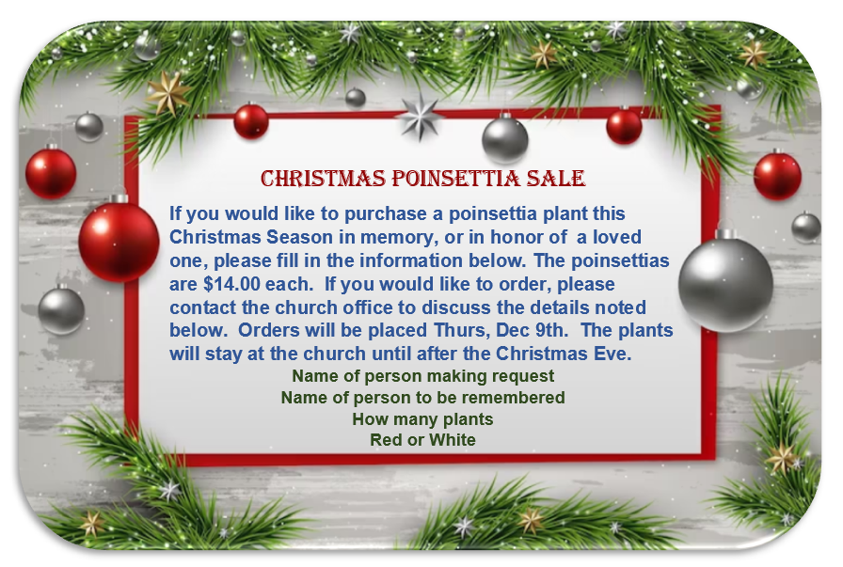
===========================================================

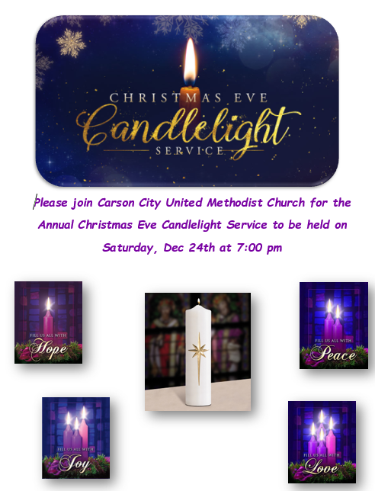

Sunday night Women’s Group will not be meeting during the month of December.

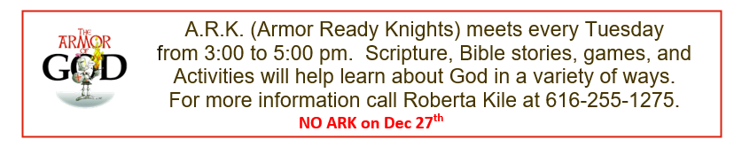

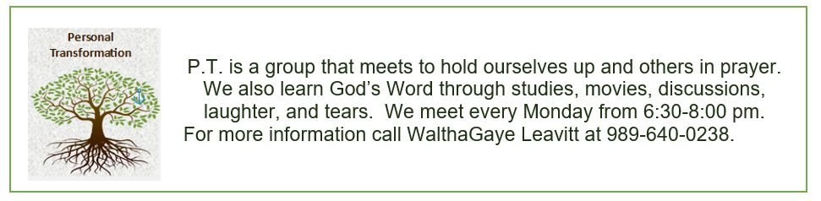

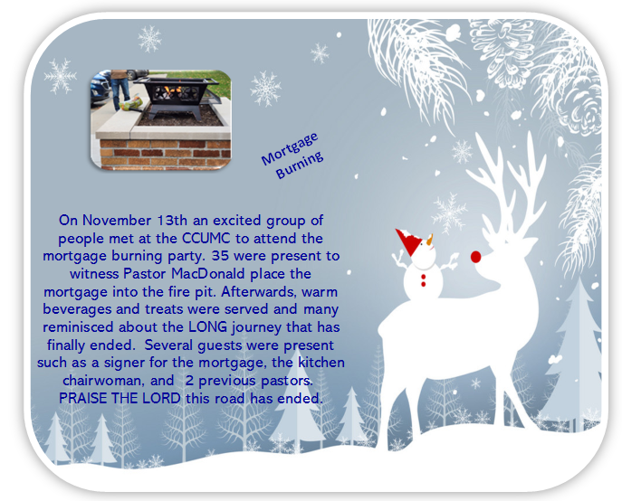

Native American Heritage Month
November was Native American Heritage Month. Please check out the bulletin board…the outhouse one. There is a short quiz- take the quiz and then help to raise awareness by telling friends and family what you learned.
Did you know that many Native American families on the Eastern Navajo Reservation are living on 7 gallons of water per day. Only 7 gallons for cooking, drinking, and bathing…for a family! In comparison, the average family in drought-stricken California uses 362 gallons per day.
The reservation has purchased 3 trucks and makes daily deliveries to families in the most populated areas of the reservation. They have also been able to revive an old, abandoned water well and created a storage tank so that the trucks can fill up. But- families across the reservation need the water. There are not enough drivers to reach the isolated areas of the reservation. To reach more families, they need more funds especially for the cost of fuel.
Could you live on 7 gallons of water per day? Try it. To give donations to this project:
St. Bonaventure Indian Mission and School
P.O. Box 610
Thoreau, New Mexico 87323-0610 or www.stbonaventuremission.org

United Women in Faith:
We held a “Come eat with Us” November 7th. The potluck meal was enjoyed by all. After the meal, L. Glenn Walker blessed us with music both vocal and by saxophone. Other church women were invited, but no one joined us. After the music, we held a short business meeting.
January 7th is the District Epiphany Breakfast. All are invited and it will be at Carson City UMC with Pastor Ian speaking. If you would like to come, please let me know--- and I will need greeters and servers for the refreshments.

What is Advent?
The word advent comes from the Latin word adventus meaning arrival or coming. So, Advent is the season of preparation for the coming of or Lord. It is searching within us to fins blemishes to change. It is opening our hearts to what the Lord is doing for us and will do for us.
There is much symbolism to the season. The wreath is a circle significant of God’s eternal life and love for us through his son, Jesus Christ. Covering the wreath is greenery usually pine boughs which signify immortality. Cedar specifically signifies strength and healing. Pinecones symbolize life and resurrection.
And then there are the candles. Purple or blue means a time of prayer, penance, and sacrifice. The first candle is called the Hope or Prophesy Candle. It reminds us of the foretelling of the coming of Christ. It especially should remind us of Isaiah who held on to the hope of the coming of Christ.
The 2nd candle is called the Faith or the Bethlehem Candle. This is to remind us of the journey that Mary and Joseph made to Bethlehem.
The 3rd candle is the pink or rose-colored candle. The color is significant of the liturgical color for joy. The candle is called the Joy candle or the Shepard’s Candle. This is to remind us of the joy that the world experienced at the birth of the Jesus.
The 4th candle is blue or purple and is called the peace candle or the Angel’s Candle. This is to remind us of the message that the angels brought-“ Peace on earth, Good will to men.
The 5th candle is white which is called the Christ candle. White means purity and represents the life of Christ.

Effects of the war in the Ukraine
The Ukraine is the largest wheat provider for much of Africa and Asia. This has disrupted the chain of supply which has created huge problems. Between the market volatility, economic depression, high inflation and severe weather drought conditions, food has become scarce and costly. This has led to more than 720 million people facing some level of food insecurity. Roughly 26 million children are at high risk of death from wasting- a condition caused by acute starvation.
Currently, more than 216,000 children are attending a Compassion center while waiting to be sponsored. All of them are receiving holistic program support, from education assistance to counseling to medical treatment to emergency food assistance.
News of the crisis from center staff around the world is that up to 25% of Compassion-assisted children and their families could need food assistance. If the estimated need is accurate, that would mean that more than 53,000 children waiting for a sponsor could also be waiting for their next meal, possible suffering from hunger and malnutrition.
If you would like to help these children or sponsor a child, please let WalthaGaye know. I can help you. 989-640-0238

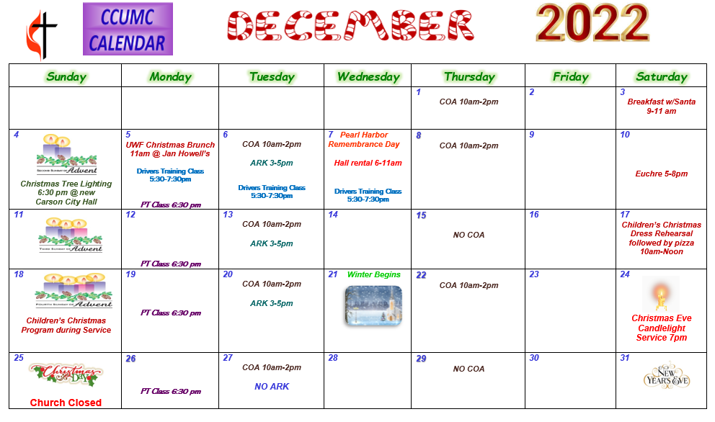

Schedule’s subject to change – contact office for more information”

Stay connected! Follow us on:

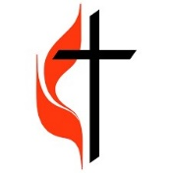
Join Us Each Sunday

Worship Services 10:30 am

(masks are optional)

Carson City United Methodist Church
Phone: 989-584-3797
Email: carsoncityumc@gmail.com
Website: carsoncityumc.com
Office Hours: Monday to Thursday, 9:00 am-Noon
After hours by appointment
Pastor: Ian McDonald (906) 322-5318
Secretary: Bonnie Seaman (989) 763-1674

Online giving available: Website: http://www.carsoncityumc.com/donate.html

Weekly Sunday Bulletin now available on our website
at www.carsoncityumc.com

