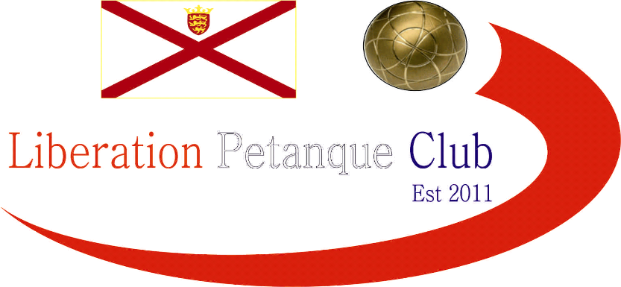

2017

Liberation Petanque Club

Doubles Open

With 20 teams taking part in this year’s competition, 6 more than last year, it was going to be tougher.

Round 1 saw several 13-1 wins with Toby Northern & Matt Pinel beating Christine Eccles & Paul Waters, Mark Nicol & Seb Renaud beating and Ross Payne & Antony Di Santo (title holders) beating.

A tough first round draw saw Andrew Bellamy-Burt & Callum Stewart beat Alan Lahiffe & Mat Scholefield and Brian Harris & Mike Ritzema beat Ian Black & James Mold.

Round 2 Callum & Andrew beat Brian & Mike, the first time Andrew has beaten Brian in a competition in two years. Mark & Seb and Matt & Toby copied each other’s results again both winning 13-3 and Gordon & Dorothy handed Paul & Christine a fanny certificate.

Round 3 saw Callum & Andrew lose to Matt & Toby 13-7, and that was the start of the end for Callum & Andrew who didn’t win another match and end up finishing 12th place, disappointing for last year’s runners up.

Matt Pinel missed several firing chances early on as himself and Toby lost 13-0 to Mark Nicol & Seb Renaud.

James & Geoffroy beat Callum & Andrew to move into contention for a top 8 places. Brian & Mike also looked good beating Alan Lahiffe & Matt Scholefield 13-1, Neil Selby & Keith Boleat won again keep up the pace.

The final round saw Neil & Keith just escape a fanny certificate from Toby & Matt who recovered well from their fourth round defeat.

Mark & Seb did not let up as Ross & Antony lost 13-0 to them also, with Ross starting to suffer from the heat!!!?

Chris Romeril & Stephen Leathem won 13-1 against Michel Morel & Helene Retrosi to make the top 8.

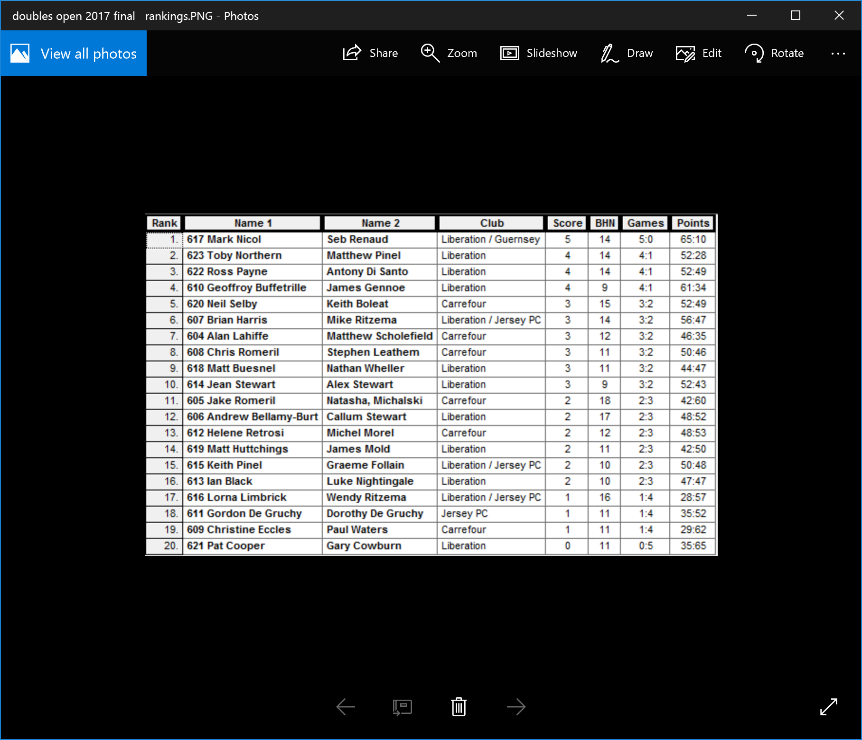

Quarter Finals

Mark Nicol & Seb Renaud v Chris Romeril & Stephen Leathem

Toby Northern & Matt Pinel v Alan Lahiffe & Matt Scholefield

Ross Payne & Antony Di Santo v Brian Harris & Mike Ritzema

Geoffroy Buffetrille & James Gennoe v Neil Selby & Keith Boleat

Mark & Seb have a tough start against Chris & Stephen but pulled through to win 13-8. In a repeat of last year’s quarter finals Matt & Toby played Alan & Matt. If was the latter who had the game of their lives never letting up with excellent placing and firing to run out 13-5 winners.

It went all the way with Ross & Antony v Brian & Mike with last year’s winners losing 12-13.

James & Geoffroy made light work of Neil & Keith winning 13-3 to make the semi-finals.

Sometimes it’s the pressure sometimes you just have to hold your hands up and say well done, which ever it was or a mixture of both Mark & Seb handed out their 3rd fanny certificate of the day in their semi-final match against James & Geoffroy.

Brian & Mike would have been confident of beating Alan & Matt having already done so 13-1 in round 4. Alan & Matt though had been improving and didn’t make it an easy ride this time, in fact taking the win to reach the final.

3rd place went to James & Geoffroy beating Brian & Mike.

Despite their improved form Alan & Matt couldn’t repeat it in the final as Mark Nicol and Seb Renaud took the title, with Mark repeating Andrew Bellamy-Burt’s feet in 2015 when he would both Liberation titles.

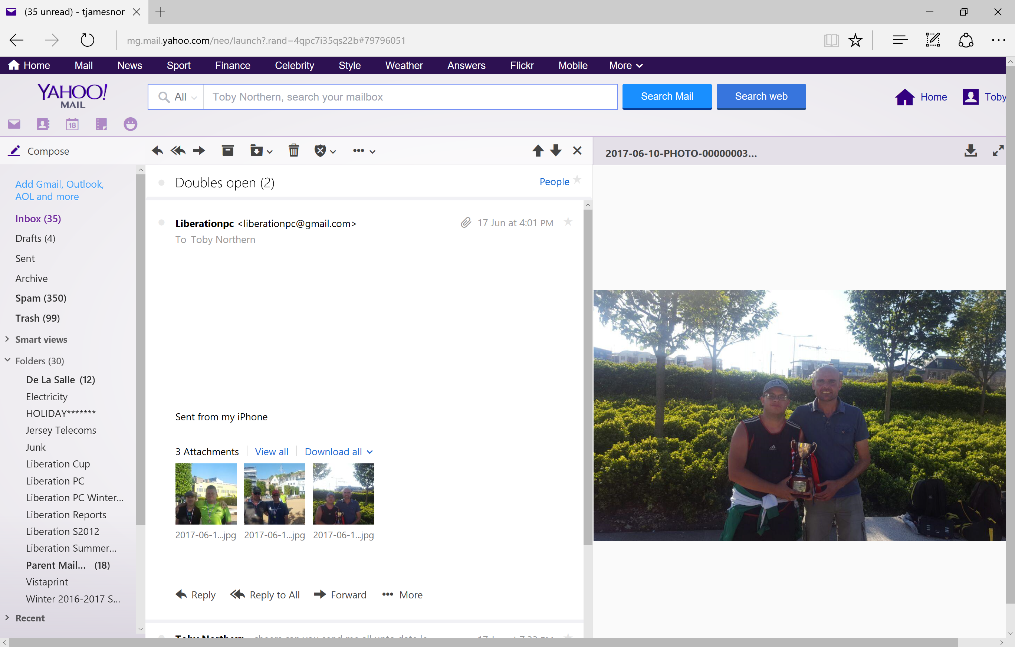

Congratulations to everyone who took part in another successful competition.

Thank you to everyone who helped prepare for this competition and the running of it on the day which takes a great deal of time and effort

NEXT UP – MIXED DOULBES SAT – 10TH AUGUST – GET YOUR ENTRIES IN NOW!.

Kind Regards

Toby Northern

Report Editor

Liberation Petanque Club

