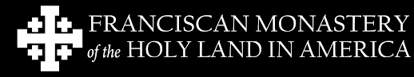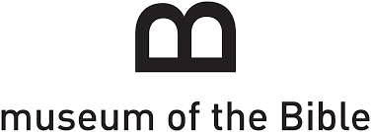
Bus Trip to the Franciscan Monastery of the Holy Land and the Museum of the Bible in Washington, DC.
Saturday, June 29, 2019
Itinerary
7:15- Departure from Our Lady of the Visitation
10am-Tour the Franciscan Monastery of the Holy Land
11am-Tour of Gardens at the Monastery
12pm-Mass at Franciscan Monastery (Father Dwight celebrant)
1-4pm-Visit the Museum of the Bible
4pm-Depart Museum of the Bible for home
We should arrive back at OLV around 6:30pm

Cost is $75 per person. For more information, please contact Travis Detwiler at 717-809-0672 or travisedetwiler@gmail.com. To register, please complete the registration form below and return it with payment to the church office or put in the collection. Please make checks payable to Our Lady of the Visitation.

Name:
Email:
Phone number:
Number going:

