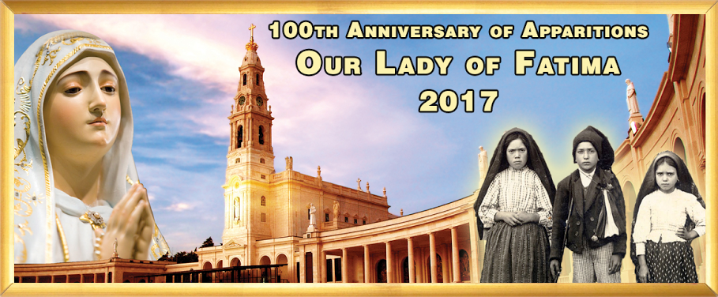 

**Pre-Book for**

**2018 NOW.**

**Limited Seats for Sept 5-16 &**

**Oct 24- Nov 4, 2017**

**Fatima, Lourdes & Shrines of Spain 2017:   
*12 Days from $1831 per person twin share***

**Religious Tours**

**THE ANGLO-INDIAN AUSTRALASIAN ASSOC. OF VIC &**

**RUBY TRAVELS WORDLWIDE PRESENT**

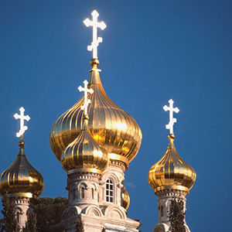

**The Holy Land Discovery:**

***8 Days from $1871 per person twin share***

Tour includes Portugal, Spain and France

Overnights in Lisbon, Fátima, Santiago de Compostela, Burgos, Lourdes and Barcelona.

Attend Mass in Fátima, join pilgrims for the Rosary and candlelight procession at Our Lady of Fátima Basilica.

2 nights in Lourdes, nightly Rosary and guided tour.

In Lisbon visit the Cathedral La Se’, where St. Anthony was baptized

**Inclusions: Sightseeing, Guides, Transportation, Hotels.**

**Flights: Not Included.**

**Join a Group from Melbourne**

**and Celebrate the**

**100th Anniversary of Apparitions**

**Call June to book your TOUR & FLIGHTS**

**0401 895 998**

Tel Aviv, Jerusalem, Nazareth, Bethlehem, Jericho,

Visit Jerusalem’s Old Town, the Garden of Gethsemane, the Jewish Quarter

and Western Wall, the Basilica of the Holy Sepulchre & Via Dolorosa

In Nazareth, visit the Church of the Annunciation, visit Cana of

Galilee, Mount of Beatitudes,

In Bethlehem, visit Church of the Nativity, situated on the site where Jesus was born.

Scenic Highlights: Sea of Galilee, Jordan River, Dead Sea, Jordan Valley, Mount Carmel.

**Inclusions: Sightseeing, Guides, Transportation, Hotels.**

**Flights: Not Included**

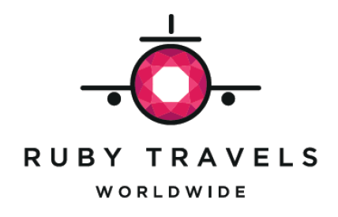

***Ruby Travels Worldwide is an Authorised Agent for Globus Family of Brands***

***For detailed itinerary email: june.rubytravels@gmail.com***