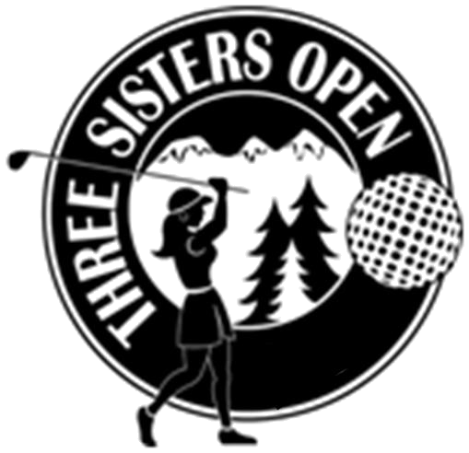
THREE SISTERS OPEN
2019 Sponsorship Opportunities and Descriptions

Title Sponsor $5,000
Name and logo included on ALL print material
1 Large banner displayed at event
Announcement in newspaper
Name/Logo on golfer gifts
Listed as Title Sponsor on thank you sign at event
Listed as Title Sponsor in event thank you ad in the newspaper
First Right of Refusal as Title Sponsor for next year’s event
Business card ad & recognition in Quota’s Holiday Auction program
One team entry (4 players) in TSO Golf tournament
Recognition Sponsor $2,000
Name & Logo included on ALL print material not yet printed
1 Large banner displayed at event
Listed as Recognition Sponsor on thank you sign at event
Listed as Recognition Sponsor in thank you ad in the newspaper
Flight Sponsor $1,000
The sponsored flight will be bearing your name throughout the tournament for any announcements, awards, scoring sheets, etc. (i.e., “C Flight” will be listed or referred to as the “Jones Furniture Flight”)
Listed as Flight Sponsor on thank you sign at event
Listed as Flight Sponsor in thank you ad in the newspaper
Logo in Event Program
Logo on 2 banners (1 on each nine holes)
Golf Cart Sponsor $1,000
Business name/logo on all golf carts (72, if full field)
Listed on thank you sign at event & in thank you ad in the newspaper
Logo in Event Program
Luncheon Sponsor $1,500
1 Large banner displayed at event.
Listed on thank you sign at event & in thank you ad in the newspaper
Logo in Event Program
Breakfast Sponsor $750
1 banner displayed at event.
Listed on thank you sign at event & in thank you ad in the newspaper
Logo in Event Program
KP (Closest to Pin) Sponsor $300
KP sponsor sign placed at each of the 2 holes designated as KP’s
Name announced during awards
Listed on thank you sign at event & in thank you ad in the newspaper & Listed in Event Program
Long Drive Sponsor $300
Long Drive sponsor sign placed at each of the 2 holes designated as Long Drives
Name announced during awards
Listed on thank you sign at event & in thank you ad in the newspaper & Listed in Event Program
Putting Green, OR Driving Range Sponsor $250 each
Hole sponsored by “ ” sign placed at either the Putting Green or Driving Range
Listed on thank you sign at event & in thank you ad in the newspaper, & Listed in Event Program
Tee & Hole Sponsors $200 each
Tee/Hole sponsored by “ ” sign placed at designated tee/hole.
Listed on thank you sign at event & in thank you ad in the newspaper, & Listed in Event Program

To secure one of these sponsorships, please call or email:
Tess Tompos, quotatess@bendbroadband.com 541-408-6328 www.qico.club

