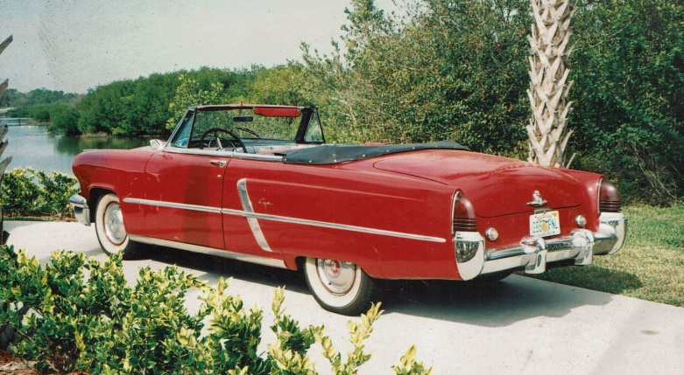
FOR SALE
1952 Lincoln Capri
2 door Convertible
“Designed for Modern Living.”

The Capri was sold by Lincoln for the 1952 through 1959 model years. It is this car that earned the “Hot Rod Lincoln” term, having won the top four spots in the Stock Car category of the Pan American Road Race in both 1952 and 1953. 14,342 Capris were sold in its debut year. The Capri had a new Lincoln 90 degree, 337 cu in (5.5 L) 2-bbl. Flathead V8 . It has slab sides, with projecting headlights, raised fender crowns, and a pronounced rear fender line. The grille was almost completely involved on the bumper. In the October, 1952 issue of Popular Mechanics, a Lincoln Capri was tested, 0-60 mph time was 14.8 seconds, while the quarter-mile was 21.3 seconds. The Capri was also one of the first vehicles to offer an automatic headlight dimmer as optional equipment.
The most significant improvements were underneath, with the first ball-joint front suspension, doing away with king-pins, and a completely redesigned frame, with six cross-members and K-type reinforcement. Wheelbase 123.0 in, Length 1952: 214.0 in, Width 77.5 in, Height 62.6 in, Curb weight 4,600 lb
"Son, you're gonna' drive me to drinkin' if you don't stop drivin' that Hot Rod Lincoln."

Asking $45,000
Pistorius Collectible Autos
Antique & Classic Car Sales and Restoration Services
Brando Pistorius (813)917-9205
Tampa, Florida USA www.OldWheel.com

