2017
FLAGLER COUNTY FAIR
& YOUTH SHOW, INC.

Livestock Rules
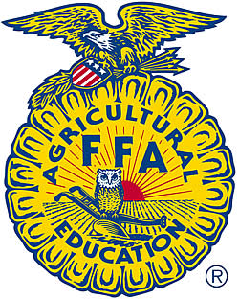
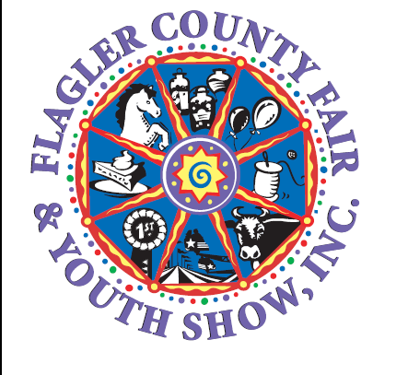

April 5-9, 2017
President: Walton Cowart

Carnival Rides and Games, Community Exhibits, Arts/Crafts & Commercial Vendors
Livestock Show & Sale

Live Entertainment and more!

FLAGLER COUNTY FAIRGROUNDS, BUNNELL

Table of Contents

Exhibitor Requirements…………………...…………………………………… 3-4
Dorothy Bullard Award.………………………………………………………… 5
General Livestock Rules and Regulations…………………………………… 6
Appropriate Attire……………………………………………………………….. 7
Sportsmanship Award………………………………………………………….. 7
Buyers Letters…………………………………………………………………… 8
Market Steer Rules……………………………………………………………… 9
Market Swine Rules…………………………………………………………….. 10
*Pig Pool Registration Form……………………………………………….. 11
Market Wether Rules…………………………………………………………… 12
Show Pen Guidelines………………………………...………………………… 13
Herdsmen Award………………………………………………………………… 13
Pen Cleaning Requirements……………………………………………………. 13
Awards (Summary)………………………………………………………………. 14
*Exhibitor Agreement (Must be signed and submitted with entry)………… 15
*Livestock Entry Form (Must be completed and submitted with entry)…… 16
*Exhibitor Release Form (Must be signed and submitted with entry)…….. 17
*Exhibitor Service Hour Log Sheet (Complete and submit by 4/4/17)…… 18
>4H Exhibitor Requirement Record (Complete and submit by 4/1/17)……19
Important Dates to Remember…………………………………………………. 20
Contact Information……………………………………………………………… 21

* Required forms for ALL exhibitors
>Required form for 4H exhibitors

Reminders
- It is your responsibility to read and understand all of the rules and regulations associated with participation in the Flagler County Fair and Youth Show.
- Entries must be complete with all required forms, information and signatures to participate.
- The Flagler County Fair & Youth Show strives to provide our exhibitors with a variety of opportunities to develop into responsible adults. We reserve the right to make final decisions based on the best interests of our participants and the fair.
Exhibitor Requirements
2017 Flagler County Fair & Youth Show

These rules pertain to all Livestock divisions

- Exhibitor must be a resident of Flagler County or attend a Flagler County School AND be a member of an appropriate Flagler County 4H Club or FFA Chapter. Exhibitor must meet minimum membership requirements of the respective club/chapter as accepted by the Flagler County Fair and Youth Show. (See attached 4H requirements)
- ALL exhibitors are required to wear approved 4-H and FFA attire when showing and selling animals. Exhibitor will NOT be allowed to show or sell their animal if they are not properly attired. See guidelines in rules packet.
- “2 HOURS OF SERVICE RULE”- ALL exhibitors must complete 2 HOURS of service towards the Fair. The hours must be completed by Saturday April 1, 2017 If the hours are NOT completed the exhibitor will not be allowed to show or sell at the fair. The EXHIBITOR will be RESPONSIBLE for making sure the RECORD OF INDIVIDUAL EXHIBITOR SERVICE HOURS form is filled out completely and accurately. The EXHIBITOR will be responsible for obtaining signatures from the Livestock Committee person present at designated clinics, workshops and workdays. The MANDATORY MEETING does NOT count towards these hours.
*This form MUST be presented to the Fair Board on Sunday April 2, 2017 during fair check-in of the Dorothy Wright Bullard Requirements.
In order to help you complete these required hours, several workshops and clinics may be held. Workdays will be held. The dates of these events will be announced later. The purpose of the 2 HOURS of service rule – is to share some of the responsibilities associated with holding a fair with the youth that we hold this fair for. (NOTE: These hours do not count toward 4-H community service hours or projects.)
- MANDATORY MEETING: There will be a MANDATORY MEETING held this year. For your convenience this meeting will be held on two different nights. You will have a choice as to which night you can attend, Wednesday, January 11, 2017 at 6:30 P.M. or Thursday, January 12, 2017 at 6:30 P.M., at the Extension Service Auditorium. PARENT(s) and/or GUARDIAN(s) MUST attend one of these meetings along with the exhibitor. If the Parent and/or guardian and exhibitor do not attend one of these meetings, the exhibitor will NOT be able to show or sell an animal at the fair. This meeting does NOT count towards the 2 HOURS of service.
- RECORD BOOK CLINICS ARE ONLY REQUIRED FOR NEW EXHIBITORS. DATE TBD
- EXHIBITOR ATTIRE. Exhibitors will be REQUIRED to show and sell in appropriate 4H or FFA clothing. Exhibitors will NOT be allowed in the ring if not appropriately dressed. The guidelines are included in the rules, for any additional questions see your 4H Agent or FFA Advisor. TENNIS SHOES ARE NOT PERMITTED

- PEN CLEANING: Each EXHIBITOR is responsible for maintaining a clean and attractive pen at all times. At the close of the fair, each exhibitor is responsible for the cleaning of his or her pen. The pen should be left in the same manner as it was found at the start of the Fair. There will be a $50.00 fee DEDUCTED from monies due to the exhibitor if the pen is NOT cleaned by 6 P.M. on Sunday, April 16th, 2017 Your pen must meet the approval of the Livestock Committee, or any member thereof. Please see Pen Cleaning Guidelines on page 12 for specific.rules.
- RECORD BOOKS DEADLINE – 5 P.M. on Monday April 24. Record books must be completed, signed and turned in to the Extension Service office by the deadline. If the record book is not COMPLETED and TURNED IN by this deadline, date and time, the exhibitor will not be eligible for record book awards. You must score a minimum of a Blue Ribbon to receive awards.
- The exhibitor and his or her guardian(s) agree to forfeit and relinquish any and all monies generated from the sale of the exhibitor’s animal and participation at the Flagler County Fair, to the Flagler County Fair & Youth Show for the failure of the exhibitor to submit a completed record book. Record Books not turned in by April 24th, will not be eligible for awards.
- NEW REQUIREMENT – THE DOROTHY WRIGHT BULLARD AWARDAll Livestock Exhibitors (Including Chapter Animals) Must participate in three (3) or more of the Exhibitions in the Cattleman’s Hall. These will include the following: Horticulture, Home and Family Division (you can enter in numerous divisions within this department), Shoe Box Float, Skillathon or Country Critter. (See the next page for the requirements and points assessments for this Award and Requirement.
If you do not meet the required entries into the Dorothy Wright Bullard Award, you will not be eligible to show or sell your animal.

The service hour form is your documentation that you have met your service requirements. While we will make every effort to record your participation, your properly completed log sheet is your insurance that you will be receiving full credit for your participation.
Dorothy Wright Bullard Award
The purpose of this award is to:
- Encourage more youth participation and increase entries in the Flagler County Fair and Youth Show’s other divisions.
- Encourage currently participating youth to explore other divisions

All livestock exhibitors are required to participate.

Requirements:
- Must be a resident of Flagler County or attend a Flagler County School AND be a member of an appropriate Flagler County 4H Club or FFA Chapter. Exhibitor must meet minimum membership requirements of the respective club/chapter as accepted by the Flagler County Fair and Youth Show.
- Age Requirements AS OF SEPTEMBER 1, 2016
Junior 8 to 10 years Intermediate 11 to 13 years Senior 14 to 18 years
- Any youth (excluding cloverbuds) participating in any livestock exhibition (including rabbits and chickens) must participate in at least 3 or more of the following programs:
  - Horticulture
  - Home and family Division (a list will be provided of each division within this division - you can enter this division numerous times)
  - Shoe Box Float
  - Country Critter
  - Skillathon

- All entries must be turned in by the end of the day on April 2nd from 12 -4 pm and Monday April 3rd from 1-6 pm at the cattleman’s hall. (Please see the rules for each division you are entering in.) If you have not met this requirement, you will not be permitted to show or sell your animal.
- All entries must be picked up on Monday April 10th from 1 pm to 6 pm
- Points awarded based on placing in each division
For example:
1st place – 20 Points
2nd Place – 15 Points
3rd place – 10 points
Best in Show 50 points

- Cash Awards for each age division
1st Place - $50.00
2nd Place - $25.00
3rd Place - $10.00
General Livestock Rules and Regulations
These rules pertain to all Livestock divisions

(Also see exhibitor requirements on page 3)

- Tampering with an animal entered, such as filling with a foreign substance, etc. is prohibited. The use of tranquilizers or any type of calming agent on show animals will be considered as a form of tampering and will disqualify the entry.
- ALL animals will be divided into classes. The Modified Danish System will be used.
- A Showmanship contest will be held and awards given for each division.
- EACH exhibitor will furnish feed and care for their animal on a daily basis. This will include care up to the time the animals are removed from the Fairgrounds, which will be on Sunday.
- Animals will not be allowed to roam freely on the fairgrounds; they are restricted to designated areas of the fairgrounds and must not be taken from these areas.
- There will be no weight shrink on animals for sale purposes.
- ADD-ON money will be accepted by the Flagler County Fair & Youth Show.
- The Flagler County Fair & Youth Show will DEDUCT three percent (3%) of each exhibitor’s sale price for a “Thank You” photo and plaque that is presented to your buyer.
- Market animals will be scheduled for removal by the Flagler County Fair Board.
- Record books must be completed and turned in to the Flagler County Extension Office by Monday April 24th, 2017, no later than 5:00 P.M. Record books received after 5:00PM will not be eligible for awards. The exhibitor and his or her guardian(s) agree to forfeit and relinquish any and all monies generated from the sale of the exhibitor’s animal and participation in the Flagler County Fair if record books not turned in on this day and time.
- In market classes the sale order will be as follows:
    - Grand Champion
    - Reserve Grand Champion*
    - Showmanship: Junior, Intermediate & Senior (Order determined by class placing)
    - Danish System Ribbons – 1st, 2nd and 3rd will be recognized in each class
- All sheep and goats must have Official Veterinary Health Certificates as outlined in each division and required by the Florida Department of Agriculture.(Swine are exempt since all will be sold for slaughter.) Certificate must be dated after January 4th, 2017, which is 90 days prior to fair.
Appropriate Attire

IMPORTANT! All exhibitors must follow the guidelines below to participate in the Flagler County Fair and Youth Show. This policy was adopted to promote a positive image for the participants, their projects and the Flagler County Fair and Youth Show.

- For all shows and the sale, all exhibitors are required to wear appropriate attire for the organization under which they are exhibiting.
  - 4-H
    - Long-sleeved, collar type, white shirt or blouse
    - Dark black jeans or slacks
    - Prominent 4-H emblem or accessory

  - FFA
    - White Shirt with a white collar
    - Dark Black jeans or slacks
    - FFA Jacket
    - Appropriate tie/scarf (as described in State FFA Guidelines)

- No Hats or Caps.

- Closed-toed shoes or boots required (dark in color). TENNIS SHOES ARE NOT PERMITTED.

4. Clothes should be well fitted, with pants worn at the waist. No baggy, gaudy or otherwise inappropriate clothing will be allowed in the show/sale ring.
- EXHIBITORS WILL NOT BE ALLOWED TO PARTICIPATE IN THE SHOW OR THE SALE IF NOT IN DESIGNATED ATTIRE FOR THEIR ORGANIZATION.
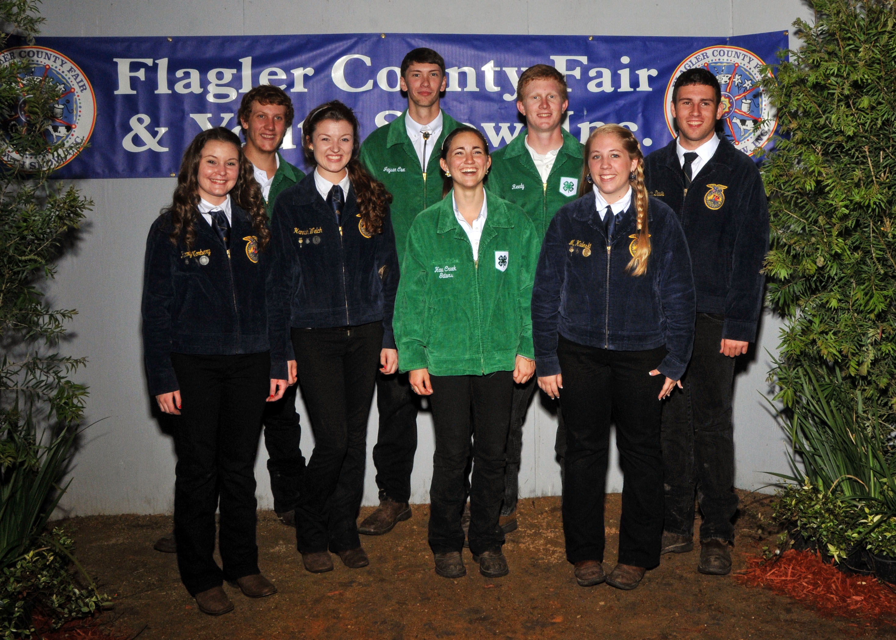

Sportsmanship Award

Throughout your fair experience, take note of fellow fair exhibitors who demonstrate good sportsmanship. On Friday afternoon all exhibitors will be asked to vote for the one fellow exhibitor that has best demonstrated sportsmanship. As you vote consider exhibitors that have been especially helpful, not only to you but to others. Think about exhibitors that demonstrate a positive, cheerful and encouraging manner. Also, consider exhibitors that have done exemplified good animal handling skills and a knowledge of their project.

Buyers Letters

- Exhibitors are expected to distribute individual letters to prospective buyers in order to encourage their participation in the Flagler County Fair and Youth Show Livestock Sale.

- The Flagler County Fair provides each prospective buyer with an information packet and two admission passes.

- The exhibitor is responsible for developing their own list of potential buyers along with their correct addresses by Friday February 17,2017. (The Flagler County Fair or its representatives will not provide any exhibitor with a list of potential buyers.)

- Suggestions:

Who to Send to:
Family Friends Family Business Contacts
Local Businesses Relatives
Producers Any one you think might consider participating in the sale

What to include:
Personal Information (Name, Age, etc)
Project Information (Types, Breed, Age, Current or Projected Weight)
Fair Times & Dates (Show, Sale)
Invitation to attend and participate
Optional:
Years experience
Skills learned
Plans for profits (for example: expand project, college, etc)

Tips
- Most buyers respond better to handwritten letters.
- Pictures help buyers identify with your project.
- Invite buyers to view your project or meet you before the sale.
- Have a parent, leader, agent, or advisor proofread your draft copy for errors.

The Fair will provide a Buyers’ Letter Clinic hosted by Amy Warwick. Date to be determined.
Buyer’s names and addresses are due at the Fairboard by Friday, February 17, 2017 We will be mailing out buyers passes and an information packet.
Please remember to include your name, the buyer’s full name, and their complete and verified address. (The Bunnell Post Office will not deliver to a street address unless there is a mailbox. We have spent several days trying to hand deliver returned mail in past years because the exhibitors did not use the correct Post Office Box.)
It would be very helpful if your addresses were in Microsoft Excel (or almost any table format) and e-mailed to flaglerctyfair@bellsouth.net
- (If you must submit addresses hand written, please be sure they are easily read.)
Thank you!!!
Market Steers
Livestock Division

2017 Flagler County Fair & Youth Show

RULES & REGULATIONS
- First OFFICIAL Weigh-In and Entry Deadline: 3 to 6 P.M., Thursday, November 3th, 2016 at Anderson’s cow Pens on Lake Disston Road. Minimum weight 550 pounds. ALL paperwork must be turned in to the Livestock Superintendent by 6 P.M. on this date. PROOF of ownership must be submitted with the steer entry form. An exhibitor may enter two steers, but may only show/sell one at the fair.
- All steers must be dehorned by the first initial weigh in and weigh a minimum weight of 550 pounds. Steers will also be ear tagged, de-loused, de-wormed and implanted at this time.
- Fair Check-In: Tuesday, April 4th, 2017 from 3 to 6 P.M. at the Flagler County Fairgrounds. Minimum weight 900 pounds.
- Steer Show: Wednesday, April 5, 2017, immediately following the Lamb and Wether show. Sale will take place on Friday, April 7, 2017 starting at 7 P.M. (6 PM Exhibitor Meeting)
- Eligibility to enter: ALL entrants must be a resident of Flagler County or attend a Flagler County School AND be a member of an appropriate Flagler County 4-H or FFA Chapter. (See General Livestock Rules) Exhibitors may show as either 4-H or FFA. Junior participants must be 8 to 10 years old as of September 1, 2016. Intermediates must be 11 to 13 years old as of September 1, 2015. Seniors must be 14 years old or older by September 1, 2016.
- Only steers born to and bought from a Flagler County Rancher can be entered.
- All steers that don’t meet minimum quality and weight requirements at the Fair weigh-in on April 4th will be removed from the fairgrounds and are not eligible to participate in any further activities. All steers older than 24 months at the time of the Fair will be ineligible for the contest.
- Animals must be in acceptable condition and trained to be handled. Animals that cannot be properly handled by the exhibitor will not be accepted. No nose tongs or other restraining devices will be allowed at the show.
- Animals will be sifted; any animal portraying undesirable traits will be disqualified from participation.
- Steers will be divided into classes by weight. There must be a minimum of 3 entries per class.
- At the initial weigh-in, steers will be ear tagged, de-loused, de-wormed and implanted.
- All judged market steers are required to be sold and slaughtered.
Market Swine
Livestock Division

2017 Flagler County Fair & Youth Show

RULES & REGULATIONS
- Pig Pool Program. All pigs will be provided to each exhibitor at cost. The fair will purchase a “POOL” of pigs from the same breeder. These pigs will all be approximately the same age and weight at time of purchase. Pigs from outside of this pool will not be eligible for show.
- Purchase price of pigs will be $150.00 for the 2017 Flagler County Fair.
- Arrival and Distribution of Swine – Date to Be Determined.
- Upon arrival, a fair and equitable method of distributing the pigs will be organized by the fair board and will include a preview program on animal selection, a preview period for exhibitors and adults and a lottery type of selection process.
- Registration form and deposit in the amount of $75.00 will be due by October 3rd by 4:00. Please deliver to the Extension Office. If you are unable to make this time, please make arrangements with a fair board member to turn in at a different time. Balance is due when you pick up your pig.
- Preview will be at 9:00 on selection day and the selection process will begin at 10:00. Exhibitors will select their animals in the order drawn (pigs will be tagged prior to this time). In the event an exhibitor cannot be present, an alternate day, at a later time, will be scheduled. (THERE WILL BE NO EARLY SELECTIONS). Any balance due will be payable at this time.
- Fair Check-In: Tuesday, April 4th, 2017 from 3 to 6 P.M. at the Flagler County Fairgrounds. Minimum weight 240 pounds. Swine weighing more than 300 pounds will be sold at a maximum weight of 300 pounds.
- Swine Show: Thursday, April 6, 2016 at 7 P.M. Sale will take place on Friday, April 7, 2017 starting at 7 P.M. (6 PM Exhibitor Meeting)
- Eligibility to enter: ALL entrants must be a resident of Flagler County or attend a Flagler County School AND be a member of an appropriate Flagler County 4-H or FFA Chapter. (See General Livestock Rules) Exhibitors may show as either 4-H or FFA. Junior participants must be 8 to 10 years old as of September 1, 2016. Intermediates must be 11 to 13 years old as of September 1, 2015. Seniors must be 14 years old or older by September 1, 2016.
- If exhibitor is unable to attend the selection process, they can select an alternate person to make that selection for them. This person will not be included in the lottery number selection; they will be placed at the end of the selection process and will pick from the left over pigs.
- All swine that don’t meet minimum quality and weight requirements at the Fair weigh-in on April 4th will be removed from the fairgrounds and are not eligible to participate in any further activities. Animals must be in acceptable condition and be able to be directed into the show ring.
- Swine will be divided into classes by weight. There must be three (3) acceptable swine to make a class. All animals are judged on the Modified Danish System.
- Market swine are required to be sold for slaughter.
FLAGLER COUNTY FAIR AND YOUTH SHOW, INC.
REGISTRATION FORM

2016-2017 PIG POOL PROGRAM

This form must be completed by each exhibitor that intends to participate in the 2016-2017 Pig Pool Project. This form must be completed and returned along with your deposit of $75.00, no later than October 3rd, 2016 by 5:00 at the Flagler County Extension Office. Each registration form and deposit must be turned in by the individual exhibitor or parent of the exhibitor.

Name of exhibitor:______________________________________

Youth Group ________4H ____________FFA Age of Exhibitor_________

Contact Mailing Address & Phone Number:____________________________________

_______________________________________________________________________

__________________________________ _____________________________________
Parent Name Email Address
__________________________________ ______________
Parent Signature Date

Completion of this form is required in order to reserve your pig. A limited number of pigs will be available through this program. If you do not turn in your registration form and deposit on the days specified, you will not be eligible to show a pig in the 2017 fair. Any questions, please call Walton Cowart 931-5384 or Penny Buckles 931-6597.

Deadlines:
Deposit in the amount of $75.00 and registration form due October 3rd by 5:00 p.m.
Pig Selection Clinic TBD
Arrival date for pig has not been determined yet.
Any balance due for pigs will be required when you pick your pigs up on selection day.
Market Wethers
Livestock Division

2017 Flagler County Fair & Youth Show

RULES & REGULATIONS

- Entry Deadline: 4 P.M., December 5, 2016. ALL paperwork must be turned in to the Extension Service by 4 P.M. on December 5, 2014. PROOF of ownership or lease contract must be submitted with the wether entry form. An exhibitor may enter two wethers, but may only show/sell one at the fair.
- Tag Deadline: 5 P.M. Monday, January 30, 2017. ALL wethers must be wearing ear tags by Monday, January 30, 2017. It is your responsibility to contact the fair board to arrange for tagging before this date. At this point a member of the board will coordinate the tagging.
- Fair Check-In: Tuesday, April 4, 2017 from 3 to 6 P.M. at the Flagler County Fairgrounds. Minimum weight 50 pounds and maximum age 12 months (must be carrying milk teeth).
- Market Wether Show: Wednesday, April 5th , 2017 at 7 P.M. (6 PM Exhibitor Meeting)
- Eligibility to enter: ALL entrants must be a resident of Flagler County or attend a Flagler County School AND be a member of an appropriate Flagler County 4-H or FFA Chapter. (See General Livestock Rules) Exhibitors may show as either 4-H or FFA. Junior participants must be 8 to 10 years old as of September 1, 2016. Intermediates must be 11 to 13 years old as of September 1, 2016. Seniors must be 14 years old or older by September 1, 2016.
- LIMIT one wether per exhibitor.
- Animals must be no older than 12 months and must weigh a minimum of 65 lbs.. Animals will be placed in classes based upon weight only and judged on the Modified Danish System. Minimum weight 65 pounds.
- Animals must be in acceptable condition and trained to be handled. Animals that cannot be handled properly by the exhibitor will not be accepted.
- Health: ALL goats consigned for public exhibition in Florida must be covered by an official health certificate issued by an accredited veterinarian certifying the animal to be free from scabies and all other infections and communicable diseases or known exposure thereto.
- Market wethers are required to be sold for slaughter.
- OCVI (Official Certificate of Veterinary Inspection) must be presented before unloading wether at check-in on April 4, 2017 and be dated no earlier than 90 days prior check-in date which would be January 4, 2017 National Sheep and Goat Scrapie Eradication Program: All wethers must be identified through the USDA program including premise ID and Individual Animal Identification.

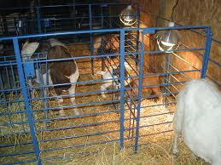

2017 Flagler County Fair & Youth
Show Pen Cleaning Guidelines

No foreign material such as hay, straw, sawdust, or plywood
Will be allowed in pens.

***NEW***HERDSMEN AWARD - Pens will be judged on the following:
      - Condition and Cleanliness of animal 15 Points
      - Daily care of animal (including feed/water) 15 Points
      - Attractiveness of pens 15 Points
      - Neatness and cleanliness of exhibitor 15 Points
      - Courtesy of herdsmen 10 Points
      - Cleanliness of stalls 10 Points
      - Cleanliness of aisles 10 Points
      - General Cooperation 10 Points

Final Pen Cleaning Requirements

All feed, manure, and any other material must be removed from the pens. All pens must be kept clean at all times.
All nametags, signs and ribbons must be removed and neatly disposed of.
All pens must be neatly raked and leveled out.
All feed buckets, brushes, shampoo bottles, etc must be removed from the pens and bathing areas.
If these criteria are not met by 6 p.m. Sunday, April 16, 2017 you will be charged $50.00 which will be taken out of your fair check.

2017 Flagler County Fair & Youth Show
Awards

Steer Awards

1. Grand Champion Trophy and $150.00
2. Reserve Grand Champion Trophy and $100.00
3. Showmanship – Junior, Intermediate & Senior Trophy and $100.00
4. Record Books – Junior Intermediate & Senior Trophy and $50.00
5. Individual animal awards 1st place – blue
Modified Danish System 2nd place – red
3rd place - white

Swine and Wether Awards
1. Grand Champion Trophy and Rosette and $100.00
2. Reserve Grand Champion Trophy and Rosette and $75.00
3. Showmanship – Junior, Intermediate & Senior Trophy and $75.00
4. Record Books – Junior, Intermediate & Senior Certificate and $50.00
5. Individual animal awards 1st place – blue and $20.00
Modified Danish System 2nd place – red and $15.00
3rd place – white and $10.00

Herdsman Award
1st. Place $75.00 2nd Place $50.00 3rd Place $25.00

Carcass Contest
Steer Champion Carcass – $250.00 Swine Champion Carcass –$250.00
Pullets
- All entries will receive participation ribbons
- Ribbons will be awarded in each age division – using Modified Danish System
- 1 Best of Show Rosette and $25.00 will be awarded
- Best of Breed Rosette
- Showmanship – Rosettes and $25.00 will be awarded in each age division – Ribbons for 1st, 2nd and 3rd Places.
- Record Book – Certificate and $25.00 for each age division winner

Rabbits
- All entries will receive participation ribbons.
- Ribbons will be awarded in each age division.
- Rosettes will be awarded in each Age Division for Best Rabbit. No rosettes will be given to Cloverbuds – they will receive participation ribbons.
- 1 Best of Show Rosette and $50.00 will be awarded.

Dorothy Wright Bullard Award
Cash Awards for each age division
1st Place - $50.00 2nd Place - $25.00 3rd Place - $10.00
2017 Exhibitor Agreement
FLAGLER COUNTY FAIR AND YOUTH SHOW

“2 hours of service rule”: In order for each exhibitor to show an animal, they must have completed at least two (2) hours of service towards the fair. These hours must be completed by Saturday April 1, 2017. If these hours are not completed by the deadline, the exhibitor will not be allowed to show or sell their animal(s). These hours will consist of such things as beautifying the Fairgrounds, painting signs, making copies, cleaning pens, clinics, etc. All exhibitors must check in and out at the Livestock Barn upon start and completion of their hours. The purpose of this is to share some of the responsibilities of the fair with you, the youth that the fair is held for. There will be a workday at the fairgrounds on Tuesday March 28 from 5 pm to 7 pm, Thursday March 30from 5 pm to 7 pm. Exhibitors that are unable to attend the workday MUST make alternative arrangements at least 2 WEEKS in advance. These times and dates may change.
Mandatory Meeting. Each exhibitor and a parent will be required to attend a mandatory Exhibitor meeting. You will have your choice of two dates in January 11th or 12th , 2017. (This meeting will not count towards your Service Hours.)
Pen Cleaning. Each exhibitor is required to maintain clean an attractive quarters at all times. At the close of the Fair exhibitors are responsible for the cleaning of their pen(s). The pen(s) should be left in the same condition that it was in at the start of the fair (or better). There will be a $50.00 fee deducted from the exhibitor’s sale or premium money if the pen is not cleaned properly by 6 p.m. Sunday, April 16, 2017. Your pen must meet approval by any member of the livestock committee. See “Pen Cleaning Guidelines” for specific requirements.
Record Book The exhibitor and his or her guardian(s) agree to forfeit and relinquish any and all monies generated from the sale of the exhibitor’s animal and participation in the Flagler County Fair, to the Flagler County Fair & Youth Show for the failure of the exhibitor to submit a completed record book by 4PM on Monday April 24th at 5:00 p.m. . A Mandatory Record Book Clinic is scheduled for February 7th at 6:00 and February 21st at 6:00 at the extension office. This clinic does not count towards you Service Hours.NO ALTERNATE CLINICS WILL BE HELD. PLEASE MAKE ARRANGEMENTS TO BE AT ONE THAT IS SCHEDULED.
MANDATORY DOROTHY WRIGHT BULLARD AWARD – All livestock exhibitors are required to participate in this award. You are required to enter into at least 3 or more of the exhibits in the Cattleman’s Hall (Horticulture, Home and Family, Shoe Box Float, Skillathon or Country Critter, Chapters showing animals are required to meet this requirement as well). If you do not meet this requirement you will not be permitted to show or sell your animal at the fair.
I have read and understand the above guidelines regarding the “2 hours of service”, the mandatory meetings, the clinics, the record book requirements, the pen cleaning fees and the Dorothy Wright Bullard Requirements.
Exhibitor Print Name:____________________________________________________ Signature:____________________________________________________________________
Parent or Guardian:_______________________________________ Date:______________________________________________
Livestock Entry Form
Flagler County Fair and Youth Show
Steers/Swine/Wethers
Date: ________________________
Name: _________________________________________________ DOB: _______ Gender: __________
Address: __________________________________________City/Zip: _____________________________
Phone: (_____)___________________ Email: _______________________________________________
Animal: Circle only ONE per entry form: Market Steer Market Swine Market Wether
School: _____________________________________ Member of: (circle one) 4H FFA

Club Name: _________________________________________________________________________

Circle one: Junior (8-10) Intermediate (11-13) Senior (14-18) As of Sept 1st , 2016

Parent Name: ____________________________________________ Phone: (_____)______________

Parent Email: ________________________________________________________________________

Parent Signature: ____________________________________________________________________

________________________________Office Use Only________________________________________

Breed: _______________________________________ Age/DOB of Animal: ______________________
Ear Tag # __________ Initial Weight: __________________
Deposit Paid: _____________ Date: _________ Cash/Check Check # __________ Initial _____
Remainder Paid: _____________ Date: _________ Cash/Check Check # __________ Initial _____
RELEASE FORM

For good and valuable consideration, including being permitted to participate in activities on the fairgrounds and participate in the Flagler County Fair and Youth Show, I, for myself, and if applicable for my minor child, my and his or her successors, heirs, assigns, executors, administrators, legal representatives, employees, agents and affiliates (collectively referred to as Exhibitor) forever release and discharge the Flagler County Fair and Youth Show, Inc. and each of its officers, trustees, directors, employees, agents, and affiliates (collectively referred to as Flagler County Fair) from all claims, demands, losses, costs, expenses (including attorneys’ fees and costs), suits, damages, obligations, liabilities, causes of action and judgments whatsoever, in law or in equity, against any of the foregoing, which the Exhibitor ever had, now has or which they hereinafter can, shall or may have for, upon, or by reason of any matter, cause or thing whatsoever including, without limitation, personal injury or death, damage or destruction to property, or theft or other loss to property, arising out of Exhibitor’s participation and involvement in the Flagler County Fair and Youth Show, the Flagler County Fair, or any other event held at the fairgrounds. Exhibitor agrees to and does hereby assume any and all risks of personal injuries to Exhibitor, including death, and damages or other loss to Exhibitor’s property, whether such injury, death or loss of property is caused by negligence of the Flagler County Fair or not. From time to time, photos will be taken of exhibitors and thei activities, etc. The fair reserves the right to use these photos for news releases, the fair website, fair related videos and slide presentations, marketing purposes, etc.
The fair will allow members of the media to take pictures of exhibitors and events for publication. At times, AT THE DISCRETION OF THE FAIR. Photographer’s will take photos for resale and make them available to
Exhibitors’ and parents. The fair feels that these are legitimate opportunities for the exhibitors to be in the “limelight” and promote the fair.
ALL PREMIUM AND ADD ON CHECKS MUST BE CASHED AND/OR DEPOSITED NO LATER THAN 30 DAYS AFTER AWARDED TO EXHIBITOR. IF NOT CASHED, A STOP PAYMENT WILL BE INITIATED AND EXHIBITOR RELINQUISHES ALL RIGHTS TO PROCEEDS.
THE EXHIBITOR, OR HIS OR HER GUARDIAN IS OVER THE AGE OF EIGHTEEN (18) YEARS, HAS READ THE FOREGOING RELEASE AND INDEMNIFICATION AND HAS HAD THE OPPORTUNITY TO SEEK LEGAL ADVISE REGARDING INTERPRETATION, AND HAS SIGNED FREELY AND VOLUNTARILY.

I have also read and will comply by all of the rules and regulations as imposed by the Flagler County Fair and Youth Show.

Parent/Guardian: ___________________________________ Date: _____________
Exhibitor: __________________________________________ Date: _____________
Parent Email Address:__________________________________________________
Exhibitor Email Address:______________________________________________
EXHIBITOR SERVICE HOUR LOG SHEET
Complete and submit by 6pm April 4th

Exhibitor Name:____________________________Address:_________________________________________________

Phone Number:___________________________EmailAddress:_____________________________________

Divisions:_____Steer ______Hog_____Lamb_____Goats____Pullets_____Rabbbits

Parent/Guardian Name:_______________________________________________________________________

- Exhibitors will be responsible for maintaining a Fair Service Hour and Dorothy Wright Bullard Award Log.
- Each time you participate in an approved activity you are to log in the time spent and have the entry initialed by a Fair Board Member supervising the activity.
- If you lose your log sheet you will have to start over.
- Service hours must be completed prior to the start of the fair. April 4th 2017.
- You are also required to have this form completed and signed by Superintendent of the divisions you have entered your Dorothy Wright Bullard Requirements in. (Horticulture, Home and Family Division, Show Box Float, Country Critter)

Date:________________Time In:___________Time Out:_____________ Activities:_______________________________

Fair Board Signature:________________________________________________________

Date:________________Time In:___________Time Out:_____________ Activities:_______________________________

Fair Board Signature:________________________________________________________

Date:________________Time In:___________Time Out:_____________ Activities:_______________________________

Fair Board Signature:________________________________________________________

Horticulture ________________________ Home & Family _______________________________
Shoe Box Float _____________________ Country Critter _______________________________
Skillathon____________________________________

Flagler County 4-H Youth Development Program
Exhibitor Requirement Record
As of September 1, 2008 all Flagler County 4-H members will adhere to the following policies:
The Flagler County Fair Board states that in order to show an animal in the Flagler County Fair & Youth Show, you must be enrolled in the Flagler County 4-H Youth Development Program by October 1st and be a member in good standing as related to the policies stated below.
In order to show a market animal in the Flagler County Fair & Youth Show, 4-H members must attend at least 5 club meetings. In the event that a 4-H member needs a make up opportunity, an alternate activity may be assigned to you by your organizational club leader. This may include: a community service activity, an extra club responsibility, or a public speaking event. You are allowed one makeup. It is your responsibility to communicate in a timely manner (within one week) with your leader if you miss a meeting to discuss how you can make it up. And it is each member’s responsibility to ensure they have met these requirements.
If 4-H members are enrolled as an independent member, they must meet with the 4-H Agent 5 times before the fair. In the absence of a 4-H Agent, independent members must meet with the Livestock Agent. Clubs meet monthly and so independent members must also meet monthly. If you are enrolled as an independent member, you will need to meet with the agent at least once per month at the Extension Office beginning September and ending in March. Independent members must obtain the 4-H Project Book that relates to their chosen project. The project books available are: Beef, Cattle, Meat Goat, Poultry, , and Swine. You must obtain your books from the 4-H office in September, complete one activity per month and discuss what you have learned during your monthly agent meeting. You must also have the agent sign off on your progress using this sheet. Independent members do not have the opportunity for alternate activities as make ups.
If you fail to meet these requirements, you will be denied the opportunity to show your animal in the fair. This form is due to the Fair Board by April 1, 2017
Exhibitor Requirement Record

Monthly 4-H Club or Agent Meeting | Date of Meeting or  Alternate Activity Completed | Leader or Agent Initials | Date
Meeting 1
Meeting 2
Meeting 3
Meeting 4
Meeting 5
Alternate Activity
I agree that all requirements have been met.
Exhibitor: ________________________________________________ Date: ____________

Parent: __________________________________________________ Date: ____________

Leader/Agent: ____________________________________________ Date: ____________

IMPORTANT 201-2017 DATES TO REMEMBER
September 30th, 2016 | Entry deadlines for Pullets and Rabbits
Saturday, October 29, 2016 | 9 am. Pick up pullets and Pullet Clinic to be attended by family member at Bunnell Feed and Supply
Saturday, October 03, 2016 | $75.00 deposit due for Swine
Thursday, November 03, 2016 | Steer Weigh In 3 pm to 6 pm
Monday, December 05, 2016 | Entry Deadline for Wethers
To Be Determined | 9:00 Preview and 10:00 selection of swine. Selection will be held at the FFA barn on CR 13
Wednesday, January 04, 2017 | Official Certification of Veterinary Inspection (OCVI) see applicable rules
January 11th and 12th, 2017 | Mandatory Exhibitor Meeting 6:30 pm on each night you must attend one meeting
February 7th and 21st , 2017 | Mandatory Record Book Clinic 6 PM each night - Extension Office. WE WILL NOT HOLD ANY OTHER MAKE UP CLINICS. YOU MUST ATTEND ONE OF THESE SCHEDULED CLINICS
Friday, February 17, 2017 | Prospective Buyers List Due to Fairboard
March 28 and 30th , 2017 | Fair Workday 5 to 7 at Fairgrounds
Saturday, April 01, 2017 | All pullets, rabbits and chickens must be turned in from 9 to 10
Saturday , April 01, 2017 | Pullet show begins at 12 pm and rabbit show to follow
April 2 & 3rd , 2017 | All Dorothy Wright Bullard entries must be turned in Sunday 12-4 and Monday 1-6 pm
Tuesday April 4, 2017 | Steers, Wethers, Swine turn in 3 to 6 pm
Wednesday April 5, 2017 | 7:00 Shows: Wethers and Steers
Thursday , April 06, 2017 | 7:00 Show: Swine
Friday, April 07, 2017 | 6:00 Exhibitor Meeting in barn
Friday, April 07, 2017 | 6:30 Opening Ceremonies
Friday, April 07, 2017 | 7:00 Pullet, Rabbit and Livestock Sale Begins
Sunday, April 09, 2017 | Removal of all animals after 6 PM
Monday April 10th, 2017 | All Entries in Cattleman’s Hall must be picked up 1-6 pm
Sunday April 16, 2017  April 24th, 2017 | All pens must be cleaned by end of day  Record Books Due by 5 PM

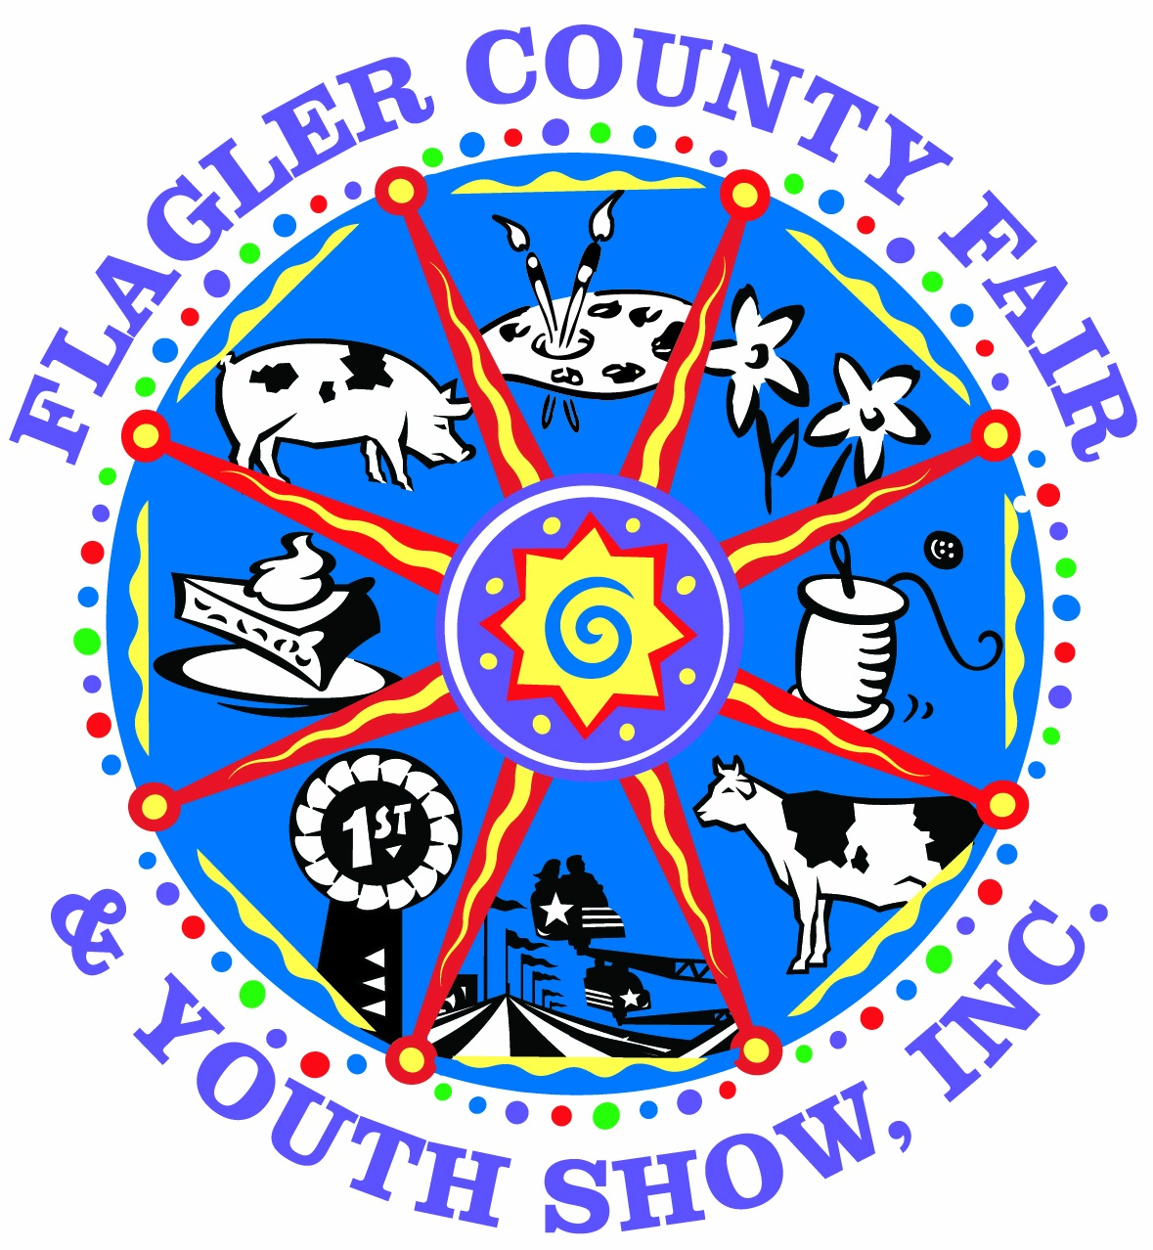

IF YOU NEED ANY ADDITONAL INFORMATION YOU CAN CONTACT ONE OF OUR OFFICERS OR DIRECTORS

Walton Cowart, President 386-931-5384
Penny Buckles, Vice President and Fair Manager 386-931-6597
Jeanette Jones, Secretary 386-931-9013
Kris Simmons, Treasurer
Mike Boyd, Board Member and Livestock Superintendent 386-503-4134
Dan Cody, Board Member and Barn Superintendent 386-503-5335

Flagler County Fair and Youth Show, Inc.
P.O. Box 517
Bunnell, Fl. 32110
Office 386-437-2551
Fax 386-437-8444
Email: flaglerctyfair@bellsouth.net Website: www.flaglercountyfair.com

