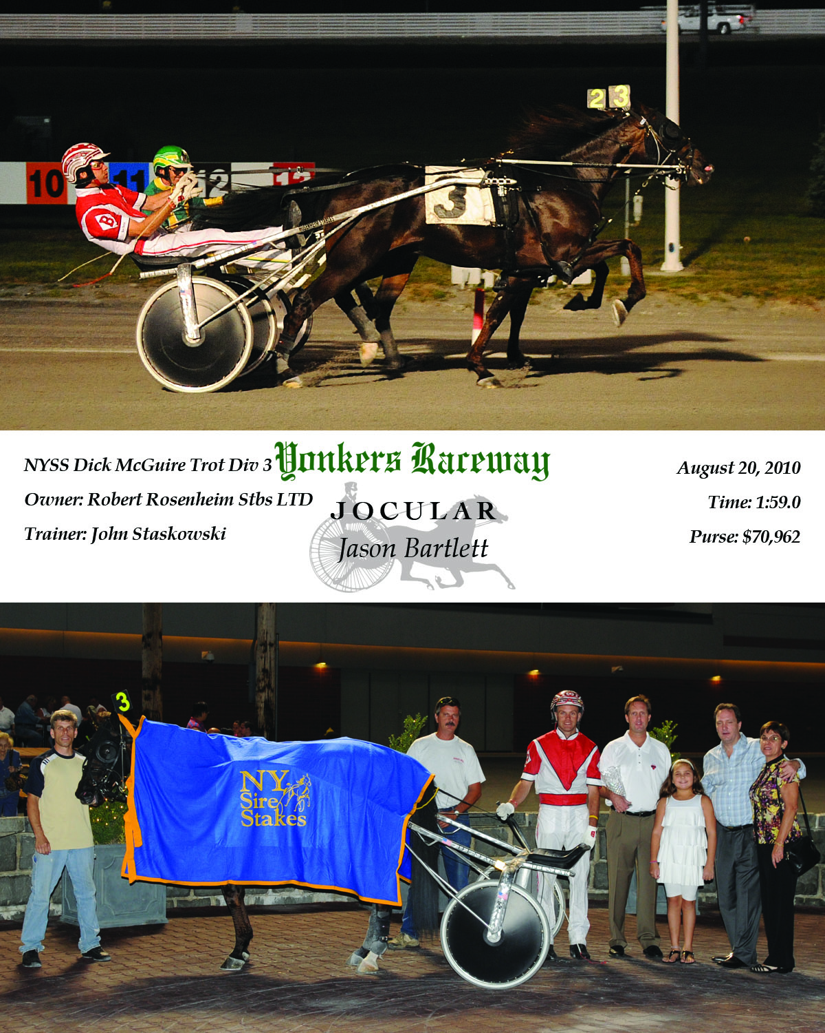
The Third Annual Dick McGuire Trot Tonight at Yonkers Raceway…
REMEMBERING KNICKS GREAT, BASKETBALL HALL OF FAMER DICK MCGUIRE: HE LOVED HORSIN’ AROUND
BY JOHN CIRILLO
What a way to extend the summer! This year’s Dick McGuire Trot falls on the day after Labor Day, so we get an extra cherry on top of the summer sundae for delightful fun as we pay tribute to “Dick the Knick.” It is difficult to fathom that this evening’s McGuire Trot at Empire City Casino at Yonkers Raceway moves into a third rendition after its inaugural spin in 2010. So, we gather with the McGuire family and friends to share a lifetime of memories, and create some more. Let the good times roll in the Empire Terrace for the third annual McGuire Trot for N.Y.S.S. three-year-old colts and geldings.
Dickie always got a kick out of a day or night at the races, but a stakes race in his name being worth $250,000-plus, now that would have him shaking his head – perhaps even muttering to himself – for sure. He was an ardent $2 punter, and his wife Teri laughs that he “broke even” every time after countless trips to racing establishments across the country in between scouting players.
Thanks to raceway President Timothy J. Rooney and VP/COO Bob Galterio, the McGuire Trot is a fixture on the Yonkers summer stakes calendar, and all who loved him have another chance to honor Dick his favorite turf – the racetrack.
Said Rooney: “We are truly delighted and privileged to honor one of New York’s greatest sportsmen, and an avid racing fan, with the third annual Dick McGuire Trot. Yonkers Raceway looks forward to hosting the event for many years to come, and to having his family, friends and many fans at our historic track during the height of our summer stakes season.”

The gang’s all here, Dick’s wife Teri, daughter Leslie, sons Michael, Scotty and Richard, a gaggle of grandkids, the horde of more family and friends including, Freddie and Teri Klein.
The planets had to have been aligned when my path crossed with Dick McGuire, two gents who loved the Knicks and got to work for them, and devout horseplayers who got to spend some time at the art of picking winners. What a great ride from the Knicks championship ride in 1994 under Pat Riley to his number being hoisted to the Garden rafters to enshrinement into the Naismith Basketball Hall of Fame, with stops at Roosevelt and Yonkers Raceways, Belmont and Philly Parks and the Meadowlands sprinkled in along the way.
Dick McGuire, a Bronx native, Rockaway product, and longtime Dix Hills, Long Island resident, was a cornerstone of the Knicks franchise, and those of us who were able to serve as masons and add a brick or two over the years, with the smiling Irishman Dick McGuire at our side, are forever grateful for those experiences.
You’ve heard the stories, but let’s relive them tonight.
Believe it or not, I first met Dick McGuire right here at Yonkers Raceway in the early eighties. We invited him to judge the “Mad Hatter’s Ball,” a best hat competition. Somehow, as the raceway’s young publicist, I had unearthed the fact that Dick was a horseplayer. He was a gracious and engaging guest.
Little did I know that just a few years later, I would become the Knicks public relations director and have a chance to see and work with the great Knick, “Dick the Knick,” on a daily basis.
I was wowed and amazed at the speed and quickness of the NBA players, sitting courtside for the first time at a pre-season game at the Garden, and at that very moment, made a promise to myself that I wouldn’t go onto the court after a practice or before a game, and make a complete fool of myself. Respect their domain, Cirillo, I told myself, and held true to that promise for years. One day, I couldn’t resist. I broke the vow.
Standing on the court at the College of Charleston, gabbing with Dick McGuire, and my public relations assistant Dennis D’Agostino. We talked about the new horizons for the Knicks in the first year under Pat Riley. As we talked, Dickie was twirling a basketball on the tip of his finger, then started bouncing the ball, then switching hands as the dribble quickened.
Suddenly, he mumbled: “Let’s play two on one.” This was 25 years ago, so he was 60, me 30. It was the PR duo against the Legend. Oh, no! Oh, yes! On the first play, Dickie came at us slowly, made one quick move, and with a head fake left us in the dust to score. Two zip, McGuire. Next, possession, Dickie dribbles behind the back, and blows past us for a reverse layup. I did a double take and said: “Hey, Dickie, let’s get the heck out of here, it’s time to take the writers out for dinner.” Though I had seen many highlight reels, it was a first-hand glimpse of the amazing skills he must have had in his heyday, because there was still plenty left despite three decades that had passed since he hung up the sneakers.
Here’s a typical conversation with a waitress at any track restaurants over lunch or dinner: (imagine Dickie’s rapid-fire delivery):

Dickie: “How’sTheSoupMiss.”
Waitress: “The soup is very good.”
Dickie: “TheSoup’sVeryGoodThenI’llHaveTheSoupMiss.”
Dickie: “How’sTheSteakMiss.”
Waitress: “The steak is our special today.”
Dickie: “ThenI’llHaveASteakMiss.

Not sure exactly why, but Dickie calling a waitress or stewardess “miss” always brought a huge smile to my face. It was a moniker out of a bygone era, so respectful, so endearing. I think Dickie was the only one left on the planet who used it, and I loved listening to him place his dinner order as much as I did going to the races or playing cards in his company.

At times I am a pretty good handicapper, so once in a while I’d reel off three winning picks in a row, with Dickie often riding my bandwagon. He was absolutely joyful on those occasions, saying with clear diction (I know, it’s hard to believe): “John, you are an excellent handicapper.” Then, he’d stroke the back of my head three or four times, as if I were a puppy dog that had learned a new trick. That feels like yesterday, it was very cool, and I still smile harkening back when the good times rolled.

At the Charleston camps or on playoff road trips, the evenings would likely end with a friendly card game with a group that often included community relations director Cal Ramsey, longtime scout, the late Fuzzy Levane, and, of course, Dickie. We’d play for nickels, dimes and quarters, not high stakes, and what a time we had listening to the war stories of the NBA’s early years, brother Al, St. John’s and the Rockaways. My favorite card game was the time we used the vegetable crudite – cucumber, zucchini, yellow squash and carrot slices – as chips of varying denomination. It sure was a scene out of a movie.

How lucky could a kid from Brooklyn be? Dickie taught me the nuances of basketball, and that makes watching a game so much more fun. I still think I have a better understanding of the game than most, and have Dick McGuire to thank for my self-proclaimed expertise. Hey, a little bit had to rub off on me.

John Cirillo was Knicks director of communications and vice president of public relations from 1984-97. Also a former public relations director at Yonkers Raceway, and now the president of Cirillo World publicrelations in New York City, he was proud and privileged to call Dick McGuire “friend.”

