REGULAR MEETING
AUGUST 17, 2023

The Regular Meeting of the Town Board of the Town of Hampton, County of Washington and the State of New York was held at the Town Hall, 2629 State Route 22A, Hampton, New York, on the 17th day of August, 2023.

PRESENT: David K. O’Brien------------Supervisor
Donald Sady----------------- Councilman
Tamme Taran----------------Councilwoman - absent
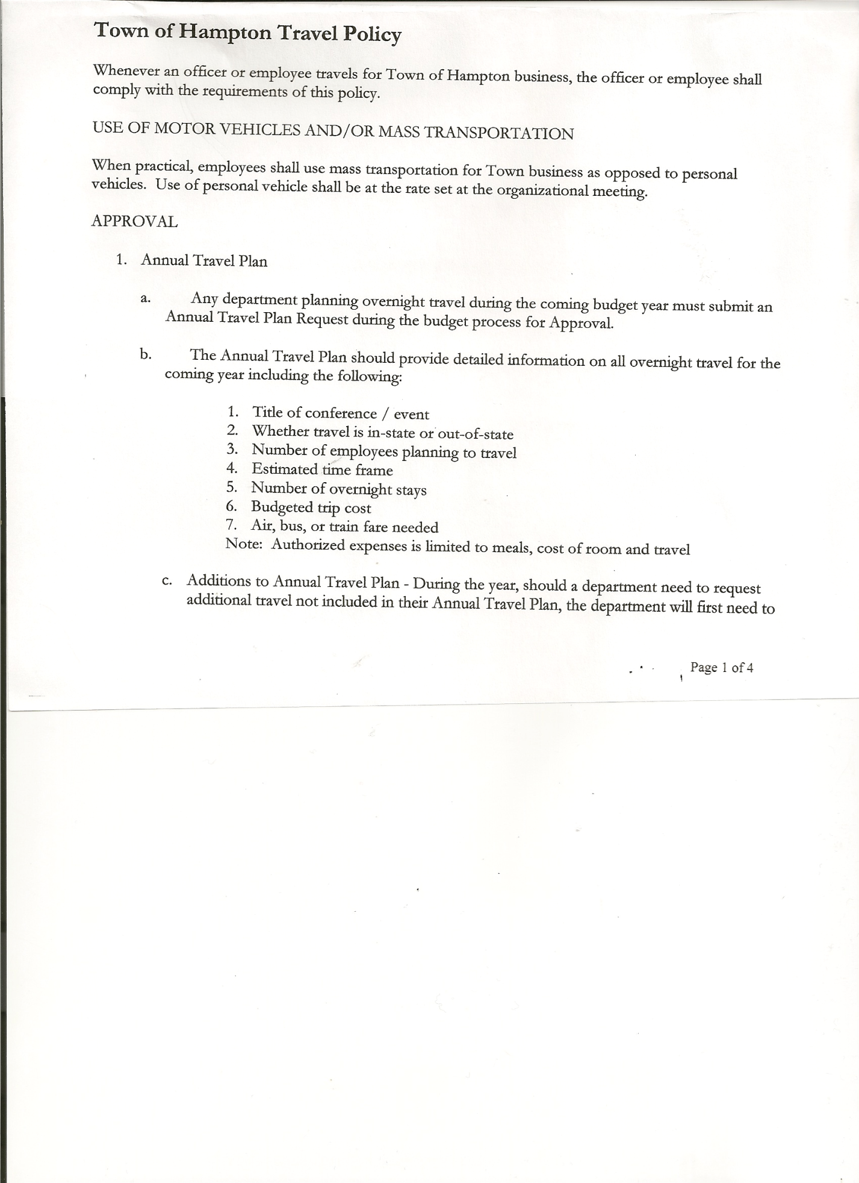
Michael Pietryka------------Councilman
Andrea Kugler---------------Councilwoman - absent
Rebecca Jones---------------Town Clerk
Camilla Shaw----------------Deputy Town Clerk
Tyler McClure---------------Highway Superintendent - absent

Planning Board Member (s):… Bonnie Hawley, Chair; Richard Cole, Matthew Pratt and Rene Rountree
Others present at the Town Hall: see attached sheet

The Regular Meeting was called to order by Supervisor O’Brien at 7:30pm, followed by the Pledge of Allegiance. Location of Fire Exits were given. Quorum of board members present.

Supervisor O’Brien asked for a moment of silence in memory of Matthew Thomas’ dad.

RESOLUTION NO. 67-2023
APPROVAL OF THE MINUTES
On a motion of Councilman Sady, seconded by Councilman Pietryka, the following resolution was ADOPTED: AYES 3 O’Brien, Sady, Pietryka
NAYS 0
ABSENT 2 Taran, Kugler
RESOLVED, that the Regular Town Board Meeting Minutes for July 20, 2023 are approved.

Dog Control Officer, Rachel Brown was not present, but submitted her report from April to August 2023 (copy is attached).

Tax Collector Report…..no activity. The Town Clerk/Collector had Board Members review and sign bank reconciliation statements for the Tax Collector Account July 31, 2023.

Bonnie Hawley, Chair Planning Board…copy of the minutes of their meeting held August 16, 2023 are attached.

Tyler McClure, Highway Superintendent submitted his report, copy of which, is attached.
Job search for Highway Employee…Tyler will be interviewing an applicant, who is a Hampton resident.

TOWN BOARD MEETING
AUGUST 17, 2023 PAGE 2

SUPERVISOR’S REPORT/COUNTY UPDATES/COMMUNICATIONS

RESOLUTION NO. 68-2023
APPROVAL OF SUPERVISOR’S MONTHLY REPORT
On a motion of Councilman Pietryka, seconded by Councilman Sady, the following resolution was ADOPTED: AYES 3 O’Brien, Sady, Pietryka
NAYS 0
ABSENT 2 Taran, Kugler
RESOLVED that, the Supervisor’s Monthly report be accepted as submitted for JULY
06/30/23 07/31/23
ACCOUNT BALANCE RECEIPTS DISBURSEMENTS BALANCE
General Fund $ 71,396.84 $ 7,513.17 $ 7,588.06 $ 71,321.95
Highway Fund $219,790.45 $ 5.50 $ 18,009.55 $ 201,786.40
Equipment Reserve$149,976.52 $ 3.82 $ 0.00 $ 149,980.34
Fire #1 $ 23,185.50 $ 0.00 $ 0.00 $ 23,185.50
Fire #2 $ 7,680.50 $ 0.00 $ 0.00 $ 7,680.50
Cemetery $ 2,022.38 $ .89 $ 0.00 $ 2,023.27
Totals $474,052.19 $ 7,523.38 $ 25,597.61 $ 455,977.96
All Board Members present signed Supervisor’s Report.

NEW BUSINESS

2024 Budget Sheets handed out…..back to Supervisor by September 1st

Health Insurance information handed out to Board members…cost is going up $80.00 starting in December. Information on Vision and Dental, board members to consider offering to employees.

Rene Rountree, Planning Board member discussed having a Market Day/Community Day here in Hampton.
Following the above discussion, the following resolution was introduced:
RESOLUTION NO. 69-2023
MARKET DAY @ THE TOWN HALL
On a motion of Councilman Sady, seconded by Councilman Pietryka, the following resolution was ADOPTED: AYES 3 O’Brien, Sady, Pietryka
NAYS 0
ABSENT 2 Taran, Kugler
RESOLVED, to hold a Market Day at the Hampton Town Hall (outside) this fall, date to be determined.

PUBLIC COMMENTS/COUNCIL COMMENTS
Richard Cole….speeding on the South Road and other roads is increasing. Supervisor O’Brien to ask the Sheriff’s Department for more patrols.

Supervisor O’Brien shared photos of the claim of damages on the Tractor rental, insurance paid $3600.00, town paid $1000.00 deductible. In the future, photos should be taken when equipment is delivered and just prior to being picked up.

TOWN BOARD MEETING
AUGUST 17, 2023 PAGE 3

RESOLUTION NO. 70-2023
AUDIT OF CLAIMS
On a motion of Councilman Sady, seconded by Councilman Pietryka, the following resolution was ADOPTED: AYES 3 O’Brien, Sady, Pietryka
NAYS 0
ABSENT 2 Taran, Kugler
RESOLVED that the bills have been reviewed by the Town Board and are authorized for payment in the following amounts.
General Fund No.93 through No. 99 $ 31,899.86
Highway Fund No.74 through No. 85 $ 15,711.92
Total both funds $ 47,611.78

The Town Clerk’s report for July 2023 was submitted to the Board. The Town Clerk had Board Members review and sign bank reconciliation statements for the Town Clerk Account and Special Clerk Account dated July 31st, 2023.

RESOLUTION NO. 71-2023
MEETING ADJOURNED
On a motion of Supervisor O’Brien, seconded by Councilman Sady, the following resolution was ADOPTED: AYES 3 O’Brien, Sady, Pietryka
NAYS 0
ABSENT 2 Taran, Kugler
RESOLVED that the meeting adjourned at 8:33pm.

Respectfully submitted,

Rebecca S. Jones, RMC
Town Clerk

