Archetypes
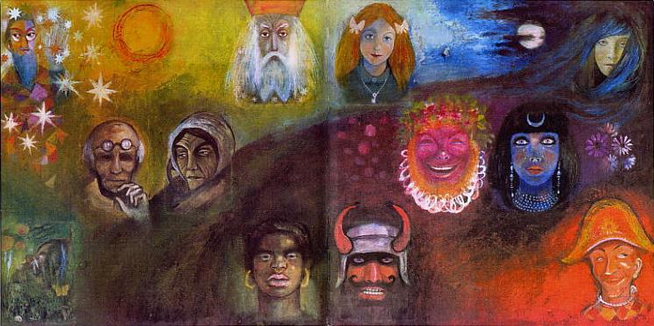
An archetype is an idealized model of a person, personality or behavior (e.g. Hero, soldier or martyr). They can be viewed as inner blueprints for being and doing that we access in the course of our actions and interactions.
Shadow Work® utilizes the four archetypes outlined by Robert Moore and Douglass Gillette in the book King Lover Warrior Magician. For the purpose of gender neutrality, the king archetype is referred to as the sovereign archetype.
All four archetypes make up our personalities and are involved in our functioning; however, each person has a high and a low archetype. This means that, on average, there is a particular archetypal energy we tend to operate from more than the others. Our low archetype is the one we express least in our lives.
It should be noted that context often dictates which archetypal energy we access. Although an individual’s “warrior energy” may be low typically, certain circumstances may provoke its expression. Certain roles may also compel us to operate from an archetype that is not our primary mode of functioning. One of the benefits of Shadow Work® coaching is its potential to help bring balance, and choice, with regards to our expression of these energies.
Below is a more detailed explanation of how the archetypes are conceptualized in the Shadow Work® model:

Lover
We access this archetypal energy when we allow ourselves to rely on the support and assistance of others. The lover archetype is present when we are at play and during creative endeavors. It is primarily about our connection to others and ourselves.

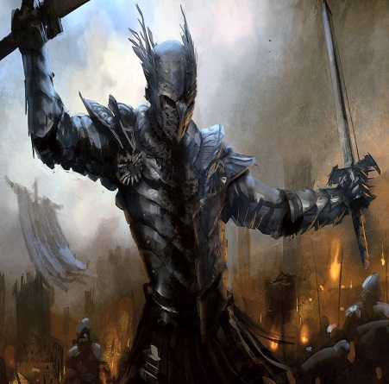
Warrior
We access the warrior archetype to set and maintain boundaries; to protect our territory- the territory of ourselves and our possessions. We utilize the warrior archetype to stay focused and get things done. This archetype also helps us to define who we are as a unique and separate individuals in relation to others.

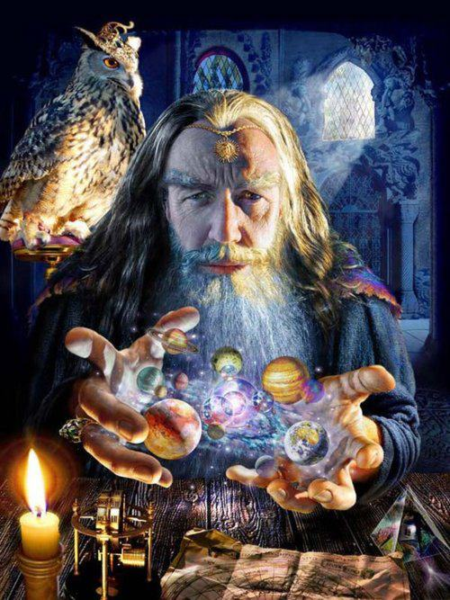
Magician
The magician archetype helps us to gain clarity, perspective, and discernment. We access magician energy when problem solving or seeking to resolve an issue or dilemma. The magician archetype is associated with our thinking and reasoning functions.

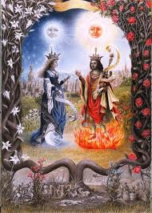
Sovereign
Sovereign archetypal energy is accessed when we assume positions of authority or leadership; whether leading others or simply ourselves. This archetype is implicated in our desire to identify and manifest a vision or live with meaning and purpose. We access the sovereign archetype when assuming a mentoring or caretaking role or in the fostering of another human being in some way.

