Winter Holiday Wreath Order Form
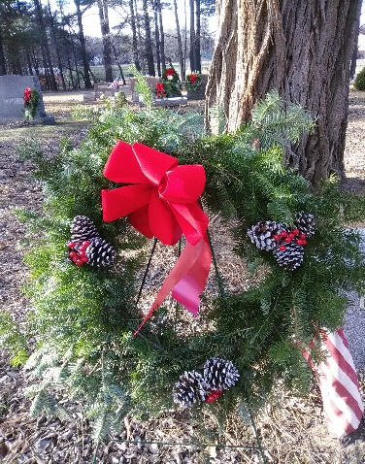
Bethlehem Cemetery Association
PO Box 456
Glenmont, NY 12077
518-439-2394

Purchaser:
Address:
City: State: Zip:
Phone:
Email:

Name of Loved One(s) Section & Lot Number

Quantity @ $45 each = $

If you would like to donate a wreath to decorate a lot in our highly visible historic section, please indicate here: Quantity @ $45 each = $

Please return this form with your check or money order payable to Bethlehem Cemetery Association at the address above by December 1.

For Office Use Only
Ck # Rcvd

