Top 10 Vision Therapy Techniques for the Primary Care Optometrist

After performing a comprehensive optometric exam, the next step is to form an appropriate assessment and plan. Myopia? Spectacles. Presbyopia? Reading glasses. Diabetic retinopathy? Refer. Prescribing refractive correction and making the appropriate referrals are major treatment options for the primary care optometrist and the diagnoses they most frequently encounter, but some patient’s symptoms cannot be resolved as easily. Those with binocular vision or ocular motility disorders may be best treated with vision therapy, yet providing this type of care is seemingly harder to recommend. However, a wide range of therapy techniques can be prescribed just as easily as contacts or glasses, and or in addition to stress relieving, developmental, therapeutic glasses,, and should therefore be embraced as viable tool in the primary care optometrists’ toolbox.

Disclaimer: The following list has been compiled in an educational endeavor to widen my personal scope of practice. Most techniques outlined below are not my own ideas, but have been taught to me at the Illinois College of Optometry and refined over the last 7 weeks by Dr. Randy Schulman, Dr. Narvan Bakhtiari, and Ms. Debra Murray. It is not intended to replace knowledge, facts, and/or experience should it be read by anyone else. And I got my ideas from Harris, Shankman, Gruning, Shaby, Byne, Swartout, Forkiotis, Shapiro among others…

10. A Modified Exam
Investigating your patient’s complaint may require additional testing not in the typical battery of tests. Joined with their complaint, symptoms, and test results, it may be possible to diagnose an oculomotor, binocular, or accommodative disorder, and the proper treatment can be started. Consider evaluating the following areas in addition to an objective measure of phoria, such as a cover test, and test of stereopsis.
- Fixation/Pursuits/Saccades
- Near Point of Convergence
- Accommodative Flipper Facility
- Prism Flipper Facility
- In-phoropter phorias and vergences
- Prism bar vergences
- Near retinoscopy
- Fused Crossed Cylinder
- Visual-Motor/Visual-Spatial activity
Some data can also be extrapolated from more standard testing. For example, it is possible to evaluate pursuits while checking EOMs and vice versa. Performing these tests on patients with binocular vision issues, young children, and those with traumatic brain injuries may determine their areas of deficiency and a treatment plan can begin to take shape.

9. Eye Movement Activities
If your evaluation of fixation, pursuits, and/or saccades or uncovers poor tracking skills or poor motility, consider the following exercises for the patient to practice at home. Since accurate and efficient saccades and pursuits are required for reading and comprehension, these activities can be recommended to those who lose their place while reading or skip lines, have poor comprehension, or have slow reading times. Test choice should be made based on age and abilities. Have the patient patch one eye and perform the exercise with the unpatched eye.
- Following a Moving Ball (on a string, in a pie tin)
- 4 Corners, Column Jumping, Wall Saccades
- Michigan Tracking, Alphabet Saccades, X’s and O’s,
- Mazes
- Word Search

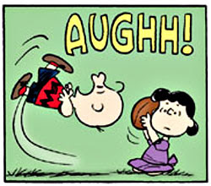
8. Visual Integration Activities
This section of vision therapy exercises would likely be the least used in primary care, but may come in handy for the right case. Patients that have trouble integrating their visual system with their other senses may require more attention and treatment than home-based exercises. Such patients may have an autism-spectrum disorder or other developmental delay, traumatic brain injury, or stroke. However, these exercises may benefit those who desire to improve their coordination or memory or even to add variation to other vision therapy tasks.
- Visual Motor: RALA, Arrow Charts, PDBQ, Slap Tap,
- Visual Spatial: Block Building
- Visual Memory: Pattern Copying, Find the Difference

7. Near/Far Activities
Shifting the focusing system between near and far targets is an incredibly practical skill. Examples are copying from the board at school and looking from the road to the dashboard while driving. With this in mind, it is easy to see that accommodative flexibility is important to a wide range of patients. These activities can simultaneously work on tracking and eye movement skills.
- Near Far Chart
- Hart Chart 100
- Calendar Rock
- Phonetic Focus

6. Red/Green Overlays & Red Green Glasses
Anything can be made into a red/green activity with the addition of red/green overlays and then viewed through red/green glasses. This modification can be useful for patients with strabismus or diplopia and can increase the patient’s awareness of their condition. It can also be used to increase the difficulty of +/- or BI/BO flippers. Consider taping the overlays to a TV or tablet.
- Box of 6 Red/Green Glasses | Bernell | $
- Cellophane Overlays | Deb says ask April | $ can get from bernell too
- Red/Green Bar Reader | Bernell | $
Probably should have a disclaimer on strab/ambly to refer to a specialist in VT to work on…
5. Patching
Patching is useful for treating amblyopia and is simple to prescribe. It is also a good idea to have a supply of patches on hand to distribute to those who need to perform activities monocularly.
- Box of 12 Eyepatches | Bernell | $

Again may want to have some guideline for patching at home with active engagement. Can recommend amblyiNet and other computer programs for binoc/processing cases.
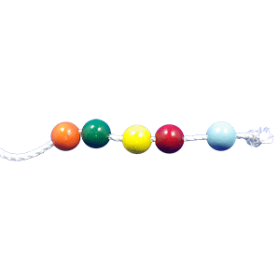
4. Brock String, Eccentric Circles, and Lifesaver Cards
These activities can help those who struggle with convergence or divergence. All three are extremely valuable for primary care as routine patients may present with signs or symptoms of vergences disorders. Additionally, they may provide an alternative to wearing lenses or prism.
          - Brock String | Bernell | $
          - Eccentric Circles | Bernell | $
          - Livesaver Cards | Bernell | $

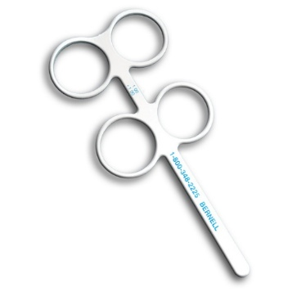
3. Flippers
Flippers are available in both +/- as well as BI/BO and therefore can be used for both accommodative and vergence dysfunctions. Consider keeping a thorough range of powers on hand and increasing at a subsequent visit. Make sure able to clear and see singly on both sides before increasing.
- +/- Flippers | Bernell | $
- BI/BO Flippers | Bernell | $

2. Lenses and/or Prisms
If any signs or symptoms of binocular or accommodative issues are apparent, glasses with lenses and/or prisms can be prescribed for relief. Remember that vision is more than acuity.

1. Refer…

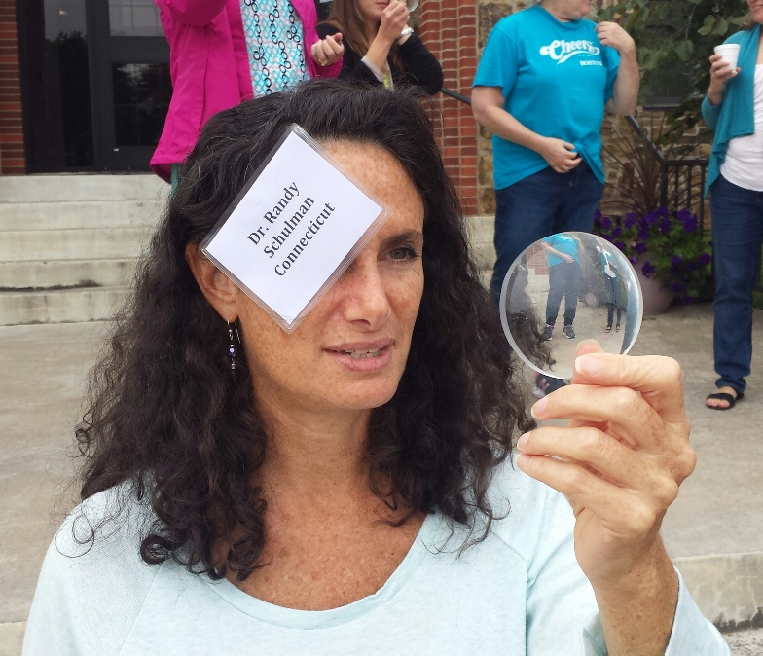

HAHA

If you assigned homework only but still did a weekly office visit, how would you bill it? Can you bill orthoptics without a vision therapy practice? Some sort of registration as place that offers therapy?
Yes to all of the above. Better to bill as office visit and vision therapy. Join oepf.org and covd.org or contact vision3d.com to become a member and get referrals.
Really great overall. Be good to include a checklist of signs and symptoms in each of these areas.

