Seventh Annual Fullerton Schools
Community Jogathon
Official Sponsor Form
November 3rd 2018 at Fullerton HS
Benefitting local Fullerton School Clubs and Ending Polio in the World

Why Sponsor?
The Rotary Club of Fullerton is proud to announce our 8th annual Jog-A-Thon dedicated to Promoting Literacy and Assisting Local Youth in Need at our Fullerton Schools and to support the welfare of local youth clubs. By becoming a sponsor, you and your company will:
- Two Events for the price of one - Connect with over 1500 local Fullerton students, faculty and families at the Jogathon plus 1000+ participants in this year’s Fullerton 5K Pumpkin run that concludes at the FUHS Stadium the morning of our JATVI.

- Ensure that our local students have the support they need to continue extracurricular activities, such as athletics and the arts, and promoting literacy and assisting youth in need at our local schools.

Schedule of Events:
7:00 am – Pumpkin Run 5K starts to raise money for reading assistance for underprivileged Fullerton Students
8:30 am – Pumpkin Run awards and fun at Fullerton Joint Union Stadium
9:00 am – Jogathon Begins at Fullerton Joint Union Stadium.
Sponsor Levels | Silver $250 | Gold $500 | Platinum $750 | Titanium  $1500 | Diamond  $2500
Business Shown in Event Program
Logo listed on Website
10 x 10 Booth Space at Event
Name (no logo) on event T-shirt
Logo Displayed on event Banner
Logo on all Print Material
Logo on event T-shirt
Logo/Name recognition on Social Media
Recognized as premier sponsor on website and event promotional materials
Live verbal promotion during event
10 Complimentary 5K runner entries
Company Banner displayed on main stage
----------------------------------------------------------------------------------------------------------------------------------------------------------------
Registration Form
Business Name:____________________ Contact Name:_____________________ Contact Email:_______________
Address: ________________________________________ Phone Number:_____________________
School Club to Benefit:______________________ Amount:______________ Payment Method: __________________________

Return this form with check or Credit Card info to:
The Fullerton Rotary C\O Susan Ellis
2941 E Miraloma Ave, Suite #3 Anaheim, CA 92806
Note: Make checks payable to the Fullerton Rotary Foundation. The FRT is a registered 501c(3) non profit. Tax ID #33-0506574

For more info go to WWW.ROTARYJOGATHON.COM or contact Susan Ellis at susan@assuredav.com Ph# 714-535-1414
Fullerton Rotary is on the Cusp of Making History!

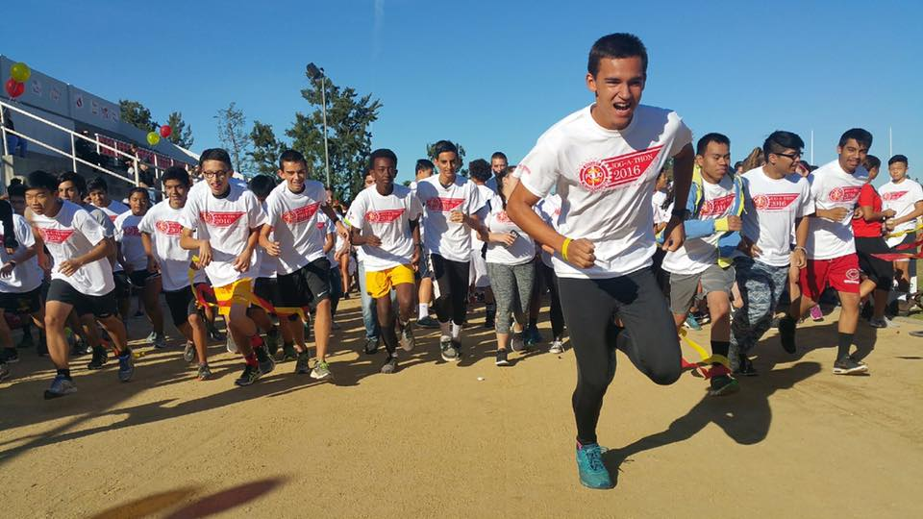

With only 9 cases reported so far in 2017 we have a chance to really seal the deal on Polio this year.
Last year our clubs 15K effort resulted in 112K going towards ending polio. Here is the math:
$15K Fullerton Rotary was then matched as follows:
$15K Greg Owen Match
$60K Bill & Melinda Gates match
$15K District Match
$7.5K World Fund Match
$112,500 Total!
Congratulations Fullerton Rotary. These same matches have been extended to this year’s event and YES you get PHF points for your Sponsorship.. So let’s make it happen!

