Please see the process including images below to register and undertake the 5 lessons training to receive your certficate as outcome

go to this site - https://www.dental-referrals.org/

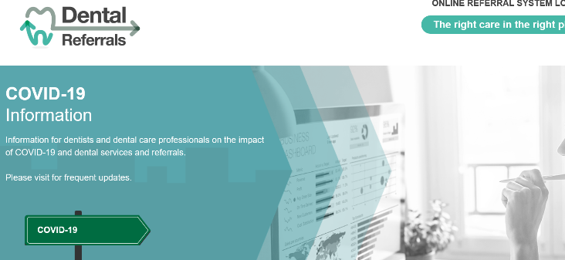

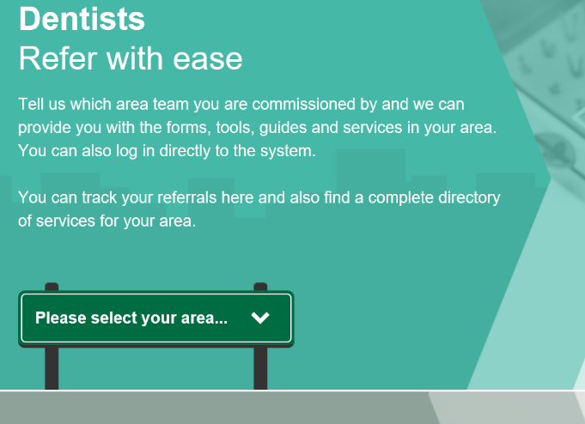

Choose Greater Manchester

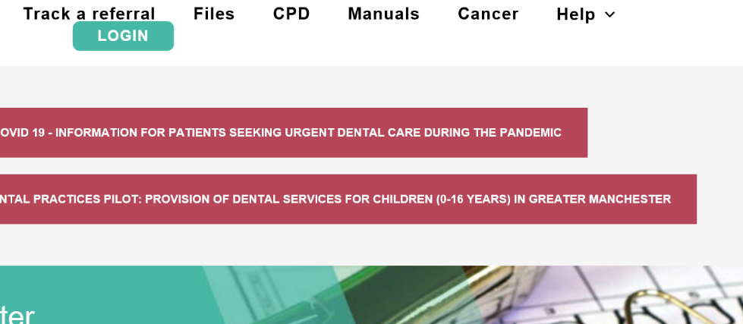

Select CPD

You will need to register to take CPD regardless if you subbmited referals previously

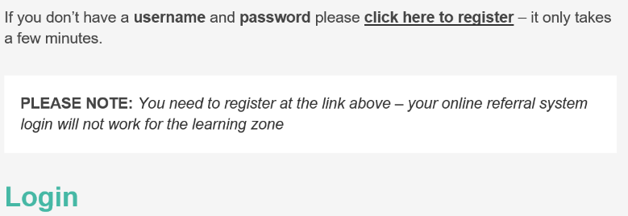
Once registered to undertake CPD once registered and logged in select

Click onto take this course

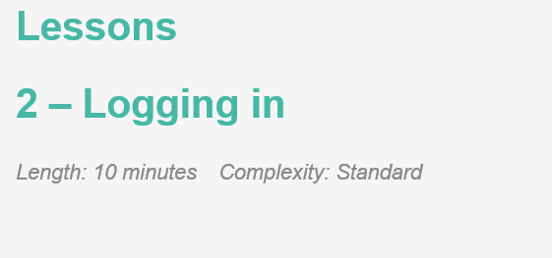

This will then appear click on the referral system

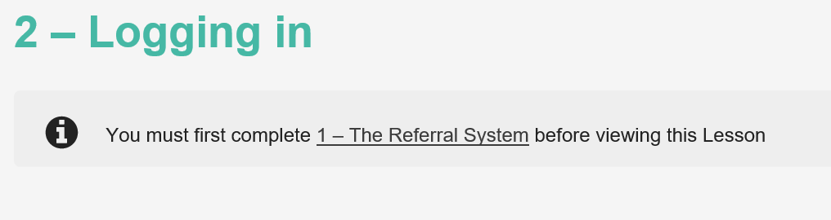
scroll to the bottom and click on view lesson quiz and continue through

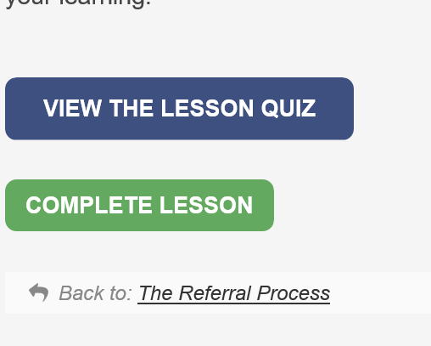

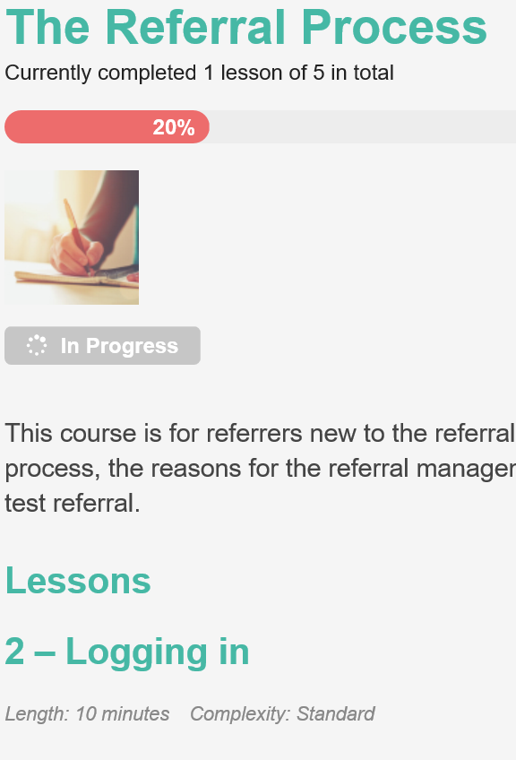

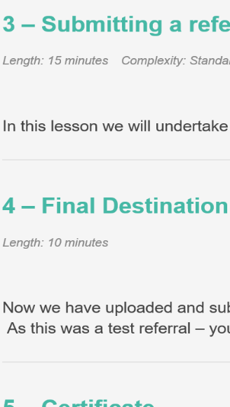
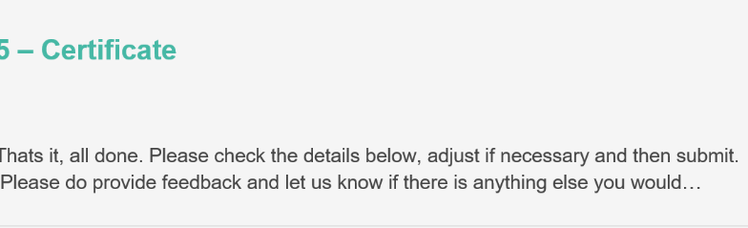

Once each section of the above is completed you will be awarded your 5 lessons certficate to provide to you PCF as outcome 4 of the accreditation,

4. All dentists and therapists to familiarise themselves with online referral system. At least one dentist to undertake training on electronic 2 week referral (available on the Dental Referral site under ‘Pathways and Referrals – ‘’referral Process – 5 lessons’ https://www.dental-referrals.org/course/the-referral-process/

