SECOND SUNDAY OF ADVENT
DECEMBER 8-9, 2018
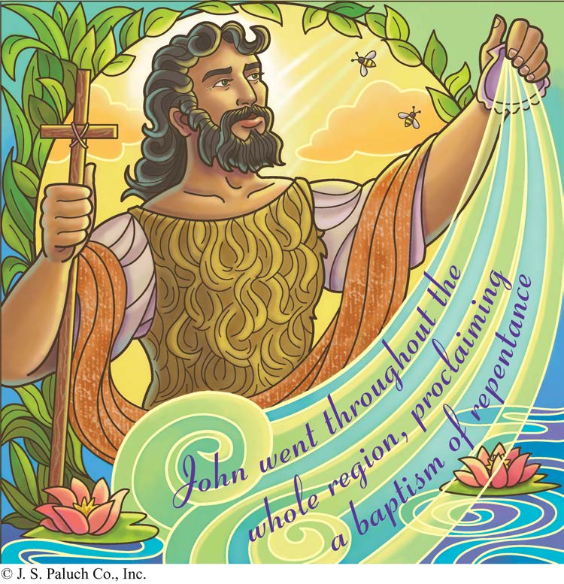
AWAITING THE SALVATION OF GOD

The world does not seem big enough to contain the jubilation of the first reading. In the Gospel reading, the Roman Empire isn’t big enough, either. The great powers of Rome are named and made to stand waiting for the arrival of God’s salvation. And we find Paul meditating joyfully on what really matters.
According to Baruch, the city of Jerusalem is like a person standing on tiptoe looking for God’s salvation, which is coming from the east. Those who were led away on foot, heads down, now come back, a proud people. Why? The very way is smoothed out. The path is lined with fragrant, lush tress. It can’t get any better than this, can it? Well, yes, it can. For a voice calls out in the desert. Here is the beginning of the salvation of God.

TWO REALMS
By: Dennis Tavares

There are two vast realms of reality, namely the spiritual world and the material world. We are familiar with both realms because humans are a composite creature with a material body and a spiritual soul. We have the five senses that inform us of the material world, and our intellect and will which are attributes of our spiritual soul and which inform us of the spiritual world. Humans are the only creatures in the material world who are persons, that is beings with an everlasting soul. The spiritual world also has persons; one is the only Divine Creator God, and the other kind of spiritual person is the individual angel of which God created a multitude. So there are only three kinds of persons in all of reality, whether spiritual or material. Everything else in reality then is decoration in the interplay of God, angels, and humans.
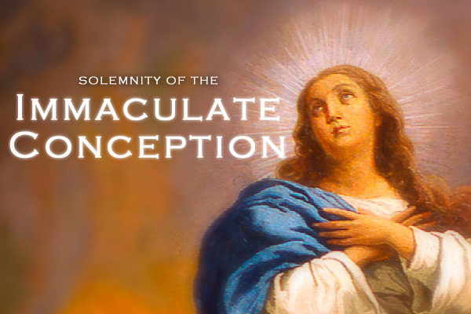
REFLECTING ON
THE IMMACULATE CONCEPTION OF MARY

The fragment that we hear today from the Book of Genesis is the first sad moment in the Bible. We see what happens when we turn from God. When God call out for them, Adam and Eve go into hiding. In answer to God’s question, ”Where are you?” the man replies: “I heard you in the garden; but I was afraid, because I was naked, so I hid myself” (Genesis 3:9, 10).
Adam has moved from being the custodian of the garden, entrusted with the care of all that God has made, to a creature skulking around, fearful of being naked before his Creator. Nakedness here is a symbol of being vulnerable, open, and obedient before God. But Adam and Eve wanted to be “like Gods who know what is good and what is bad” (3:5).
In contrast, we have Mary, the Handmaid of the Lord, the one who accepts God’s intimacy, receiving God’s plan into her life and living out God’s plan, not her own. Mary is willing to serve as God sees fit. And this willingness to serve extends outward. Her elderly cousin’s condition is revealed and Mary goes on the road to be with her until Elizabeth gives birth.
Faith is not a still pond but a river flowing forth in streams of love. Mary’s Immaculate Conception did not make her less human but more human, more indebted to God the more she was graced. God graced her appropriately to the divine plan for her. So, too, for each of us.

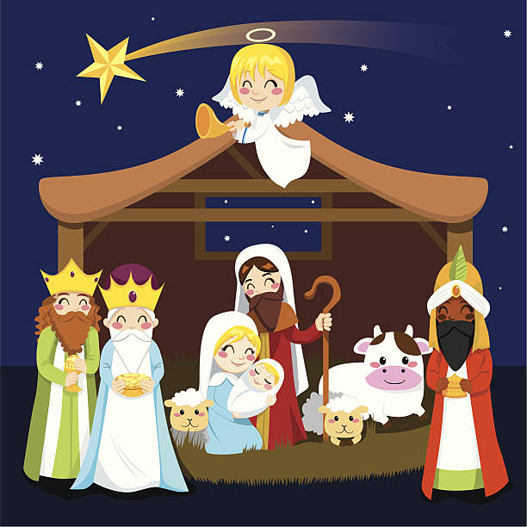
FATHER ANDRE WILL CELEBRATE
MASS AT SHERWOOD OAKS HEALTH CENTER
ON WEDNESDAY, DECEMBER 19TH AT 10AM.
PLEASE, JOIN US TO CELEBRATE CHRISTMAS WITH OUR SENIOR PARISHIONERS.
ANY QUESTIONS, PLEASE CALL SALLIE RICHARDS AT 964-4446.

IMPORTANT ANNOUNCEMENT
ADVENT CONFESSIONS WILL BE ON WEDNESDAY, DECEMBER 19, 2018, 6PM-8PM.

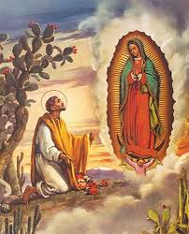
FEAST OF OUR LADY OF GUADALUPE

On December 12th, we will celebrate the
Feast of Our Patroness of the Americas, Our Lady Of Guadalupe.
There will be the Mañanitas at 5am, a recitation of the Rosary and a Mexican Breakfast (hot chocolate, coffee and pastries).
At 5:30pm, we shall have a procession followed by Mass and a gathering at the Michaelraj Hall.
The whole community is invited.
We request your participation and generous donation for this special event. The second collection for this weekend will be for this event.
You may drop of your donation at the office, Monday – Friday from 10am – 2pm or in the collection basket (Mark your envelope: Feast of Our Lady of Guadalupe).

May Our Mother’s mantle of love bring blessings of peace and harmony to families in our faith community.

WEEKLY COLLECTION
DECEMBER 01 & 02, 2018… $2,436.11
LIABILITY INSURANCE: $741.00

THIS WEEKEND’S SECOND COLLECTION:
FEAST OF OUR LADY OF GUADALUPE
NEXT WEEKEND’S SECOND COLLECTION:
RETIREMENT FUND FOR RELIGIOUS

THANK YOU
FOR YOUR SUPPORT & CHRISTIAN GENEROSITY

READINGS FOR THE WEEK:
Monday: Is 35:1-10; Ps 85:9-14; Lk 5:17-26
Tuesday: Is 40:1-11; Ps 96:1-3, 10ac, 11-13;
Mt 18:12-14
Wednesday: Zec 2:14-17 or Rv 11:19a; 12:1-6a, 10ab;
Jdt 13:18bcde, 19; Lk 1:26-38 or Lk 1:39-47,
Or any readings from the Common of the Blessed Virgin Mary, nos. 707-712
Thursday: Is 41:13-20; Ps 145:1, 9-13ab; Mt 11:11-15
Friday: Is 48:17-19; Ps 1: 1-4, 6; Mt 11:16-19
Saturday: Sir 48:1-4, 9-11; Ps 80: 2ac, 3b, 15-16,
18-19; Mt 17:9a, 10-13
Sunday: Zep 3:14-18a; Is 12:2-6; Phil 4:4-7;
Lk 3:10-18

PRAY FOR OUR FAMILY AND FRIENDS THAT ARE IN THE MILITARY SERVICE
José Araiza Jr., Edgar Toscano, Marina González, Alondra Jara,
Sonia Jara, Jason Lorenz, Matt Mill y Jared Schroeder.

ATTENTION
CALENDARS FOR 2019 ARE AVAILABLE AT THE VESTIBULE OF THE CHURCH.
THERE WILL BE AN ENGLISH ADVENT RETREAT
ON THURSDAY, DECEMBER 20, 2018
FROM 6:00 – 7:00PM IN THE CHURCH,
TO BE LED BY FR. ANDREW PACHECO.
THE ATTENDANCE FOR PARENTS AND GODPARENTS OF OUR CHILDREN IN CATECHISM IS MANDATORY.

POINSETTIAS ARE NEEDED
IN YEARS PAST, WE HAVE ASKED FOR DONATIONS OF POINSETTIAS FOR CHRISTMAS.
THIS YEAR WE WANT TO DO SOMETHING DIFFERENT.
WE ASK THAT YOU DONATE A POINTSETTIA
IN MEMORY OF LOVED ONES WHO HAVE
PASSED AWAY.
PLEASE DELIVER THEM TO THE OFFICE BY
DECEMBER 17th.

MASS INTENTIONS
DECEMBER 12 - 16, 2018
Wednesday (12)  Thursday (13)  Friday (14)  Saturday (15)  Sunday (16) | 6:00pm  12:05pm  12:05pm  5:00pm  6:30pm  8:00am  10:00am | Lupe Becerra †  Joaquín Sánchez †  Ruby Burns†  Catherine Cooper†  Fred & Clara White †  Evelyn Costa †  Teodoro Rodriguez †  Antonio Rodriguez †  Antonio Jose Gomes†  John & Lenore Cortez †

PLEASE PRAY FOR OUR SICK PARISHIONERS
Richard Braga, Lisa Wright, Ricardo Contreras, Florencia Chávez, Refugio Yáñez, Tarcicio Garía, Sofía García, María de Jesús Mendoza, Ana García, Antonio Cazares, Ryan Moore, Eileen Seeman, Marianne Brannan, Lilia Parrish, Nancy Smith, Julián Palomar, Luisa Martínez, Jennifer Vera, John Braet, Kim Koskinen, Margaret Valencia, Matthew Marcoulier, Dennis Tavares, Jose Freitas, Alfredo Sousa, Juana Arreguín, Aron Yasskin, Victoria Walzer, Fidela Yáñez Jara, Erika Ramos, Bill Gibson, Carla Tomas, Erasmo Yáñez, Memo Soria, Patricia Vargas, Fidela Yáñez, Elvia Flores, Camila Blanco-Cherrez, Yonel Ruíz, Angie Freitas, Russel Bryant, Derrick Heater, Luis Angel, Juan Barrera-Terán, Gabriel Hurtado, Gerald Butler, Helen Reynolds, Toni Clark, Ann Gallagher, Brianna Lopez, Margaret Milliken, Gina Pivirotto, Nick Quin, Mary Servis, Denis Sousa, Victor Venegas, Matty Walker, Charles Lorenz, Rebecca Lorenz, Ofelia Ibarra, Leonardo Naal, Gina Leal.

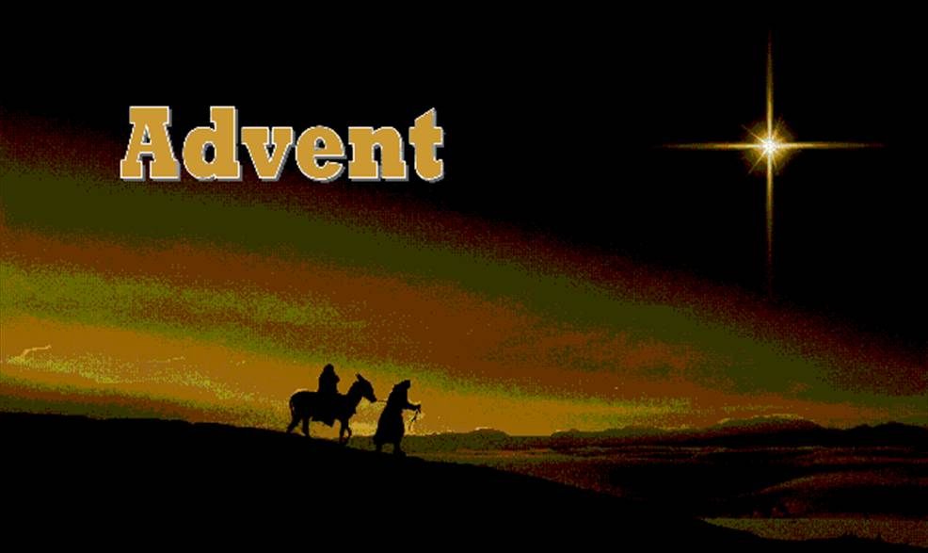
DAILY ADVENT DEVOTIONAL

DECEMBER 9, 2018
SECOND SUNDAY OF ADVENT

“John went throughout the whole region of the Jordan, proclaiming a Baptism of repentance for the forgiveness of sins.” (Lk 3:3)

Seek God’s tender love and mercy through the Sacrament of Reconciliation
this Advent.
DECEMBER 10, 2018
SECOND MONDAY OF ADVENT

“…not finding a way to bring him in because of the crowd, they went up on the roof and lowered him on the stretcher through the tiles into the middle in front of Jesus.”
(Lk 5: 19)

Consider assisting those in need by making an anonymous Christmas donation to your local Parish Church or shelter.
DECEMBER 11, 2018
SECOND TUESDAY OF ADVENT

“In just the same way it is not the will of your heavenly Father that one of these little ones be lost.” (Mt 18: 14)

Provide kind words of encouragement to a friend or loved one, who is experiencing a crisis in Faith.
DECEMBER 12, 2018
FEAST OF OUR LADY OF GUADALUPE

“Then the angel said to her, ‘Do not be afraid, Mary, for you have found favor with God.
Behold, you will conceive in your womb and bear a son, and you shall name him Jesus.’ “

Offer a Hail Mary for the safety and protection of all human life and those most vulnerable in our society.
DECEMBER 13, 2018
SECOND THURSDAY OF ADVENT

“ ‘Amen, I say to you, among those born of women there has been none greater that John the Baptist; yet the least in the Kingdom of Heaven is greater than he.’ “ (Mt 11: 11)

Ask for the intercession of Saint John the Baptist in preparing a place in your heart for Our Lord.
DECEMBER 14, 2018
SECOND FRIDAY OF ADVENT

“The Son of Man came eating and drinking and they said, ‘Look, he is a glutton and a drunkard, a friend of tax collectors and sinners.’ But wisdom is vindicated by her works. “ (Mt 11: 19)

If you need to ask someone for forgiveness, consider doing so today.
DECEMBER 15, 2018
SECOND SATURDAY OF ADVENT

“…but I tell you that Elijah has already come, and they did not recognize him but did to him whatever they pleased. So also will the Son of Man suffer at their hands.” (Mt 17: 12)

Forgive someone who has caused you pain and let go of persistent grudges.

