Name:_______________________________________ Class Period:____ Due Date:___/____/____

Guided Reading & Analysis: Territorial and Economic Expansion, 1830-1860

Chapter 12- Manifest Destiny pp 230-240
Reading Assignment:
Ch. 12 AMSCO or other resource covering 1830-1860

Purpose:
This guide is not only a place to record notes as you read, but also to provide a place and structure for reflections and analysis using your noggin (thinking skills) with new knowledge gained from the reading. This guide, if THOUGHFULLY completed in its entirety BOP (Beginning of Period) by the due date, can be used on the corresponding quiz as well as earn up to 10 bonus points. In addition, completed guides provide the student with the ability to correct a quiz for ½ points back! The benefits of such activities, however, go far beyond quiz help and bonus points. Mastery of the course and AP exam await all who choose to process the information as they read/receive. This is an optional assignment. So… young Jedi… what is your choice? Do? Or do not? There is no try. (image captured from history.com)

Directions:
- Pre-Read: Read the prompts/questions within this guide before you read the chapter.
- Skim: Flip through the chapter and note titles and subtitles. Look at images and read captions. Get a feel for the content you are about to read.
- Read/Analyze: Read the chapter. If you have your own copy of AMSCO, Highlight key events and people as you read. Remember, the goal is not
to “fish” for a specific answer(s) to reading guide questions, but to consider questions in order to critically understand what you read!
- Write Write (do not type) your notes and analysis in the spaces provided. Complete it in INK!

Key Concepts FOR PERIOD 5:
Key Concept 5.1: The United States became more connected with the world, pursued an expansionist foreign policy in the Western Hemisphere, and emerged as the destination for many migrants from other countries.
Key Concept 5.2: Intensified by expansion and deepening regional divisions, debates over slavery and other economic, cultural, and political issues led the nation into civil war.
Key Concept 5.3: The Union victory in the Civil War and the contested reconstruction of the South settled the issues of slavery and secession, but left unresolved many questions about the power of the federal government and citizenship rights.

The idea of manifest destiny fueled the continued American expansion westward. Americans from the time of the Puritans spoke of America as a community with a divine mission… and in the 1830s… this notion of “God’s Plan” developed into “Manifest Destiny.” Political leaders and Protestant missionary organizations fervently supported expansion. In 1845 Democratic newspaperman John O’Sullivan wrote that the most critical need for America was
“…the fulfillment of our manifest destiny to overspread the continent allotted by Providence for the free development of our yearly multiplying millions.”

Section 1 Overview, page 229
Read the overview of the era, and then complete the statements below.

Manifest Destiny led to the territorial acquisitions through…

- 2. 3.

Expansion and slavery led to continued sectionalism and eventual Civil War because…

- 2. 3.

The Union won the Civil War which led to…

- 2.

Opposing Views… Consider the following three questions for this unit of study:
- Was the Civil War an unavoidable conflict over slavery, or was it caused by a failure of leadership?
- Was it about states rights and federal power, or was it about moral issues?
- Was Reconstruction successful because slavery ended and African Americans received Civil Rights and suffrage, or was it a failure that required another reform movement 100 years later?

Section 2 Guided Reading, pp 230-240

- Intro: Territorial and Economic Expansion, 1830-1860 page 230

Key Concepts &  Main Ideas | Notes
The idea of Manifest Destiny, which asserted U.S. power in the Western Hemisphere and supported U.S. expansion westward, was built on a belief in white racial superiority and a sense of American cultural superiority, and helped to shape the era’s political debates. | Read the John L. O’Sullivan quote at the top of the page as well as the first two paragraphs.  Explain how O’Sullivan’s quote supports or refutes the key concept at left.  In the 1840s-1850s… Manifest Destiny played out by…

- Guided Reading Continued, pp 230-233, Conflicts Over Texas, Maine, and Oregon
As you read the chapter, jot down your notes in the middle column. Consider your notes to be elaborations on the Objectives and Main Ideas presented in the left column and in the subtitles of the text. INCLUDE IN YOUR NOTES ALL SIGNIFICANT VOCABULARY AND PEOPLE. After read and take notes, thoughtfully, analyze what you read by answering the questions in the right column. Remember this step is essential to your processing of information. Completing this guide thoughtfully will increase your retention as well as your comprehension!

Key Concepts & Main Ideas | Notes | Analysis
Enthusiasm for U.S. territorial expansion fueled by economic and national security interests and supported by claims of U.S. racial and cultural superiority, resulted in war, the opening of new markets, acquisition of new territory, and increased ideological conflicts.  Enthusiasm for U.S. territorial expansion fueled by economic and national security interests and supported by claims of U.S. racial and cultural superiority, resulted in war, the opening of new markets, acquisition of new territory, and increased ideological conflicts.  Enthusiasm for U.S. territorial expansion fueled by economic and national security interests and supported by claims of U.S. racial and cultural superiority, resulted in war, the opening of new markets, acquisition of new territory, and increased ideological conflicts. | Conflicts Over Texas, Maine, and Oregon…  Texas…  Revolt and Independence…  Annexation Denied…  Continued on next page…  Boundary Dispute in Maine…  Boundary Dispute in Oregon…  The Election of 1844…  Annexing Texas and Dividing Oregon…  Continued on next page…  Song Title: James K. Polk  In 1844, the Democrats were split  The three nominees for the presidential candidate  Were Martin Van Buren, a former president and an abolitionist  James Buchanan, a moderate  Louis Cass, a general and expansionist  From Nashville came a dark horse riding up  He was James K. Polk, Napoleon of the Stump  Austere, severe, he held few people dear  His oratory filled his foes with fear  The factions soon agreed  He's just the man we need  To bring about victory  Fulfill our manifest destiny  And annex the land the Mexicans command  And when the votes were cast the winner was  Mister James K. Polk, Napoleon of the Stump  In four short years he met his every goal  He seized the whole southwest from Mexico  Made sure the tariffs fell  And made the English sell the Oregon territory  He built an independent treasury  Having done all this he sought no second term  But precious few have mourned the passing of  Mister James K. Polk, our eleventh president  Young Hickory, Napoleon of the Stump  Written and Performed by: They Might Be Giants | List and explain the motives behind expansion into Texas, Oregon, and Main.  Support or refute President Andrew Jackson’s reasoning behind refusing to admit Texas. Make sure your response has specific evidence.  In a letter to Stephen F. Austin from John Durst, Durst asks, “We have received by the last mail a Decree Given by the executive of our Government Liberating all the Slaves in its territory… in the Name of God, what Shall we do? For God’s sake advise me on the subject by the return of mail. We are ruined forever Should this measure be adopted.”  To what extent was the Texas War for Independence caused by slavery? Explain your answer and identify an alternate view.  Compare and contrast the causes and effects of the Aroostook War with the Texas War for Independence.  Explain the key difference between the two Democrats, Andrew Jackson and James K. Polk on the issue of territorial expansion.  What was the impact of the “dark horse” victory?  James K. Polk made 5 promises in his 1844 campaign:  - to acquire California from Mexico,  - to settle the Oregon dispute,  - to lower the tariff,  - to establish a sub-treasury, and  - to retire from the office after 4 years.  Did he keep his promises?  Contextualize the Song at left.  (see Contextualization writing activities in your notebook or on the website for directions if you are not sure how to contextualize)  Local Context:  Broad Context:  Other Context:

- War with Mexico, pp 233-235

Key Concepts & Main Ideas | Notes | Analysis
Enthusiasm for U.S. territorial expansion fueled by economic and national security interests and supported by claims of U.S. racial and cultural superiority, resulted in war, the opening of new markets, acquisition of new territory, and increased ideological conflicts  The acquisition of new territory in the West and the U.S. victory in the Mexican-American War were accompanied by a heated controversy over allowing or forbidding slavery in newly acquired territories. | War with Mexico…  Immediate Causes of the War…  Continued on next page…  Military Campaigns…  Consequences of the War…  Treaty of Guadalupe Hidalgo (1848)…  Wilmot Proviso…  Prelude to Civil War?... | Support or refute the claim that Mexico incited war by killing 11 Americans. Defend your answer with specific evidence.  Explain the political, geographic, and cultural impact of the Treaty of Guadalupe-Hidalgo.  To what extent was the Treaty of Guadalupe Hidalgo a turning point in American history? Defend your answer with specific evidence.

- Manifest Destiny to the South, pp 235-236

Key Concepts  & Main Ideas | Notes | Analysis
The United States became more connected with the world as it pursued an expansionist foreign policy in the Western Hemisphere and emerged as the destination for many migrants from other countries.  U.S. interest in expanding trade led to economic, diplomatic, and cultural initiatives westward to Asia. | Manifest Destiny in the South…  Ostend Manifesto…  Walker Expedition…  Continued on next page…  Clayton-Bulwer Treaty (1850)…  Gadsden Purchase…  Expansion After the Civil War… | Compare and contrast William Walker’s expansionist goals, methods, and effectiveness to that of James K. Polk’s. Answer thoughtfully with specific evidence.  Explain the economic significance of Clayton-Bulwer and Gadsden Purchase.  What was Seward’s purchase of Alaska called “Seward’s Folly?”  Was it actually brilliant? Explain your answer.

- Settlement of the Western Territories, pp236-238

Key Concepts & Main Ideas | Notes | Analysis
Westward expansion, migration to and within the United States, and the end of slavery reshaped North American boundaries and caused conflicts over American cultural identities, citizenship, and the question of extending and protecting rights for various groups of U.S. inhabitants. | Settlement of the Western Territories…  Fur Traders’ Frontier…  Overland Trails… | Make sure you understand the following terms!  Immigration: to move into a country in order to settle there, crossing a political boundary, and usually making a permanent move from one nation to another  Emigration: to move out of one country or region to settle in another  Migration: to move within a defined boundary. For example, American Mormons migrated from the Old Northwest to Utah.  Look at the map on page 235. List each trail illustrated on the map, and explain why people were migrating. Be sure your explanation has specific information.
Asian, African American, and white peoples sought new economic opportunities or religious refuge in the West, efforts that were boosted during and after the Civil War with the passage of new legislation promoting national economic development. | Mining Frontier…  Farming Frontier…  Urban Frontier… | 1.  2.  3.  4.
- The Expanding Economy, pp238-239

Key Concepts & Main Ideas | Notes | Analysis
U.S. interest in expanding trade led to economic, diplomatic, and cultural initiatives westward to Asia.  U.S. interest in expanding trade led to economic, diplomatic, and cultural initiatives westward to Asia.  (this material also links into your Period 4 Content Outline)  Intensified by expansion and deepening regional divisions, debates over slavery and other economic, cultural, and political issues led the nation into civil war.  The North’s expanding economy and its increasing reliance on a free-labor manufacturing economy contrasted with the South’s dependence on an economic system characterized by slave-based agriculture and slow population growth. | The Expanding Economy…  Industrial Technology…  Railroads…  Foreign Commerce…  1.  2.  3.  4.  5.  Panic of 1857… | How did industrial technology impact sectionalism?  Compare and contrast the impact of the Northeastern canal system to the impact of pre-Civil War railroad development.  How did Railroad expansion impact sectionalism?  How did the Panic of 1857 impact sectionalism?

- Historical Perspectives: What Caused Manifest Destiny? pp 239-240

Traditional Historical Analysis of Manifest Destiny | Modern Historical Analysis of Manifest Destiny

Historical Perspectives continued…

“Of all the countries in history that have been robbed, Mexico was neither the most nor the least deserving. On one had, it had been the legitimate, acknowledged owner of the western part of North America all the way up to Oregon and Colorado since 1540, when Francisco Vazquez de Coronado first claimed the area for Spain. On the other hand, Mexico never really ‘did’ anything with the place. In 1821 the entire Mexican population of Alta California, Nevada, and most of Arizona and Utah was just 3,270, while Texas only had 2,500 Mexicans... By 1836 there were about 30,000 [Americans] in Texas versus 3,500 Mexicans. In California, by 1850 there were 60,000 … versus… 7,000 (along with about 1,000 African-Americans and 22,000 foreign immigrants).”
Source: The Mental Floss History of the United States by Erik Sass

Does this knowledge support or refute the notion that the Mexican-American War was inevitable? Defend your answer.

In your view, what was the main reason for Manifest Destiny?  Rugged Individualism and Pioneer Spirit?  Providence?  Racism and White Supremacy?  Economic Development (money)?  Defend your view. | How have modern views impacted the nation?  Has it led to improved race relations?  Has it led to improved curriculum?  Has it led to more or less conflict?  Is this a good thing?

“Fort Ross, located about 90 miles north of San Francisco, marked the southern-most limit of Russian territory in North America. It was founded in 1812 by the Russian-American Company as an agricultural colony to feed Russian fur trappers in Alaska. With a population of 250 at its peak, Fort Ross was actually the central hub for a number of even smaller outposts as far south as Bodega Bay and the Farallon Islands, located 40 miles north and 18 miles west of San Francisco, respectively. The Russians dismantled the colony in 1841. But Mexico was still worried about the threat of Russian expansion in their land, so they invited Anglo-American settlers to California as a buffer against Russian expansion from Alaska. The Mexican government also considered inviting Chinese colonists and Irish famine refugees to California.” Source: The Mental Floss History of the United States by Erik Sass

Does this information support or refute the view that American dominance then annexation of California was in the best long term interests of the North America. Explain your reasoning.

- Map-o-Fun!
NAME – YEAR – METHOD…
Label each significant piece of land and explain when and how America secured each part of our nation represented on the map below. Highlight or color each region a different color. See Unit 4 page of website for more notes and a map to help.

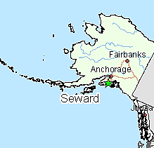

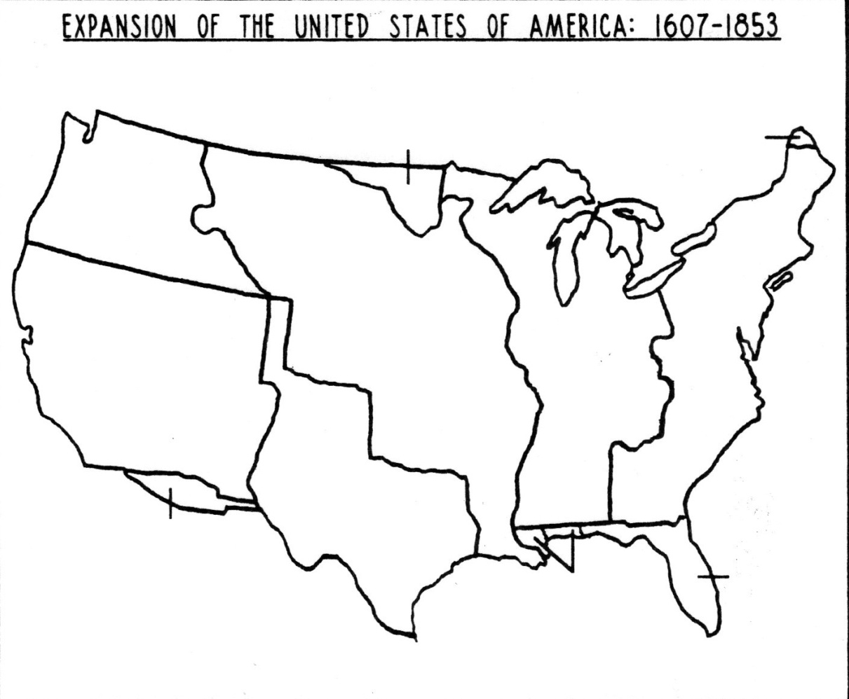

Caption:
(summarize how and why the country grew)

Reading Guide written by Rebecca Richardson, Allen High School
Sources include but are not limited to: 2015 edition of AMSCO’s United States History Preparing for the Advanced Placement Examination,
2015 Revised College Board Advanced Placement United States History Framework, and other sources as cited in document and collected/adapted over 20 years of teaching and collaborating..

